Press Release

Transducers enable true RMS value measurement for AC currents up to 5 A

Berlin, Germany – Knick Elektronische Messgeräte (www.knick.de) is a globally recognized manufacturer of high quality signal, sensor, current and voltage measurement devices for utility, rail, ship, and other rugged environments. With the announcement of their series P 43000 TRMS AC/DC high voltage transducers, Knick have defined a completely new class of AC/DC transducers for true RMS values. Input values range from 100 mA up to 5 A AC. They are output as standardized analog DC signals (0…20 mA, 4…20 mA, 0…10 V).
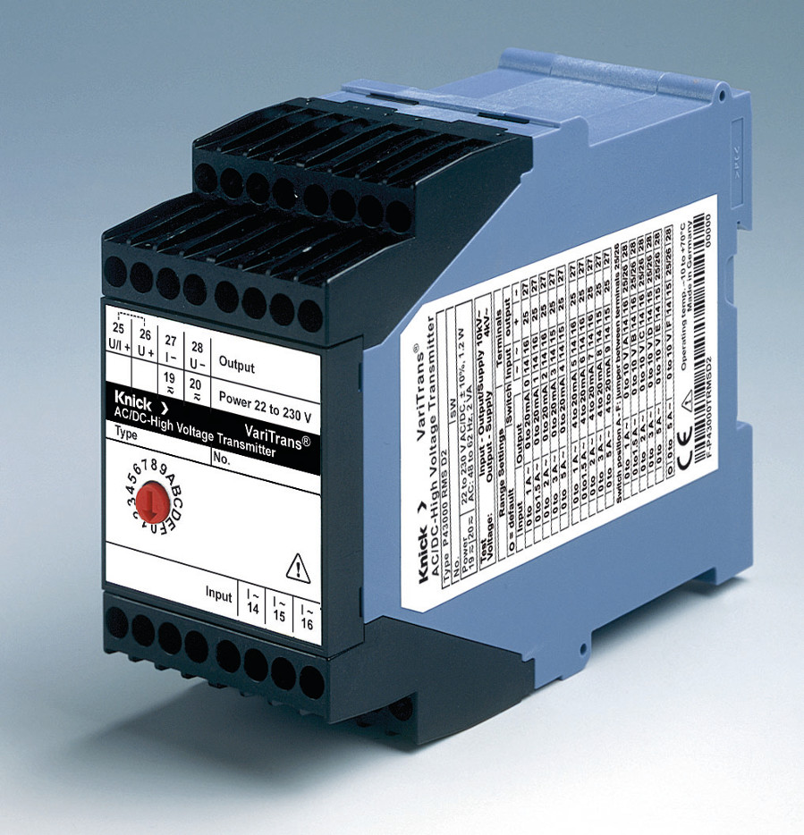
Illustration: AC/DC high voltage transducers: P 43000 TRMS from Knick

A rotary coding switch on the front facilitates comfortable, calibrated switching between up to 16 customized ranges. Traditional AC/DC transducers are very susceptible to errors due to their poor insulation and are only designed for pure sinewave measurement. The Knick P 43000 TRMS, however, has been developed to also accurately process distorted input signals. The highly accurate true RMS circuit converts signals with a crest factor of up to 5 in the frequency range of 40 Hz to 1000 Hz or 8 Hz to 400 Hz. The VariTrans P 43000 TRMS withstands working voltages up to 3600 V AC/DC and test voltages up to 15 kV. Protective separation of the input, output and power supply provide protection from electric shock up to 1800 V AC/DC according to EN 61140.
Knick's own TransShield technology facilitates an extremely compact, shielded design of the high-voltage transformers, allowing the VariTrans P 43000 TRMS to fit into a very compact, only 45 mm wide housing. Vacuum encapsulation provides maximum long-term protection against aggressive environmental influences, shock and vibration. In addition, VariTrans P 43000 TRMS transducers come with an integrated VariPower broad range power supply for supply voltages from 20...253 V AC/DC, which ensures maximum safety even in regions where auxiliary power is shaky.
Knick VariTrans P 41000 TRMS transducers come with a five-year warranty. For more information please contact Knick Elektronische Messgeräte at info@knick.de or visit us at www.knick.de.

Illustrations: | P43000-TRMS | Char.s: | 2,003
File name: | 201701047_pm_p43000-trms_en | Date: | 03-22-2018
About Knick
Founded by engineer Ulrich Knick in Berlin more than 70 years ago, Knick Elektronische Messgeräte GmbH & Co. KG still uphold the family company tradition today. The innovative enterprise manufactures measuring and monitoring devices for the chemical industry, system engineering, and industrial automation.

Contact:  Knick Elektronische  Messgeräte GmbH & Co. KG  Carsten Koska  Beuckestraße 22  14163 Berlin  Tel.: +49 30 / 80191 - 0  Fax: +49 30 / 80191 - 200  E-Mail: info@knick.de  Internet: www.knick.de |  | gii die Presse-Agentur GmbH  Immanuelkirchstr. 12  10405 Berlin  Germany  Tel.: +49 . 30 . 538 965-0  Fax: +49 . 30 . 538 965-29  E-Mail: info@gii.de  Internet: www.gii.de

