Press Release

Robust, precise, and tiny:
IZAL series of matchstick-size LVDT displacement sensors

Ottobrunn – No more than 4 mm wide, the slim LVDTs (linear variable differential transformers) in Inelta's IZAL series of reliable and highly precise miniature displacement sensors are especially suitable for demanding environments. The sensors with housings made from nickel-plated steel ensure IP65 ingress protection and are designed for environmental temperatures from -25 °C to +85 °C, or an even wider range upon request.
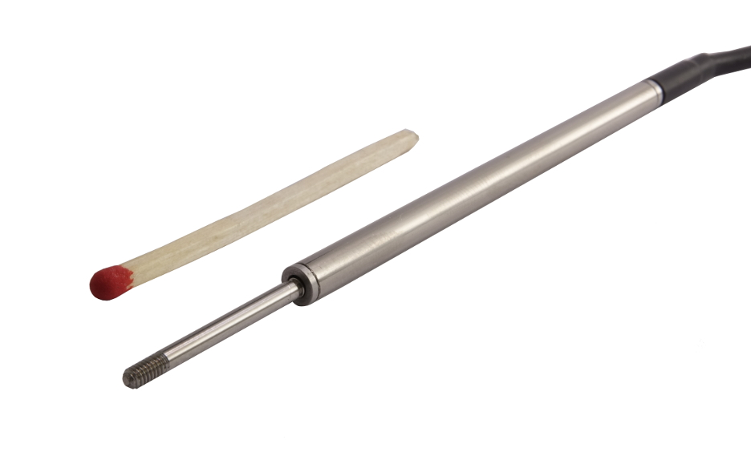
Illustration: Almost as slim as a match: IZAL series displacement sensors from Inelta are only 4 mm wide and 55 mm tall.

They are actuated by an unguided core with a diameter of 2 mm. These LVDTs are available in versions for 2 mm, 5 mm and 10 mm measuring distances. Since their function is based on contactless inductive measurements, they are wear-free, achieve < ±0.5% linearity tolerance, and can optionally be supplied with a linearity tolerance of <±0.25%. IZAL series sensors are also very robust: they are highly impact-resistant (200 g over 2 ms) and vibration-proof (10 g at sinusoidal frequencies ranging from 2 Hz to 2000 kHz). Encased in 55 mm housings, these sensors are only slightly taller than a match and thus easily fit even into very tight installation spaces. In order to ensure exceptionally high measurement quality despite the extremely compact dimensions of these miniature differential transformer measuring system, the tiny coils in these devices are wound by hand under microscopes in Inelta's production facility. The sensors come with a 1 m connection cable or other cable lengths on request. The manufacturer also optionally offers cables in different colors and supplies custom-calibrated sensors on request. For the standard signal conversion of the measured values, Inelta provides suitable external signal amplifiers for output signals in the 0..5 V, 0..10 V, ±5 V, ±10 V, and 0/4..20 mA ranges, and a print module for 0..10 V signal output.

Figures: | IZAL_Streichholz | Char.s: | 1,773
File name: | 201702016_pm_izal_en | Date: | 07-05-2017
About Inelta
About Inelta
Headquartered in Ottobrunn near Munich, inelta Sensorsysteme GmbH & Co. KG is part of the inelta group, which also comprises PIL Sensoren GmbH based in Erlensee near Frankfurt/Main, and VYPRO s.r.o., a production company in Trenčín, Slovakia. inelta Sensorsysteme draws on approxamately 20 years of experience in sensor development, production, and distribution. The product range includes sensors for distance and dimension measurement, force sensors, sensor signal amplifiers and actuator-sensor systems. PIL has been developing, manufacturing, and distributing ultrasonic sensors for ca. 30 years and VYPRO is focused on sensor processing, confection of cables and connectors. The company group is particularly focused on industry-specific and customer-specific sensor solutions, and continues to apply a wealth of interdisciplinary know-how to expand the scope of such offerings.

Contact:  inelta Sensorsysteme GmbH & Co. KG  Katrin Seubert  Haidgraben 9a  D-85521 Ottobrunn  Germany  Tel.: 0 89 / 45 22 45-0  Fax: 0 89 / 45 22 45-744  Email: katrin.seubert@inelta.de  WWW: www.inelta.de |  | gii die Presse-Agentur GmbH  Immanuelkirchstraße 12  10405 Berlin  Germany  Tel.: 0 30 / 53 89 65-0  Fax: 0 30 / 53 89 65-29  Email: info@gii.de  WWW: www.gii.de

