Press Release

Highly versatile:
compact KMM65 pressure and traction sensors

Ottobrunn – The KMM65 series of force sensors from Inelta Sensorsysteme comprises nine different models for measuring tensile and compressive forces between 1kN and 500 kN. Depending on the measuring range, sensor diameters vary between 50 mm and 260 mm, with installation heights between 18 mm and 80 mm.

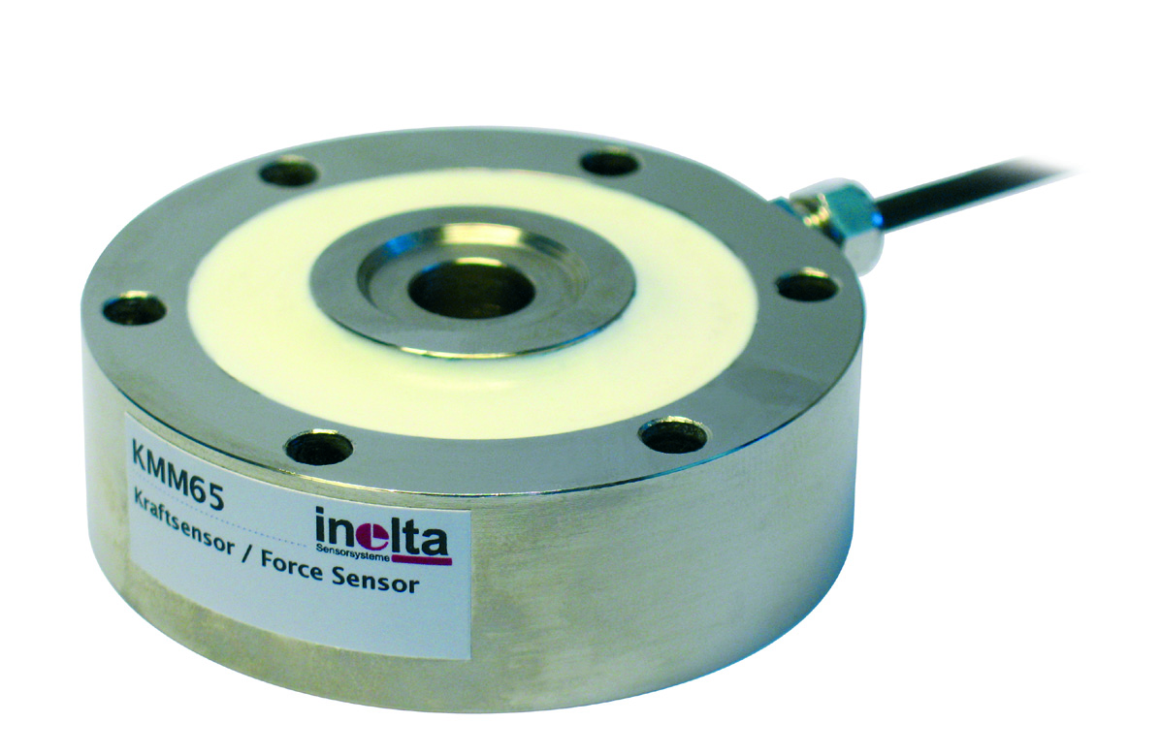
Illustration: Inelta's KMM65 series force sensors are available for measuring tensile and compressive forces between 1kN and 500 kN

KMM65 sensors use the DMS load cell measurement principle and achieve <0,1% repeatability. They are available for a nominal temperature range between -10 °C and +70 °C, or optionally for an extended temperature range from -40 to +120 °C. The housing made of nickel-plated steel features IP54 ingress protection. Due to their durability and small dimensions, KMM65 series force sensors are suitable for a wide variety of applications, ranging from weighing technology to testing facilities, to industrial presses, machine building, and even sports equipment. Depending on the model, the sensor housings feature 6 or 8 metric screw holes in M4 to M20 size for mounting. Each sensor is supplied with a two-meter cable as standard. Other cable lengths as well as individual calibrations are available on request. As a complement to these force sensors, Inelta provides IMA2 DMS external sensor signal amplifiers for 0..5 V, 0..10 V, ±5 V, ±10 V, 0/4..20 mA signal output, as well as the IVM2 DMS print module for 0..10V signals that facilitates integration into custom electronics.

Figures: | kraftsensor_kmm65_10cm | Char.s: | 1,374
File name: | 201702018_pm_kmm65_en | Date: | 06-28-2017
About Inelta
Headquartered in Ottobrunn near Munich, inelta Sensorsysteme GmbH & Co. KG is part of the inelta group, which also comprises PIL Sensoren GmbH based in Erlensee near Frankfurt/Main, and VYPRO s.r.o., a production company in Trenčín, Slovakia. inelta Sensorsysteme draws on approxamately 20 years of experience in sensor development, production, and distribution. The product range includes sensors for distance and dimension measurement, force sensors, sensor signal amplifiers and actuator-sensor systems. PIL has been developing, manufacturing, and distributing ultrasonic sensors for ca. 30 years and VYPRO is focused on sensor processing, confection of cables and connectors. The company group is particularly focused on industry-specific and customer-specific sensor solutions, and continues to apply a wealth of interdisciplinary know-how to expand the scope of such offerings.

Contact:  inelta Sensorsysteme GmbH & Co. KG  Katrin Seubert  Haidgraben 9a  D-85521 Ottobrunn  Germany  Tel.: 0 89 / 45 22 45-0  Fax: 0 89 / 45 22 45-744  Email: katrin.seubert@inelta.de  WWW: www.inelta.de |  | gii die Presse-Agentur GmbH  Immanuelkirchstraße 12  10405 Berlin  Germany  Tel.: 0 30 / 53 89 65-0  Fax: 0 30 / 53 89 65-29  Email: info@gii.de  WWW: www.gii.de

