Press Release

New compact transmitter for economic Memosens-Modbus integration

Berlin – Knick Elektronische Messgeräte expand their slim Memosens transmitter series MemoRail for control cabinet installation with a Modbus interface version: The MemoRail Modbus A1405N is the first multi-parameter analyzer that provides process technology operators with an economic, compact transmitter for full-featured integration of Memosens monitoring stations into the fieldbus standard. Up until now, operators could only choose between comprehensively equipped analyzers with a display or compact transmitters with limited functionality.
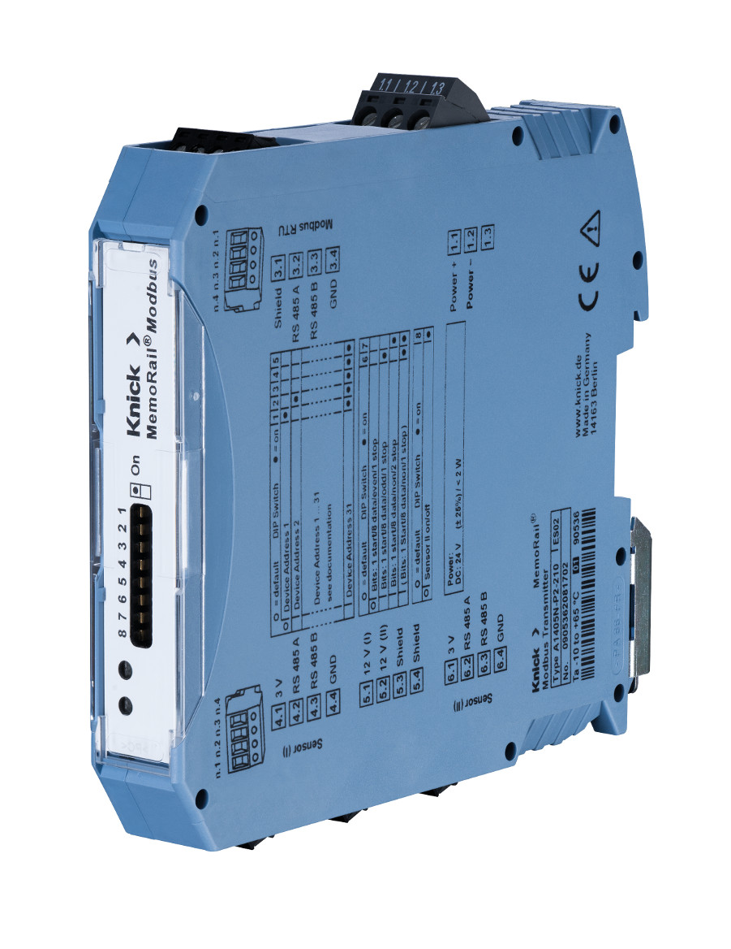
Illustration 1: MemoRail Modbus A1405N for full-featured Modbus integration of Memosens monitoring stations

The new MemoRail Modbus modules from Knick, which feature a modular housing with a width of just 17.5 mm, not only transmit all sensor data and readings to the Modbus master using the MODBUS RTU data format. Unlike conventional compact solutions, they also enable unrestricted access to device configuration and sensor calibration via Modbus. Up to 32 transmitters can be connected to a Modbus master. For the measurement of pH/ORP, conductivity or oxygen, MemoRail Modbus can be combined with all Memosens and digital sensors, whether pH glass, IsFET, oxygen, or conductivity (conductive and inductive). What's more, the DIN rail module is the only analyzer of its class that enables the connection of LDO sensors (luminescent dissolved oxygen) for the optical measurement of oxygen. The new devices come as single- or dual-channel versions with freely combinable parameters or sensors. Either two freely selectable Memosens sensors or a Memosens sensor and a SE 740 LDO can be connected. Additionally, the transmitters allow for the connection of the new SE 554 X/1-AMSN and SE 555 X/1-AMSN combination sensors that synchronously measure pH and ORP values. In this way, a dual-channel MemoRail model provides four readings as well as temperature.
The network address for rapid MODBUS configuration is set via DIP switches on the front panel. The 24 V DC supply can be connected either via TBUS or via a cable connected to the terminals at the back. Red and green LEDs indicate the device status, communication interruptions, defective sensors or device settings unsuitable to the sensor as well as the device's maintenance requirements. Knick provides a 3-year warranty on the MemoRail Modbus transmitters.

Illustrations: | MemoRail_A1405 | Char.s: | 2,248
File name: | 201702026_pm_memorail_modbus_en | Date: | 03-07-2018
About Knick
Founded by engineer Ulrich Knick in Berlin more than 70 years ago, Knick Elektronische Messgeräte GmbH & Co. KG still uphold the family company tradition today. The innovative enterprise manufactures measuring and monitoring devices for the chemical industry, system engineering, and industrial automation.

Contact:  Knick Elektronische  Messgeräte GmbH & Co. KG  Carsten Koska  Beuckestraße 22  14163 Berlin  Tel.: +49 30 / 80191 - 0  Fax: +49 30 / 80191 - 200  E-Mail: info@knick.de  Internet: www.knick.de |  | gii die Presse-Agentur GmbH  Immanuelkirchstr. 12  10405 Berlin  Germany  Tel.: +49 . 30 . 538 965-0  Fax: +49 . 30 . 538 965-29  E-Mail: info@gii.de  Internet: www.gii.de

