Press Release

New 20-channel temperature profiler for aluminum solution treatment

Fluke Process Instruments presents 10-channel and 20-channel data loggers for temperature profiling in aluminum solution treatment and age hardening processes. The new DATAPAQ TP3 loggers store up to 3.6 million data points and provide an excellent ±0.3 °C accuracy. Thermal and ingress protection have been enhanced to ensure optimal performance. The logger can automatically choose a faster sampling interval once immersed in the quench tank, enabling users to collect more data during the critical quench process. The manufacturer offers complete profiling systems including software, thermocouples, and a line-up of low-height thermal barriers that protect the electronics for 5 to 20 hours. To keep the data logger from heating above its 100 °C max. operating temperature, the thermal barrier is filled with water, which partly boils off in the first heating cycle.

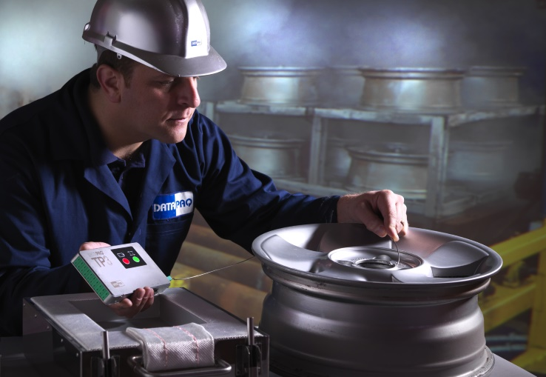
Illustration: The new 10-channel and 20-channel loggers gather detailed temperature profiles in aluminum solution reheat processes of up to 20 hours

The water reservoir is replenished when the profiler is immersed in the quench tank along with the products, thus providing ample protection in the age hardening stage. Featuring low heights between 160 mm (5-hour model) and 321 mm (19- and 20-hour models), the barriers can be used even in furnaces with very low clearances. Due to the innovative combination of insulation technologies, the barriers can be re-used instantly after a measurement run. The loggers can execute up to ten consecutive measurement runs before data download via Bluetooth or USB. The DATAPAQ Insight software enables comfortable analysis of the temperature profiles and generates ISO9000 and CQI-9 reports if required. All systems can be combined with wireless telemetry technology for real-time transmission of temperature data, allowing for instant analysis and adjustment of process parameters.

Fluke Process Instruments at the ALUMINIUM MIDDLE EAST exhibition
15–17 May 2017, Dubai International Convention & Exhibition Centre
Booth D305

Illustrations: | datapaq_tp3_1496 | Char.s: | 1.744
File name: | 201703029_pm_datapaq_tp3_aluminum_en | Date: | 2017-03-22
About Fluke Process Instruments
Fluke Process Instruments designs, manufactures, and markets a complete line of infrared temperature measurement and profiling solutions for industrial, maintenance, and quality control applications. Distributed worldwide under the Raytek, Ircon, and Datapaq brands, the products reflect the combined experience of over 125 years in manufacturing the world’s finest temperature measurement tools and devices.
About Fluke
Founded in 1948, Fluke Corporation is the world leader in compact, professional electronic test tools. Fluke customers are technicians, engineers, electricians, and metrologists who install, troubleshoot, and manage industrial, electrical, and electronic equipment and calibration processes.

Contact for Europe, Middle East, Africa:  Fluke Process Instruments GmbH  Stephan Wilke  Blankenburger Str. 135  13127 Berlin  Germany  Tel.: +49 . 30 . 478 008 - 0  Fax: +49 . 30 . 471 0251  Email: sales-info@datapaq.com  WWW: www.flukeprocessinstruments.com  Contact for Americas and Australasia:  Arlene Lucas-Starrh  arlene.lucas-starrh@fluke.com  Contact for Asia (except China):  Clothilde Bugnard  clothilde.bugnard@fluke.de |  | gii die Presse-Agentur GmbH  Immanuelkirchstr. 12  10405 Berlin  Germany  Tel.: +49 . 30 . 538 965 - 0  Fax: +49 . 30 . 538 965 - 29  Email: info@gii.de  WWW: www.gii.de

