Press Release

Versatile series of inductive proximity switches for up to +160 °C

Gettorf – With the IGMH series, sensor specialists EGE provide a range of inductive proximity switches that are particularly suited for use in extreme environmental conditions such as in drying kilns, in food industry machinery, or in heavy industry applications. Suitable for continuous operation, the compact high-temperature sensors are designed for a wide range of ambient temperatures from -25 °C to +160 °C. The sensors are equipped with a robust housing made of 1.4571 grade stainless steel and PEEK. They are available in different versions as required – the line-up e.g. includes IP68/69K-protected types that are waterproof and easily withstand high pressure cleaners.

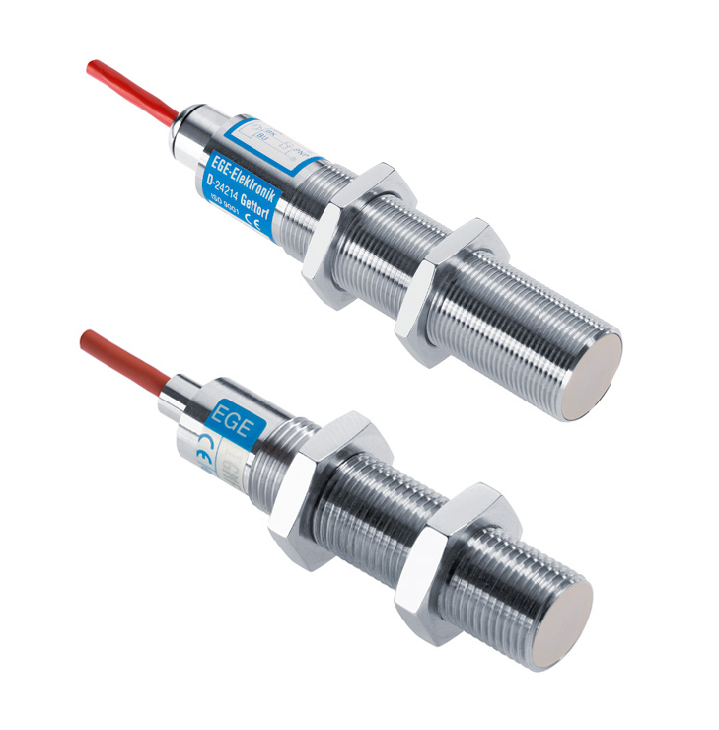
Figure: IGMH series proximity switches from EGE are suitable for temperatures up to +160 °C and are available in water-resistant, boil-proof and rolling-oil-proof versions.

IGMH series sensors can also come in boil-and-steam-resistant versions with silicone cable connections – optionally available with additional FDA-certification for use in the food industry – or in special versions for applications where oily media, such as rolling oil, are present. Depending on the specific type, the sensors are connected either via FEP or silicone cables. The devices provide nominal switching distances from 2 mm to 15 mm and are available in M15, M18 and M30 sizes. Thanks to their integrated electronics, they do not require a separate processing unit. In addition, EGE offers to develop and implement custom, application-specific sensor solutions with minimal lead times.

Figures: | imgh_beide | Char.s: | 1,365
File name: | 201704052_IGMH_sensoren_varianten_en | Date: | 2017-04-20
About EGE
EGE-Elektronik Spezial-Sensoren GmbH has been developing and manufacturing special purpose sensors for automation applications since 1976. The company serves leading international producers from a wide range of industries. Its product portfolio includes flow controllers, infrared, opto and ultrasonic sensors, capacitive proximity switches, light barriers and inductive proximity switches. EGE also provides sensors for highly sensitive applications, e.g. hazardous areas. The development department's highly qualified staff cooperates closely with all customers, ensuring continuous product updates and enhancement. A total of 89 employees, including 20 engineers and technicians, generate gross sales of approx. 19.5 million Euros worldwide.

Contact:  EGE-Elektronik Spezial-Sensoren GmbH  Sven-Eric Hiss  Ravensberg 34  24214 Gettorf  Germany  Tel.: +49 43 46 / 41 58 -0  Fax: +49 43 46 / 56 58  Email: info@ege-elektronik.com  WWW: www.ege-elektronik.com |  | gii die Presse-Agentur GmbH  Immanuelkirchstr. 12  10405 Berlin  Germany  Tel.: +49 30 / 53 89 65 -0  Fax: +49 30 / 53 89 65 -29  Email: info@gii.de  WWW: www.gii.de

