Press Release

Put an end to pressure leaks: LDS 1000 from EGE optimizes, controls and monitors compressed air networks

Gettorf – At the 2017 Hanover trade show, sensor experts EGE introduce new devices from their range of highly precise programmable pressure sensors with I/O-Link functionality. The LDS 1000 series expands the portfolio with sensors for large pipe diameters up to 200 mm. Compressed air has many advantages as an energy source, but is also relatively expensive. Undetected leaks and unnecessary additional consumption may incur high costs. Sensors of the LDS 1000 series monitor consumption in compressed air supply systems via the robust differential pressure principle. They support a broad variety of options for energy-efficient monitoring and control of compressed air networks.

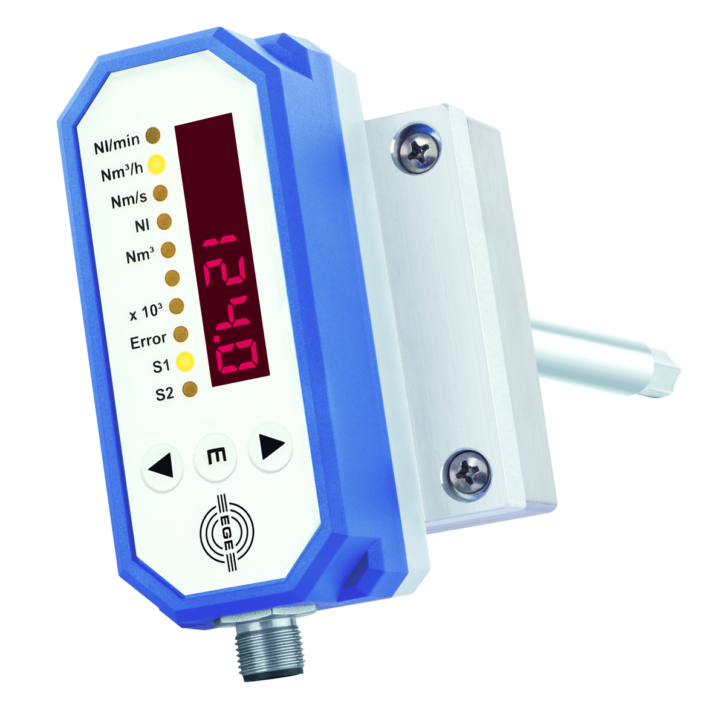
Illustration: Pressure sensors of the LDS 1000 series from EGE for large diameters are suitable for precise pressure leak detection and cost control in compressed air systems.

All devices in the series clearly show the air consumption of a pressure-supplied area, machine segment or tool on a six-digit display with sensor keys at the front. Alternatively, an I/O-Link connection facilitates easy readout of measured values directly by a PLC, as well as convenient parameterization of the sensor from a PC or notebook. The robust immersion probes are resistant to dirt and provide additional measured values for pressure and temperature as well as leakage detection. Useful features such as a dosing function, hysteresis function, tampering detection, and a switch-off delay are also integrated. LDS 1000 sensors for measuring compressed air consumption are connected by means of a self-cutting screw for through bores. This allows them to be placed at an ideal immersion depth.

Figures: | LDS_1000 | Char.s: | 1,476
File name: | 201704053_pm_LDS_druckluftverbrauch_en | Date: | 2017-04-20
About EGE
EGE-Elektronik Spezial-Sensoren GmbH has been developing and manufacturing special purpose sensors for automation applications since 1976. The company serves leading international producers from a wide range of industries. Its product portfolio includes flow controllers, infrared, opto and ultrasonic sensors, capacitive proximity switches, light barriers and inductive proximity switches. EGE also provides sensors for highly sensitive applications, e.g. hazardous areas. The development department's highly qualified staff cooperates closely with all customers, ensuring continuous product updates and enhancement. A total of 89 employees, including 20 engineers and technicians, generate gross sales of approx. 19.5 million Euros worldwide.

Contact:  EGE-Elektronik Spezial-Sensoren GmbH  Sven-Eric Hiss  Ravensberg 34  24214 Gettorf  Germany  Tel.: +49 43 46 / 41 58 -0  Fax: +49 43 46 / 56 58  Email: info@ege-elektronik.com  WWW: www.ege-elektronik.com |  | gii die Presse-Agentur GmbH  Immanuelkirchstr. 12  10405 Berlin  Germany  Tel.: +49 30 / 53 89 65 -0  Fax: +49 30 / 53 89 65 -29  Email: info@gii.de  WWW: www.gii.de

