Press Release

Mounted any way you need it: compact flow sensor with rotatable display from EGE

Gettorf – For flow measurement of water and water-based media in large pipes, sensor specialists EGE launch the new SNS 552 flow sensor that features an I/O-Link interface and a digital display. The compact device facilitates fast readout of flow volumes by showing liter or cubic meter measurements on a display that can be rotated for better visibility. In addition, the responsive sensor is highly resistant to temperature variations and provides integrated temperature measurements in a range from 0 to +80 °C.

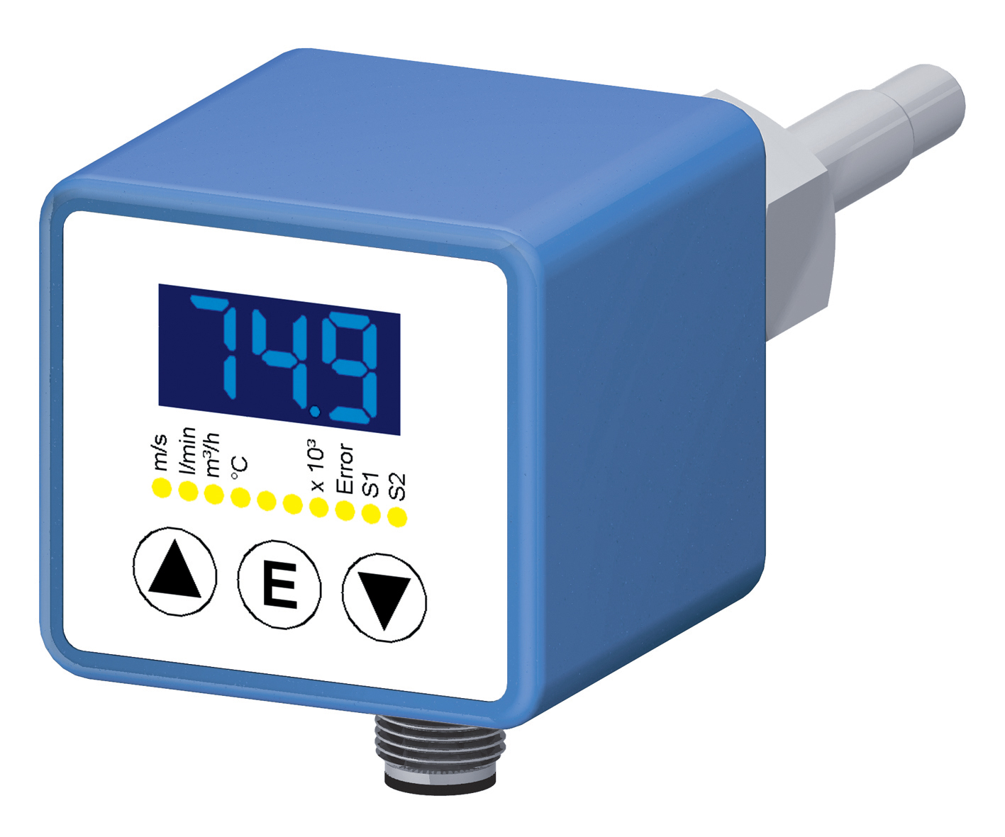
Illustration: Featuring an I/O-Link interface, SNS 552 type sensors can be used to measure the flow of water and water-based media in large pipes

The device can be parameterized with buttons or via I/O-Link. Two outputs for flow and temperature can be optionally configured as analog or switching outputs. On request, the SNS 552 is available with a teach-in input for rapid adjustment when used with various mediums. Thanks to the built-in I/O-Link functionality, set-up of the flow sensors is easily and conveniently accomplished from a PC or laptop, and the devices can be seamlessly integrated into any widely-used bus system.

Figures: | SNS_552 | Char.s: | 970
File name: | 201704054_pm_SNS552_strömungssensor_en | Date: | 05-24-2017
About EGE
EGE-Elektronik Spezial-Sensoren GmbH has been developing and manufacturing special purpose sensors for automation applications since 1976. The company serves leading international producers from a wide range of industries. Its product portfolio includes flow controllers, infrared, opto and ultrasonic sensors, capacitive proximity switches, light barriers and inductive proximity switches. EGE also provides sensors for highly sensitive applications, e.g. hazardous areas. The development department's highly qualified staff cooperates closely with all customers, ensuring continuous product updates and enhancement. A total of 89 employees, including 20 engineers and technicians, generate gross sales of approx. 19.5 million Euros worldwide.

Contact:  EGE-Elektronik Spezial-Sensoren GmbH  Sven-Eric Hiss  Ravensberg 34  24214 Gettorf  Germany  Tel.: +49 43 46 / 41 58 -0  Fax: +49 43 46 / 56 58  Email: info@ege-elektronik.com  WWW: www.ege-elektronik.com |  | gii die Presse-Agentur GmbH  Immanuelkirchstr. 12  10405 Berlin  Germany  Tel.: +49 30 / 53 89 65 -0  Fax: +49 30 / 53 89 65 -29  Email: info@gii.de  WWW: www.gii.de

