Press Release

Smart and convenient: EGE IO-Link system for inductive sensors

Gettorf – Introducing the IOL Master Kit V1.1, sensor specialists EGE complete their I/O-Link portfolio with an easy-to-use I/O-Link-to-USB master that facilitates the direct connection of sensors to all widely-used bus systems. Thanks to the point-to-point communication interface, sensors can continuously transmit process data, and measurement data can be read directly by the PLC. At the same time, the intermediary master module also allows for convenient parameterization of sensors and actuators directly from a PC or notebook. In addition to the I/O-Link master, EGE's I/O-Link system includes a USB cable for laptop or PC connection, a freely available configuration software, and a sensor connection cable. Compatible sensors with I/O-Link functionality from EGE's sensor portfolio include SNS 552 series flow controllers, the LDN 1000, LDV 1000 and LDS 1000 family of pressure sensors, and SDNC 500 series flow sensors.

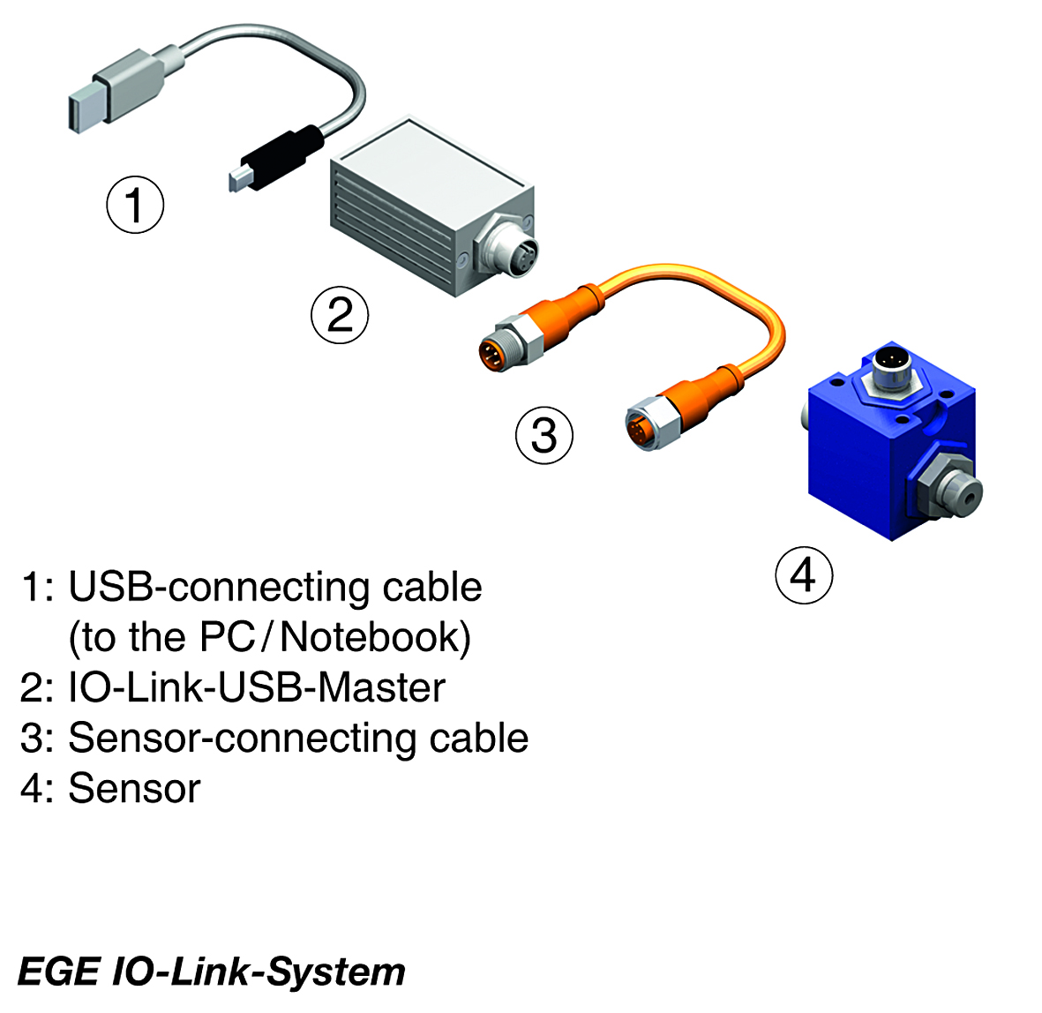
Figure: I/O-Link is a point-to-point communication interface that e.g. enables sensor and actuator parameterization from a PC system via an intermediary master module.

Figures: | EGE_IO-Link-System_e | Char.s: | 920
File name: | 201704055_pm_IO_Link_master_en | Date: | 2017-04-20
About EGE
EGE-Elektronik Spezial-Sensoren GmbH has been developing and manufacturing special purpose sensors for automation applications since 1976. The company serves leading international producers from a wide range of industries. Its product portfolio includes flow controllers, infrared, opto and ultrasonic sensors, capacitive proximity switches, light barriers and inductive proximity switches. EGE also provides sensors for highly sensitive applications, e.g. hazardous areas. The development department's highly qualified staff cooperates closely with all customers, ensuring continuous product updates and enhancement. A total of 89 employees, including 20 engineers and technicians, generate gross sales of approx. 19.5 million Euros worldwide.

Contact:  EGE-Elektronik Spezial-Sensoren GmbH  Sven-Eric Hiss  Ravensberg 34  24214 Gettorf  Germany  Tel.: +49 43 46 / 41 58 -0  Fax: +49 43 46 / 56 58  Email: info@ege-elektronik.com  WWW: www.ege-elektronik.com |  | gii die Presse-Agentur GmbH  Immanuelkirchstr. 12  10405 Berlin  Germany  Tel.: +49 30 / 53 89 65 -0  Fax: +49 30 / 53 89 65 -29  Email: info@gii.de  WWW: www.gii.de

