Press Release

ILAT series from Inelta: extra-compact inductive displacement sensors

Ottobrunn – Inelta's ILAT series features tiny LVDT sensors for precise position and path detection with single-digit millimeter accuracy. Available as ILAT2, ILAT4, or ILAT10 models, they are suitable for highly precise ±1 mm, ±2 mm or ±5 mm distance measurements.

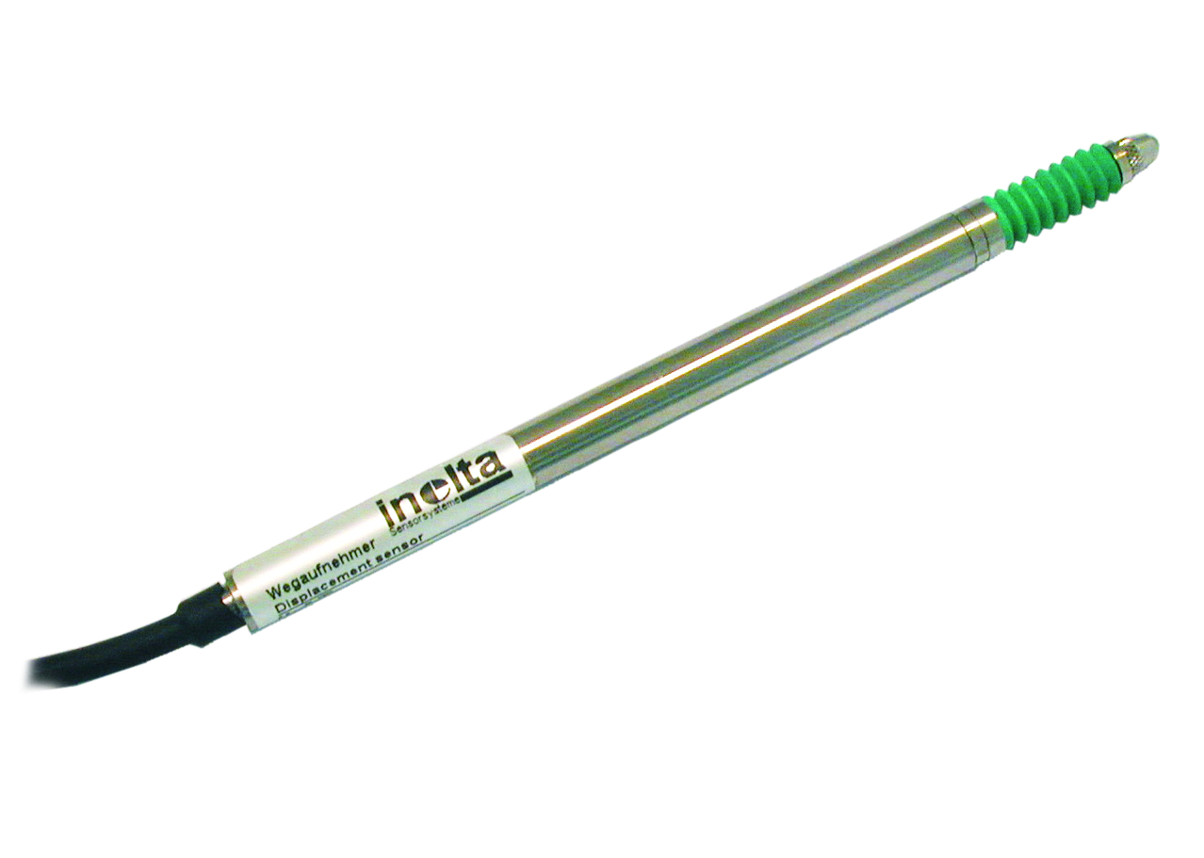
Illustration: ILAT series LVDT displacement sensors are no more than 79 mm long, with a housing diameter of just 8 mm

The sensors fit into very constricted installation spaces thanks to their extremely small dimensions. The housing is no more than 79 mm long, with a diameter of merely 8 mm, and a weight of just 30 g including the cable. Based on the inductive LVDT principle, ILAT series sensor operation is entirely wear-free, and they achieve a linearity tolerance of <0.25%. In LVDTs, or linear variable differential transformers, a coil system with a primary and two secondary windings inside the sensors transforms the linear movement of the measuring probe into an electrical signal. An even lower linearity tolerance of <0,1% is optionally available. Despite the small dimensions, ILAT sensors feature an exceptionally rugged design with a stainless steel housing that provides IP65 or optionally IP67 ingress protection. The nominal temperature range is 0 to 70 °C. Manufactured with great care and attention to detail, the linear guide is equipped with a rotation lock for the slide and lasts for more than 10 million cycles. The sensors are therefore suitable for a versatile range of applications, from medical technology to machine building, to the agricultural sector, ships, test facilities, or special purpose machine engineering. To complement ILAT series displacement sensors, Inelta also offers external IMA2 LVDT sensor signal amplifiers for 0..5 V, 0..10 V, ±5 V, ±10 V, or 0/4..20 mA output. The IVM LVDT print module with a 0..10V signal output is also available to facilitate an integration into custom electronics. Inelta also provides customer-specific sensor types with additional options, such as individual calibrations, cable lengths, and extended temperature ranges on request.

Figures: | ilat | Char.s: | 2,000
File name: | 201705014_pm_ilat_en | Date: | 07-19-2017
About Inelta
About Inelta
Headquartered in Ottobrunn near Munich, inelta Sensorsysteme GmbH & Co. KG is part of the inelta group, which also comprises PIL Sensoren GmbH based in Erlensee near Frankfurt/Main, and VYPRO s.r.o., a production company in Trenčín, Slovakia. inelta Sensorsysteme draws on approxamately 20 years of experience in sensor development, production, and distribution. The product range includes sensors for distance and dimension measurement, force sensors, sensor signal amplifiers and actuator-sensor systems. PIL has been developing, manufacturing, and distributing ultrasonic sensors for ca. 30 years and VYPRO is focused on sensor processing, confection of cables and connectors. The company group is particularly focused on industry-specific and customer-specific sensor solutions, and continues to apply a wealth of interdisciplinary know-how to expand the scope of such offerings.

Contact:  inelta Sensorsysteme GmbH & Co. KG  Katrin Seubert  Haidgraben 9a  D-85521 Ottobrunn  Germany  Tel.: 0 89 / 45 22 45-0  Fax: 0 89 / 45 22 45-744  Email: katrin.seubert@inelta.de  WWW: www.inelta.de |  | gii die Presse-Agentur GmbH  Immanuelkirchstraße 12  10405 Berlin  Germany  Tel.: 0 30 / 53 89 65-0  Fax: 0 30 / 53 89 65-29  Email: info@gii.de  WWW: www.gii.de

