Press Release

Sensor specialist FSG opens new plant

Berlin – FSG Fernsteuergeräte from Berlin, a measurement and sensor technology manufacturer, has opened its fourth location in nearby Königs Wusterhausen on 23 June 2017. Founded in 1946, the growing company pools its entire production including a paint shop and a training workshop there. 60 production staff are employed at the new location. The premises span 44,000 square meters. The company invested 5.5 million euros for the construction of two production halls with a total shop floor of 3,000 m² and a 1,350 m² administrative building that integrates canteens and changing rooms. "In addition to our three existing sites in Berlin, Heppenheim and Kablow, we chose this new location because of its excellent access to the motorway and our previous positive experiences with the city – part of our development, production and assembly has been situated here for 25 years," says co-CEO Carsten Schulz. The construction of a new plant to enlarge production capacities was necessitated by a growing demand for high-quality products from FSG. FSG produces sensors for various industrial sectors, among them the rail, ship and crane industries.

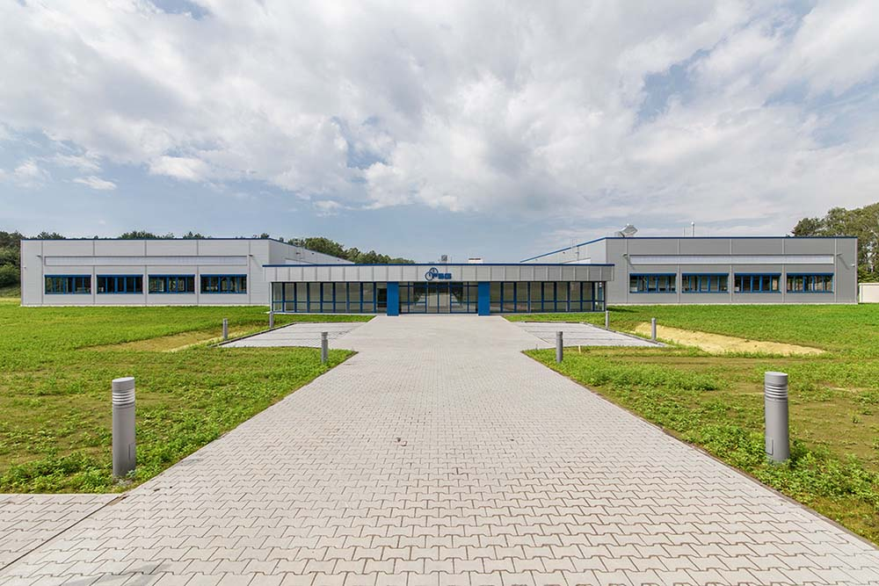
Illustration 1: Sensor manufacturer FSG Fernsteuergeräte's new plant in Königs Wusterhausen, near Berlin.

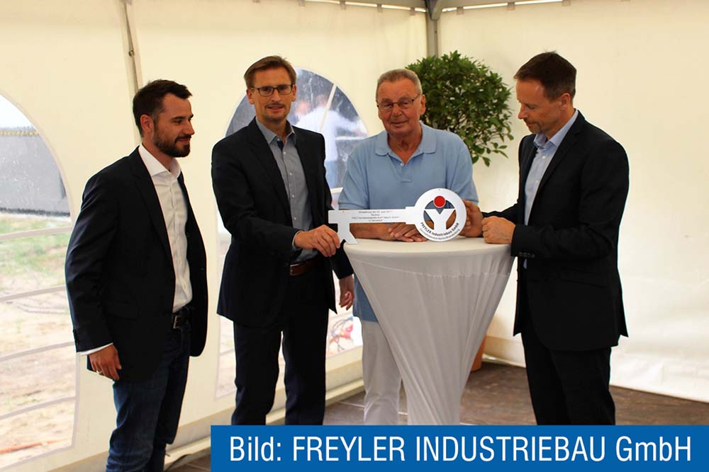
Illustration 2: Hand-over of keys for the new plant, from left to right: Mr Pape (Freyler Industriebau), FSG CEOs Christian, Klaus-Dieter and Carsten Schulz.

Figures: | Zernsdorf_Eroeffnung  Schluesseluebergabe_Freyler | Char.s: | 1.136
File name: | 201707052_pm_eroeffnung_zernsdorf_en | Date: | 08-09-2017
About FSG
FSG Fernsteuergeräte, a leading supplier of measuring and sensor technology, was founded in 1946. The company develops and manufactures high-quality measuring sensors and actuators for automation and safety engineering applications, providing a 90 % depth of production. The product portfolio includes a wide range of customer-oriented systems solutions: linear displacement transmitters, angular position transducers, wind warning systems, manual X/Y control transmitters, pedal actuated transmitters and signal indication components. FSG employs a staff of 400 at its Berlin headquarters and in its Kablow, Zernsdorf and Heppenheim plants, about 30 % of whom work in research and development, sales and quality management.

Contact:  FSG Fernsteuergeraete  Jahnstr. 68+70  12347 Berlin  Germany  Tel.: +49 30 / 6 2 91 1  Fax: +49 30 / 62 91 277  Email: info@fernsteuergeraete.de  WWW: www.fernsteuergeraete.de |  | gii die Presse-Agentur GmbH  Immanuelkirchstr. 12  10405 Berlin  Germany  Tel.: +49 30 / 53 89 65-0  Fax: +49 30 / 53 89 65-29  e-mail: info@gii.de  WWW: www.gii.de

