Press Release

The modular construction kit for flexible laboratory setups

Rheinstetten – Enclosure specialist autoVimation helps users choose individual laboratory setups and provides custom-specific configurations according to the best possible cost-benefit assessment. The advantages of a flexible modular system for laboratory setups in image processing are clear: with just a few, re-usable components it is possible to assemble complex image processing setups for laboratory tests or for a proof-of-concept at a client’s facility in a simple, fast and flexible way.

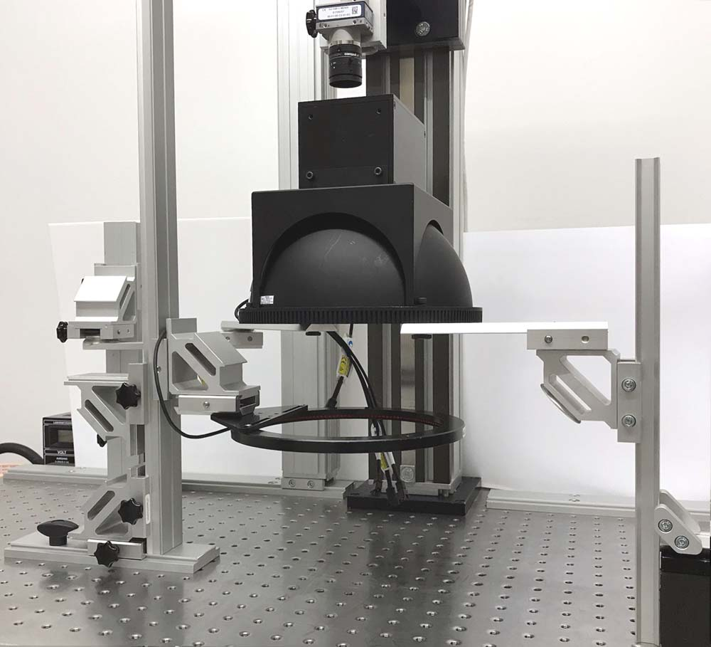
Illustration: Versatile laboratory set-up offer countless possibilities
(Source: Stemmer Imaging)

After successful tests, the system can be integrated into the final installation directly on-site, using just the existing parts and necessitating almost no adaptations. The dovetail profiles, mounting clamps and brackets enable flexible configurations. At the same time the robust rotation, tilt and ball joints offer maximum flexibility combined with excellent stability. Universal camera/lighting fixtures and laser mounts facilitate the realization of inexpensive test setups with prefabricated components. Even large illuminations and lenses are held securely, exactly positioned and aligned. On request, autoVimation provides customers with individual proposals for custom-specific setups suited to their applications.

Figures: | Labor_1 | Char.s: | 1,209
File name: | 201709012_pm_Labor_en | Date: | 09-20-2017

About autoVimation
Established in 2008, Karlsruhe-based autoVimation was founded by Peter Neuhaus to provide solutions for easier installation and adjustment of image processing components. The company has developed a modular construction kit that simplifies the connection of all required components, which does away with costly and time-consuming manufacturing of dedicated mounting brackets. The product portfolio also includes compact, easy-to-integrate enclosures that provide optimal protection for cameras and lenses in industrial applications, and ensure good heat dissipation. autoVimation supplies complete, ready-to-install mechanical solutions for cameras and light fittings, and enables the integration of special lenses, filters, light barriers, encoders, or other sensors.
autoVimation's customers include renowned companies from various industry branches, such as the pharmaceutical and food industry, measuring technology, quality control, and security technology.

Contact:  autoVimation GmbH  Peter Neuhaus  Römerweg 1  76287 Rheinstetten  Germany  Tel.: +49 721 / 627 6756  Fax: +49 721 / 627 6759  e-mail: sales@autovimation.com  WWW: www.autovimation.com |  | gii die Presse-Agentur GmbH  Immanuelkirchstr. 12  10405 Berlin  Germany  Tel.: +49 30 / 5389 650  Fax: +49 30 / 5389 6529  e-mail: info@gii.de  WWW: www.gii.de

