Press Release

Versatile industrial joystick with multifunctional handle

Introducing the new type 2020 industrial joystick for construction machinery, measuring and sensor technology expert FSG Fernsteuergeräte enables very comfortable and flexible operating and assembly concepts. The product allows for a wide range of functions to be integrated according to customer specifications. Featuring IP67 ingress protection, this joystick provides for ergonomic manual control of equipment in harsh environments, even outside an enclosed cabin. It is also suitable for various applications in the railway and shipping industries. The 2020 handle can accommodate a vibrator and up to 11 control elements such as buttons, a dead man switch, rocker switches, adjusting wheels, and a miniature joystick at the top – very versatile options for users to select functions, confirm inputs, and move with precision. Customers can freely define the placement of buttons and switches on the handle. Left- and right-hand thumb rest versions are available. Optionally, the manufacturer will integrate a capacitive handle sensor and heating. A customizable joint allows the handle to be connected to any hand-held control unit.

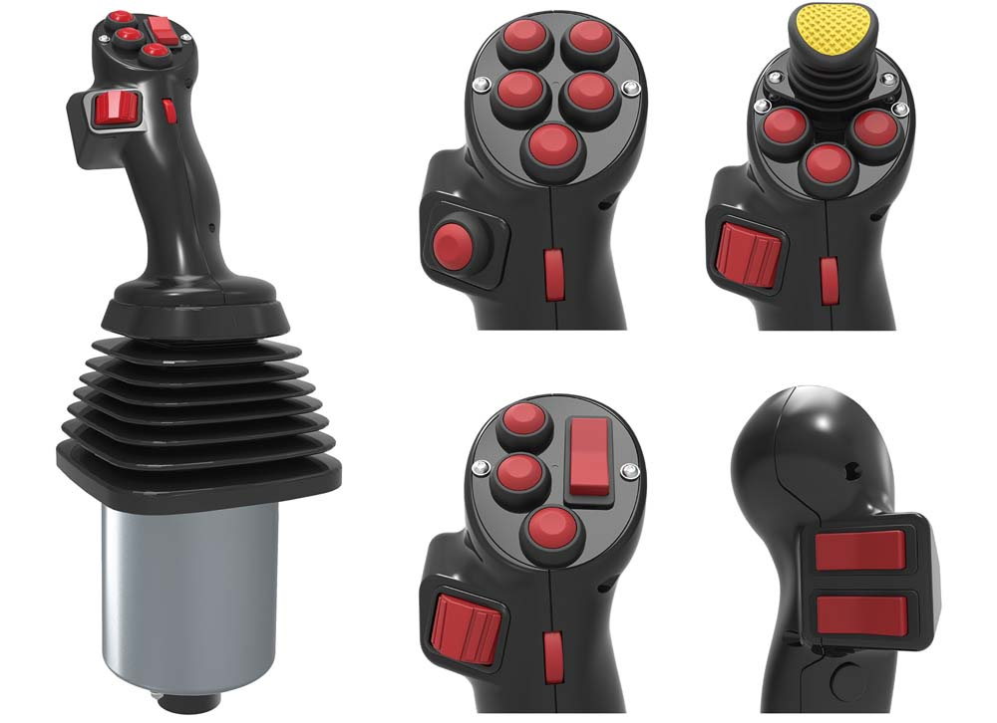
Illustration: FSG's ergonomic type 2020 industrial joystick with a multifunctional handle is freely customizable for use in mobile machinery as well as in railway and shipping applications

Illustrations: | multifunktionsgriff_2020 | Char.s: | 1,136
File name: | 201709025_pm_multifunctional_joystick_en | Date: | 02-27-2018
About FSG
FSG Fernsteuergeräte, a leading supplier of measuring and sensor technology, was founded in 1946. The company develops and manufactures high-quality measuring sensors and actuators for automation and safety engineering applications, providing a 90% depth of production. The product portfolio includes a wide range of customer-oriented systems solutions: linear displacement transmitters, angular position transducers, wind warning systems, manual X/Y control transmitters, pedal actuated transmitters and signal indication components. FSG employs a staff of 400 at its Berlin headquarters and in its Kablow, Zernsdorf, and Heppenheim plants, about 30 % of whom work in research and development, sales and quality management.

Contact:  FSG Fernsteuergeraete  Jahnstr. 68+70  12347 Berlin  Germany  Tel.: +49 . 30 . 629 121  Fax: +49 . 30 . 629 1277  Email: info@fernsteuergeraete.de  WWW: www.fernsteuergeraete.de |  | gii die Presse-Agentur GmbH  Immanuelkirchstr. 12  10405 Berlin  Germany  Tel.: +49 . 30 . 538 965 0  Fax: +49 . 30 . 538 965 29  e-mail: info@gii.de  WWW: www.gii.de

