Press Release

High-resolution pyrometers with rugged remote sensor head

Fluke Process Instruments expands the Endurance pyrometer series by models with a remote sensing head that tolerates ambient temperatures up to 315 °C. This design is ideal for applications with tight space constraints and for mounting near a heat source and in harsh environments. The sensing heads also offer improved immunity to electromagnetic interference. They are connected to a rugged IP65 electronics box via fiber-optic cable over a distance of up to 22 m. Various medium and high-temperature models cover a 250 °C to 3,200 °C measurement range. Monochrome and ratio pyrometer version are available with a 1 µm or 1.6 µm spectral response. The ratio infrared thermometers enable accurate measurements of partially obscured objects, in dirty or steam-filled atmospheres, and of small or moving objects that do not completely take up the measurement spot, notably wires, rods, or streams of molten glass or metal. Major application fields include primary and secondary metals manufacturing, primary glass manufacturing, and laser welding. Featuring a 0.1 °C measurement resolution, the Endurance pyrometers also fulfill the requirements of the semiconductor industry. Various lens options are available for different mounting distances. The sensors operate with either Power over Ethernet (PoE) or 24 VDC power supply. They feature isolated analog I/Os as well as LAN/Ethernet, Profinet, and RS-485 interfaces. The PC-based Endurance setup and monitoring software simplifies configuration and deployment. A built-in web server enables archiving of historical data for traceability, process troubleshooting, and remote viewing. All Endurance series pyrometers are offered with a best-in-class four-year warranty.

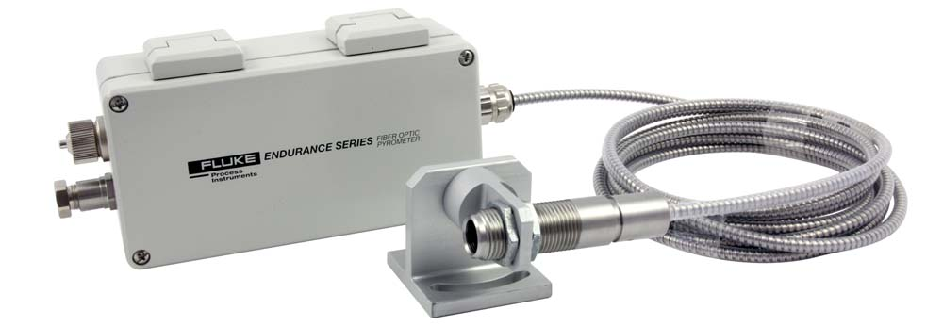
Illustration: The remote head option is available for various monochrome and ratio pyrometers for measured temperatures up to 3,200 °C

Illustrations: | endurance_fiber-optic | Char.s: | 1,719
File name: | 201710004_pm_endurance_fiber-optic_en | Date: | 10-16-2017
About Fluke Process Instruments
Fluke Process Instruments designs, manufactures, and markets a complete line of infrared temperature measurement and profiling solutions for industrial, maintenance, and quality control applications. Distributed worldwide under the Raytek, Ircon, and Datapaq brands, the products reflect the combined experience of over 125 years in manufacturing the world’s finest temperature measurement tools and devices.
About Fluke
Founded in 1948, Fluke Corporation is the world leader in compact, professional electronic test tools. Fluke customers are technicians, engineers, electricians, and metrologists who install, troubleshoot, and manage industrial, electrical, and electronic equipment and calibration processes.

Contact for Europe, Middle East, Africa:  Fluke Process Instruments GmbH  Stephan Wilke  Blankenburger Str. 135  13127 Berlin  Germany |  | gii die Presse-Agentur GmbH  Immanuelkirchstr. 12  10405 Berlin  Germany  Tel.: +49 . 30 . 538 965-0  Fax: +49 . 30 . 538 965-29  Email: info@gii.de  WWW: www.gii.de
Tel.: +49 . 30 . 478 008-0
Fax: +49 . 30 . 471 0251
Email: marcom2.emea@flukeprocessinstruments.de
Internet: www.flukeprocessinstruments.com

Contact for Americas and Australasia:
Arlene Lucas-Starrh
arlene.lucas-starrh@fluke.com

Contact for Asia (except China):
Clothilde Bugnard
clothilde.bugnard@fluke.com

