Press Release

Memosens Academy launched:
Website provides know-how on advanced liquid analysis

Berlin – The "Memosens Academy" recently launched online at memosens-academy.com teaches users the basics of Memosens digital sensor technology in an entertaining and easy-to-understand fashion. A number of real-world application showcases demonstrate how Memosens can be used to resolve typical issues in liquid analysis. Users also learn how this sensor technology can outperform conventional solutions in challenging measurement tasks. The website not only focuses on technical advantages, but notably also on the technology's economic benefits.

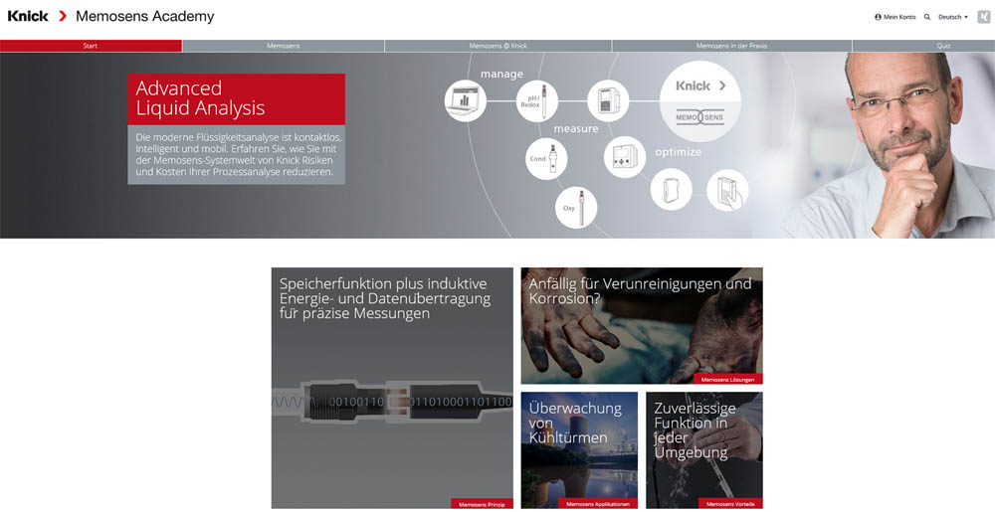
Illustration: The Memosens Academy provides comprehensive information on the characteristics of the digital sensor technology, explains technical and economic advantages and gives implementation guidance

Memosens has become the leading standard for digital process sensors since its launch almost ten years ago. Yet, many operators of process plants are not familiar with all the functions the technology offers. This includes important features that provide great benefits. Memosens Academy therefore also explains how an enormous savings potential can be leveraged, for instance, through pre-calibrating Memosens sensors in the laboratory and through implementing predictive maintenance. Based on an evaluation of the operating data collected in the sensor head, sensors can be swapped out at the ideal moment for regeneration according to their individual exposure profile. This increases their overall lifespan – for use and re-use after regeneration – by up to 40 percent.
Users browsing the Academy site for specific solutions for demanding measurement needs will also find an overview of the Knick portfolio of innovative Memosens products and their outstanding features. This wide range comprises many devices in various product categories, from space-saving MemoRail compact transmitters for integrating measuring points directly into the control system, to low-cost 2- or 4-wire Stratos series industrial transmitters, to modular full-scale systems for automated measurement, sensor calibration and sensor cleaning in rough conditions, to portable Memosens multi-parameter analyzers of the Portavo series, which are unique on the market. Knick's Memosens program is continuously expanded, with all-new compact MemoTrans transmitters currently pending for launch, which integrates a miniaturized transmitter unit right into the Memosens sensor coupling at the end of the cable.
After perusing the plentiful information on the site, visitors can test their newly acquired Memosens knowledge and liquid analysis know-how in a quiz. Enough right answers will earn them the title of "Memosens Master" as well as a chance to win a high-value Amazon voucher.

Illustrations: | memosens-academy | Char.s: | 2,498
File name: | 201710007_pm_memosens_academy_en | Date: | 10-18-2017
About Knick
Founded by engineer Ulrich Knick in Berlin more than 70 years ago, Knick Elektronische Messgeräte GmbH & Co. KG still uphold the family company tradition today. The innovative enterprise manufactures measuring and monitoring devices for the chemical industry, system engineering, and industrial automation.

Contact:  Knick Elektronische  Messgeräte GmbH & Co. KG  Carsten Koska  Beuckestraße 22  14163 Berlin  Tel.: +49 30 / 80191 - 0  Fax: +49 30 / 80191 - 200  E-Mail: info@knick.de  Internet: www.knick.de |  | gii die Presse-Agentur GmbH  Immanuelkirchstr. 12  10405 Berlin  Germany  Tel.: +49 . 30 . 538 965-0  Fax: +49 . 30 . 538 965-29  E-Mail: info@gii.de  Internet: www.gii.de

