Press Release

Silicone-free inductive sensors for continuous use at +160 °C

Gettorf, Germany – Sensor specialist EGE only uses silicone-free materials for series IGMH…GSP-L inductive proximity switches. This ensures suitability for all applications that do not allow silicone, such as cure ovens or paint shops, to ensure good adhesion and prevent coating defects. The compact high-temperature sensors come in a housing made of no. 1.4571 grade stainless steel and PEEK and with an FEP cable. IGMH…GSP-L series sensors thus achieve an IP68 protection rating. They are waterproof and tolerate ambient temperatures from -25 °C to +160 °C in continuous operation. The series comprises M12, M18, and M30 models with nominal switching distances between 2 and 15 mm. As the electronics are already integrated in the sensor, no downstream analysis unit is necessary. The product family also comprises the IGMH…GSP-D and IGMH…GSP-W series that provide sensors that can be exposed to superheated steam up to +140 °C and other models that tolerate high-pressure cleaning at up to +160 °C. Moreover, the IGEXH sensor designed for up +140 °C can even be installed in ATEX zones 0/20. In addition, EGE offers to develop and implement custom, application-specific sensor solutions with minimal lead times.

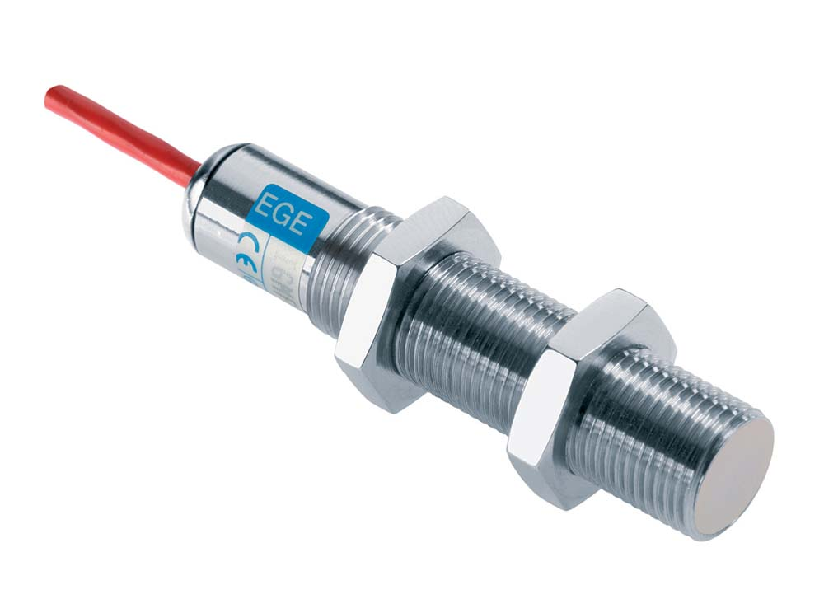
Illustration: IGMH…GSP-L inductive proximity switches from EGE are silicone-free and suitable for continuous operation up to +160 °C

Figures: | IGMH_GSP_L | Char.s: | 1,191
File name: | 201711056_pm_igmh_silikonfrei_en | Date: | 11-28-2017
About EGE
EGE-Elektronik Spezial-Sensoren GmbH has been developing and manufacturing special purpose sensors for automation applications since 1976. The company serves leading international producers from a wide range of industries. Its product portfolio includes flow controllers, infrared, opto and ultrasonic sensors, capacitive proximity switches, light barriers and inductive proximity switches. EGE also provides sensors for highly sensitive applications, e.g. hazardous areas. The development department's highly qualified staff cooperates closely with all customers, ensuring continuous product updates and enhancement. A total of 89 employees, including 20 engineers and technicians, generate gross sales of approx. 19.5 million Euros worldwide.

Contact:  EGE-Elektronik Spezial-Sensoren GmbH  Sven-Eric Hiss  Ravensberg 34  24214 Gettorf  Germany  Tel.: +49 43 46 / 41 58 -0  Fax: +49 43 46 / 56 58  Email: info@ege-elektronik.com  WWW: www.ege-elektronik.com |  | gii die Presse-Agentur GmbH  Immanuelkirchstr. 12  10405 Berlin  Germany  Tel.: +49 30 / 53 89 65 -0  Fax: +49 30 / 53 89 65 -29  Email: info@gii.de  WWW: www.gii.de

