Press Release

IGMH proximity switches are steam-resistant up to 140 °C

Gettorf, Germany – For applications where water vapor is prevalent, EGE introduces the IGMH…GSP-D series of inductive proximity switches with IP68/IP69K ingress protection that tolerate exposure to superheated steam. The sensors are designed for continuous operation in liquid or viscous media at temperatures from -25 °C to +140 °C. In dry processes, they even withstand temperatures up to 160 °C. They are therefore ideally suited for cooking processes in the food industry, including moving and positioning conveyors, sieves, baskets, and boilers. They can also be used in sterilization processes. The sensors' high thermal resistance is achieved through a special sealing technology between sensor and connector and a stainless-steel housing. This construction ensures high ingress protection. M12, M18, and M30 proximity switches with nominal switching distances between 2 and 15 mm are available. Thanks to their integrated electronics, they do not require a separate processing unit. They are connected via a 2-meter silicone cable. This sensor family is complemented by the IGMH…GSP-W and IGMH…GSP-L series, which provide high-temperature sensors that resist high-pressure cleaning in dry processes and silicone-free sensors for paint and powder-coating applications. The portfolio also includes the IGEXH sensor designed for up to +140 °C that can be installed in ATEX zones 0/20. In addition, EGE offers to develop and implement custom, application-specific sensor solutions with minimal lead times.

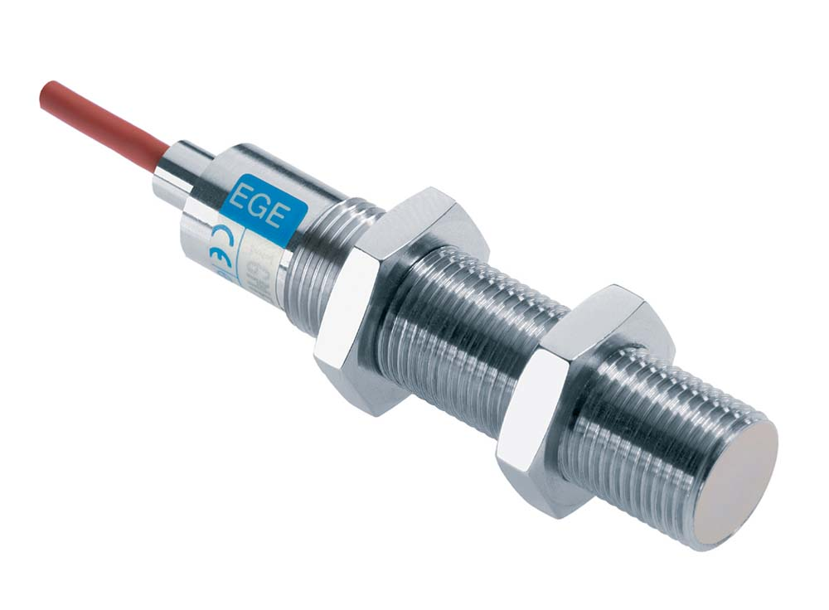
Illustration: IGMH…GSP-D series proximity switches from EGE are steam-resistant and suitable for food applications

Figures: | IGMH_GSP_D_W | Char.s: | 1,490
File name: | 201711057_pm_igmh_dampfresistent_en | Date: | 11-28-2017
About EGE
EGE-Elektronik Spezial-Sensoren GmbH has been developing and manufacturing special purpose sensors for automation applications since 1976. The company serves leading international producers from a wide range of industries. Its product portfolio includes flow controllers, infrared, opto and ultrasonic sensors, capacitive proximity switches, light barriers and inductive proximity switches. EGE also provides sensors for highly sensitive applications, e.g. hazardous areas. The development department's highly qualified staff cooperates closely with all customers, ensuring continuous product updates and enhancement. A total of 89 employees, including 20 engineers and technicians, generate gross sales of approx. 19.5 million Euros worldwide.

Contact:  EGE-Elektronik Spezial-Sensoren GmbH  Sven-Eric Hiss  Ravensberg 34  24214 Gettorf  Germany  Tel.: +49 43 46 / 41 58 -0  Fax: +49 43 46 / 56 58  Email: info@ege-elektronik.com  WWW: www.ege-elektronik.com |  | gii die Presse-Agentur GmbH  Immanuelkirchstr. 12  10405 Berlin  Germany  Tel.: +49 30 / 53 89 65 -0  Fax: +49 30 / 53 89 65 -29  Email: info@gii.de  WWW: www.gii.de

