Press Release

IGMH proximity switches suitable for high-pressure cleaning tolerate temperatures up to 160 °C

Gettorf, Germany – Special-purpose sensor manufacturer EGE provides watertight inductive proximity switches for applications that require frequent cleaning. IGMH...GSP-W series waterproof high-temperature sensors achieve IP68/69K ingress protection and are easy to rinse off with high-pressure cleaners. They are therefore suitable for food industry applications such as monitoring of frying and baking lines, baking molds, or kiln cars. Thanks to their robust housing made of no. 1.4571 grade stainless steel and PEEK, they function reliably even when exposed to extreme ambient temperatures ranging from -25 °C to +160 °C. They are connected via a silicone cable. In the same product family, the IGMH…GSP-D and IGMH…GSP-L series provide solutions that tolerate superheated steam up to 140 °C as well as silicone-free sensors for paint and powder-coating applications. The IGEXH sensor, designed for up 140 °C, can even be installed in ATEX zones 0/20. EGE also provides other customized solutions on request.

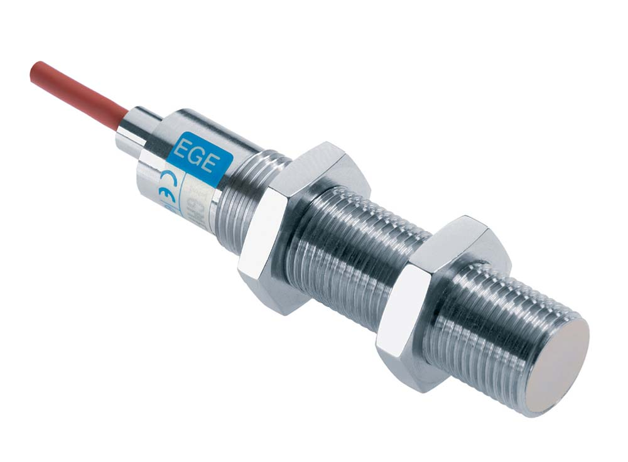
Figure:

Figures: | IGMH_GSP_D_W | Char.s: | 992
File name: | 201711058_pm_igmh_hochdruckreiniger_en | Date: | 11-28-2017
About EGE
EGE-Elektronik Spezial-Sensoren GmbH has been developing and manufacturing special purpose sensors for automation applications since 1976. The company serves leading international producers from a wide range of industries. Its product portfolio includes flow controllers, infrared, opto and ultrasonic sensors, capacitive proximity switches, light barriers and inductive proximity switches. EGE also provides sensors for highly sensitive applications, e.g. hazardous areas. The development department's highly qualified staff cooperates closely with all customers, ensuring continuous product updates and enhancement. A total of 89 employees, including 20 engineers and technicians, generate gross sales of approx. 19.5 million Euros worldwide.

Contact:  EGE-Elektronik Spezial-Sensoren GmbH  Sven-Eric Hiss  Ravensberg 34  24214 Gettorf  Germany  Tel.: +49 43 46 / 41 58 -0  Fax: +49 43 46 / 56 58  Email: info@ege-elektronik.com  WWW: www.ege-elektronik.com |  | gii die Presse-Agentur GmbH  Immanuelkirchstr. 12  10405 Berlin  Germany  Tel.: +49 30 / 53 89 65 -0  Fax: +49 30 / 53 89 65 -29  Email: info@gii.de  WWW: www.gii.de

