Press Release

Detection in the cold: Weather-proof proximity sensor for -80 °C environments

Gettorf, Germany – For use in low temperature applications, EGE provides the POLAR line-up of inductive proximity sensors. This segment comprises the IGMP series of weatherproof compact devices that tolerate high-pressure cleaning in a temperature range between +60 °C and -60 °C, as well as IGEXP series proximity switches that feature remote electronics for use in environments with dust and gas explosion hazards (ATEX zone 0/20). All models are made of no. 1.4571 grade stainless steel and PTFE. They achieve IP68/IP69K protection and operate reliably even if exposed to frequent temperature fluctuations. For an extended temperature range up to -80 °C, EGE also provides IGMP S-80 sensors with detached electronics. POLAR series sensors are ideally suited for use in deep-freezing applications in the food industry, mobile machinery, outdoor areas susceptible to frost, cryogenic processes or cooling systems. The sensors are available with nominal switching distances between 2 and 15 mm and with M12, M18 or M30 thread sizes. They are connected via a 2-meter FEP cable.

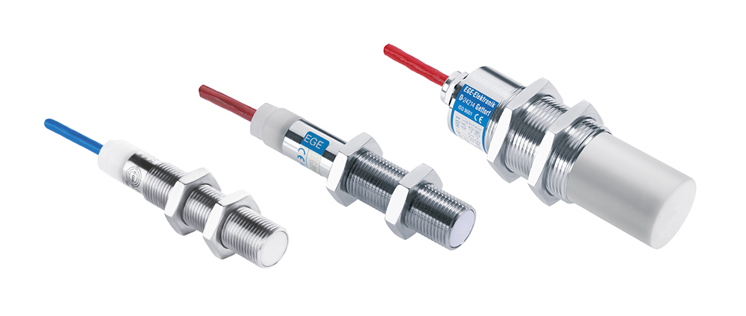
Illustration: POLAR type IGMP and IGEXP series sensors from EGE are suitable for temperatures as low as -80 °C, or dust and gas hazardous environments at -60 °C.

Figures: | IGMP_Serie | Char.s: | 1,057
File name: | 201711059_pm_igmp_en | Date: | 11-28-2017
About EGE
EGE-Elektronik Spezial-Sensoren GmbH has been developing and manufacturing special purpose sensors for automation applications since 1976. The company serves leading international producers from a wide range of industries. Its product portfolio includes flow controllers, infrared, opto and ultrasonic sensors, capacitive proximity switches, light barriers and inductive proximity switches. EGE also provides sensors for highly sensitive applications, e.g. hazardous areas. The development department's highly qualified staff cooperates closely with all customers, ensuring continuous product updates and enhancement. A total of 89 employees, including 20 engineers and technicians, generate gross sales of approx. 19.5 million Euros worldwide.

Contact:  EGE-Elektronik Spezial-Sensoren GmbH  Sven-Eric Hiss  Ravensberg 34  24214 Gettorf  Germany  Tel.: +49 43 46 / 41 58 -0  Fax: +49 43 46 / 56 58  Email: info@ege-elektronik.com  WWW: www.ege-elektronik.com |  | gii die Presse-Agentur GmbH  Immanuelkirchstr. 12  10405 Berlin  Germany  Tel.: +49 30 / 53 89 65 -0  Fax: +49 30 / 53 89 65 -29  Email: info@gii.de  WWW: www.gii.de

