Press Release

Hygienic ultrasonic sensors for aggressive media

Gettorf, Germany – Ultrasonic sensors from EGE's AGVU-...H series for a 150..1500 mm detection range are extremely durable and fulfill the most demanding hygienic requirements. Featuring IP69K ingress protection, they allow for easy cleaning with high-pressure and steam-jet cleaners. This ensures optimum hygiene in food and beverage industry applications as well as, for instance, in medical and pharmaceutical production. The sensors can be used for fill-level detection, distance measurement, presence verification, or detecting and counting moving objects. They come in a rugged, fully encapsulated, gap-free stainless-steel housing. Depending on available installation space, two sizes can be selected: either D30 or the especially compact D18, with only 30 cm total length including the hygienic cable fitting. Integrated temperature compensation enables high measuring precision in the -20 °C to +70 °C range. A protective circuit ensures short-circuit strength and protection against polarity reversal. Versions with an analogue output (4..20 mA) are supplied with pre-set response curves, while models with a switch output allow for a quick and easy adjustment of the desired switching points via teach-in.

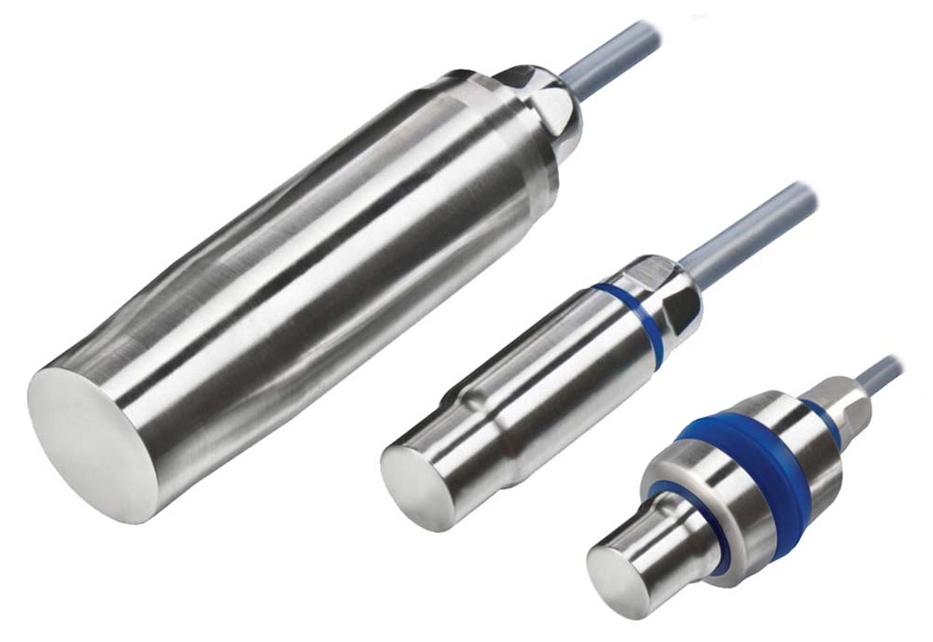
Illustration: The AGVU…H series of hygienic ultrasonic sensors includes a compact type with an 18 mm diameter

Figures: | p53_30_und_18_gruppe | Char.s: | 1.197
File name: | 201711060_pm_agvu_h | Date: | 11-28-2017
About EGE
EGE-Elektronik Spezial-Sensoren GmbH has been developing and manufacturing special purpose sensors for automation applications since 1976. The company serves leading international producers from a wide range of industries. Its product portfolio includes flow controllers, infrared, opto and ultrasonic sensors, capacitive proximity switches, light barriers and inductive proximity switches. EGE also provides sensors for highly sensitive applications, e.g. hazardous areas. The development department's highly qualified staff cooperates closely with all customers, ensuring continuous product updates and enhancement. A total of 89 employees, including 20 engineers and technicians, generate gross sales of approx. 19.5 million Euros worldwide.

Contact:  EGE-Elektronik Spezial-Sensoren GmbH  Sven-Eric Hiss  Ravensberg 34  24214 Gettorf  Germany  Tel.: +49 43 46 / 41 58 -0  Fax: +49 43 46 / 56 58  Email: info@ege-elektronik.com  WWW: www.ege-elektronik.com |  | gii die Presse-Agentur GmbH  Immanuelkirchstr. 12  10405 Berlin  Germany  Tel.: +49 30 / 53 89 65 -0  Fax: +49 30 / 53 89 65 -29  Email: info@gii.de  WWW: www.gii.de

