Press Release

Sturdy infrared thermometer for steelworks

Endurance series pyrometers from temperature measurement expert Fluke Process Instruments provide high reliability and usability in demanding primary and secondary metals production applications. The rugged infrared thermometers take non-contact measurements and are used to control process stability, product quality, and fuel efficiency. Featuring a 1 µm, 1.6 µm, or 2.4 µm spectral response, the sensors achieve significantly higher accuracies than longer-wavelength sensors. The Endurance series covers measured temperatures from 50 °C to 3,200 °C with just a few models. Therefore, it takes fewer units to monitor entire processes. Models with one-color and two-color (ratio pyrometer) operating modes are available, the latter for measured temperatures as low as 250 °C. Ratio pyrometers ensure correct readings even in dust-saturated or steamed-up surroundings.

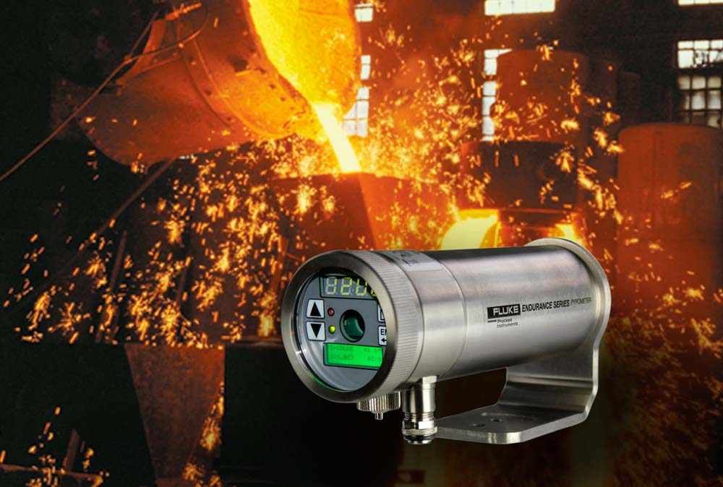
Illustration: Endurance ratio pyrometers measure temperatures from 250 to 3,200 °C

The series is designed for comfortable operation. A backlit rear-panel with tactile feedback allows for easy, intuitive on-site configuration and read-out. Furthermore, the sensors can be remotely operated. Profinet, RS-485, and Industrial Ethernet interfaces are available. What is more, Fluke Process Instruments has integrated a range of sighting options and offers a high-resolution on-board video camera for remote monitoring of the application and sensor alignment via Industrial Ethernet. Depending on visibility in the particular application, laser or LED sighting can be used to mark the position and size of the measurement spot. The sensors are enabled for the harshest industrial environments. They feature galvanically isolated I/Os and a stainless steel IP65 housing and withstand ambient temperatures up to 315 °C using cooling accessories. The manufacturer provides a best-in-class four-year warranty.

Illustrations: | endurance2_iron_foundry_ladle | Char.s: | 1,785
File name: | 201801025_pm_endurance_metals_en | Date: | 02-07-2018
About Fluke Process Instruments
Fluke Process Instruments designs, manufactures, and markets a complete line of infrared temperature measurement and profiling solutions for industrial, maintenance, and quality control applications. Distributed worldwide under the Raytek, Ircon, and Datapaq brands, the products reflect the combined experience of over 125 years in manufacturing the world’s finest temperature measurement tools and devices.
About Fluke
Founded in 1948, Fluke Corporation is the world leader in compact, professional electronic test tools. Fluke customers are technicians, engineers, electricians, and metrologists who install, troubleshoot, and manage industrial, electrical, and electronic equipment and calibration processes.

Contact:  Fluke Process Instruments GmbH  Stephan Wilke  Blankenburger Str. 135  13127 Berlin  Germany |  | gii die Presse-Agentur GmbH  Immanuelkirchstr. 12  10405 Berlin  Germany  Tel.: +49 . 30 . 538 965-0  Fax: +49 . 30 . 538 965-29  Email: info@gii.de  WWW: www.gii.de
Tel.: +49 . 30 . 478 008-0
Fax: +49 . 30 . 471 0251
Email: marcom2.emea@flukeprocessinstruments.de
Internet: www.flukeprocessinstruments.com

Contact for Asia (except China):
Clothilde Bugnard
clothilde.bugnard@fluke.com

