Press Release

MemoTrans:
new 2-wire compact transmitter for Memosens sensors

Knick Elektronische Messgeräte has expanded its range of compact transmitters for the Memosens standard by adding MemoTrans, an extremely lean 2-wire multiparameter solution that supports 4 – 20 mA and HART communication. The combination of transmitter and sensor interface in a single space-saving unit enables a direct, loop-powered connection of the measuring point to the process control system. Thereby, Memosens technology can now also be employed in applications where conventional 2-wire transmitters do not require displays or control units on location, or where there is not enough space for a conventional transmitter.

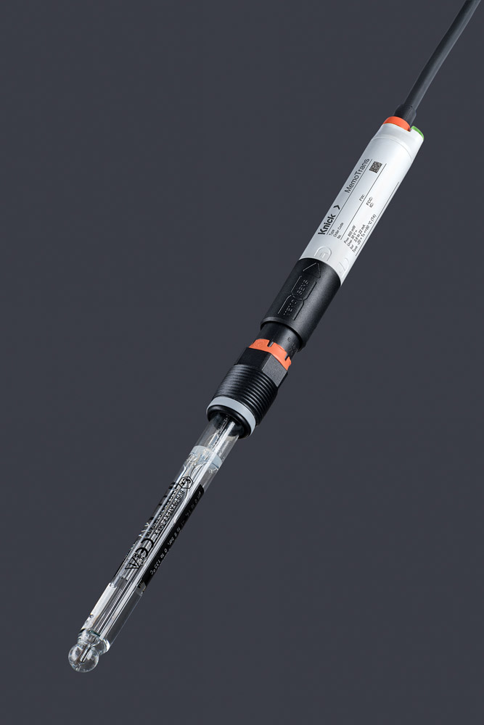
Illustration: MemoTrans with a connected Memosens pH sensor

While sensor devices with an integrated transmitter unit have been available on the market for several years now, such combinations meant that the transmitter had to discarded along with the sensor whenever it had to be replaced – and all internally stored configuration and calibration data was lost in that process. The replacement device inevitably required a new configuration, with the associated maintenance and operating expenses. MemoTrans eliminates these drawbacks since the compact transmitter features an inductive sensor connection that can be disconnected. Furthermore, MemoTrans is a multiparameter transmitter. It can be used with all Memosens sensors for measuring pH/ORP, oxygen (amperometric measurement), or conductivity. A red or green LED on the MemoTrans housing indicates whether it is connected to the sensor. Once successfully connected, the Memosens sensor can be automatically identified by its sensor ID. Featuring an integrated Bluetooth interface, MemoTrans provides technical personnel with flexible and convenient direct access to the measuring point without necessarily requiring a display unit. All MemoTrans devices are visualized in the MemoTrans app for iOS and Android smartphones or tablets. Users can thereby set up the transmitter and calibrate and configure the sensor on the spot. The app also displays all current sensor and diagnostic data. In addition, MemoTrans supports the HART fieldbus standard and can therefore be accessed from the control system or via a HART handheld.

Illustrations: | memotrans_sensor_gesteckt_led | Char.s: | 2.152
File name: | 201802025_pm_memotrans_en | Date: | 04-04-2018
About Knick
Founded by engineer Ulrich Knick in Berlin more than 70 years ago, Knick Elektronische Messgeräte GmbH & Co. KG still uphold the family company tradition today. The innovative enterprise manufactures measuring and monitoring devices for the chemical industry, system engineering, and industrial automation.

Contact:  Knick Elektronische  Messgeräte GmbH & Co. KG  Carsten Koska  Beuckestr. 22  14163 Berlin  Germany  Tel.: +49 . 30 . 80 191-0  Fax: +49 . 30 . 80 191-200  Email: info@knick.de  Internet: www.knick.de |  | gii die Presse-Agentur GmbH  Immanuelkirchstr. 12  10405 Berlin  Germany  Tel.: +49 . 30 . 538 965-0  Fax: +49 . 30 . 538 965-29  Email: info@gii.de  Internet: www.gii.de

