Press Release

Two in one: combined rotary encoder and inclinometer

Sensor technology specialist FSG has developed a rotary encoder for simultaneous angle and tilt measurement, for instance in draw-wire systems and cable drums. The series MH64-II-CAN/Mems/GS65 magnetic multi-turn encoder features a redundant Hall sensor for measuring a maximum of 64 turns as well as a redundant single-axis inclinometer that detects tilt angles from 0° to 360°. Without internal gears, the sensor can also be used as a single-turn encoder. The rotary encoder and the inclination sensor both feature 14-bit signal resolution. Main target applications are construction machinery, reach stackers, mobile work platforms, as well as ship and harbor cranes. A CAN bus interface supports CANopen and the CANopen safety protocol for signal output. The sensor is therefore also suitable for safety applications. The GS65 housing provides IP67 ingress protection. It can be wired up or connected via M12 plug.

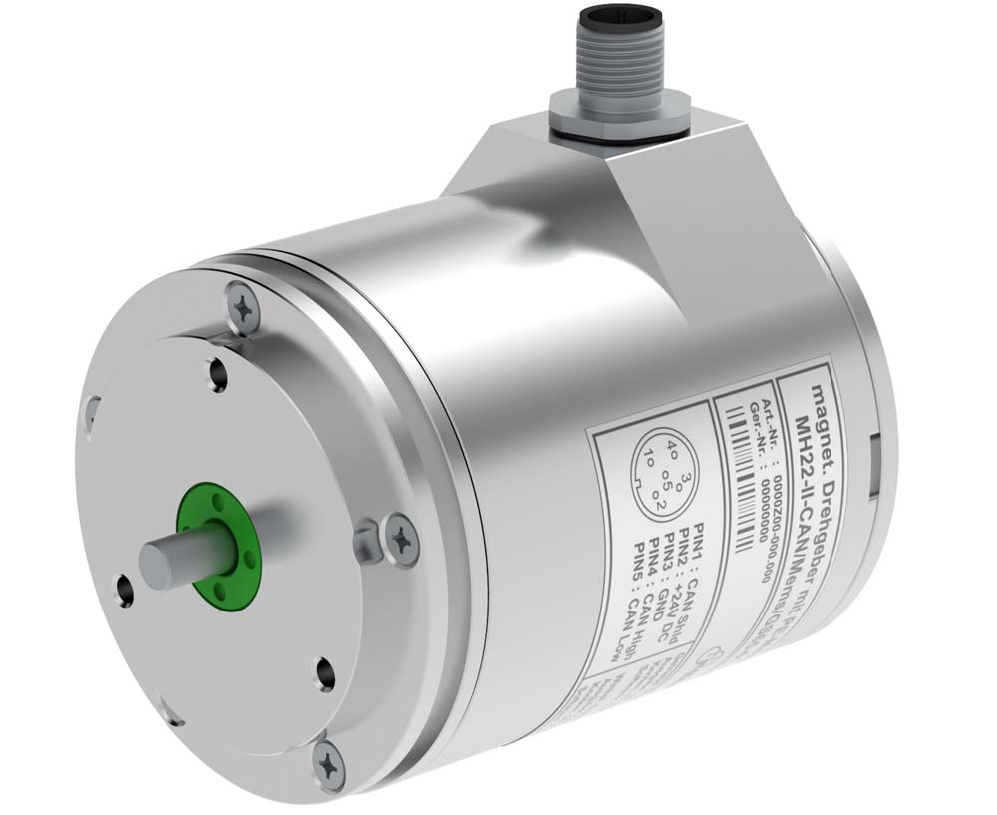
Illustration: The multi-turn encoder with an integrated tilt sensor is designed for construction machinery and cranes

Illustrations: | MH64-II-CAN-Mems-GS65 | Char.s: | 917
File name: | 201802030_pm_rotary_encoder_feat_tilt_sensor_en | Date: | 09-18-2018
About FSG
FSG Fernsteuergeräte, a leading supplier of measuring and sensor technology, was founded in 1946. The company develops and manufactures high-quality measuring sensors and actuators for automation and safety engineering applications, providing a 90% depth of production. The product portfolio includes a wide range of customer-oriented systems solutions: linear displacement transmitters, angular position transducers, wind warning systems, manual X/Y control transmitters, pedal actuated transmitters and signal indication components. FSG employs a staff of 400 at its Berlin headquarters and in its Kablow, Zernsdorf, and Heppenheim plants, about 30 % of whom work in research and development, sales and quality management.

Contact:  FSG Fernsteuergeräte  Jahnstr. 68+70  12347 Berlin  Germany  Tel.: +49 . 30 . 629 11  Fax: +49 . 30 . 629 1277  Email: info@fernsteuergeraete.de  WWW: www.fernsteuergeraete.de |  | gii die Presse-Agentur GmbH  Immanuelkirchstr. 12  10405 Berlin  Germany  Tel.: +49 . 30 . 538 965 0  Fax: +49 . 30 . 538 965 29  Email: info@gii.de  WWW: www.gii.de

