Press Release

Low-cost universal encoder for safety applications

Introducing the MH64-II-CAN(MU) series of multi-turn encoders, sensor specialist FSG offers compact and cost-efficient sensors for angle detection in category PLd safety-critical applications. Enclosed in an aluminum housing, the device weighs no more than 160 grams. It is equipped with a redundant Hall sensor that can track up to 64 turns. Due to its compact design, the sensor is suitable for applications in construction machinery, mobile work platforms, and for length measurements in draw-wire systems. A CAN bus interface supports CANopen and the CANopen safety protocol for signal output. Featuring internal signal monitoring and error detection, the sensor also qualifies for category PLd safety-critical applications. Alternatively, the sensor can use a 4 – 20 mA interface for safety category PLc. The IP67-protected encoder is suitable for ambient temperatures from -30 °C to +80 °C and features 25 g shock resistance as well as 4 g vibration resistance. The encoder can also be supplied as a single-turn variant. It can be wired up or connected via M12 plug.

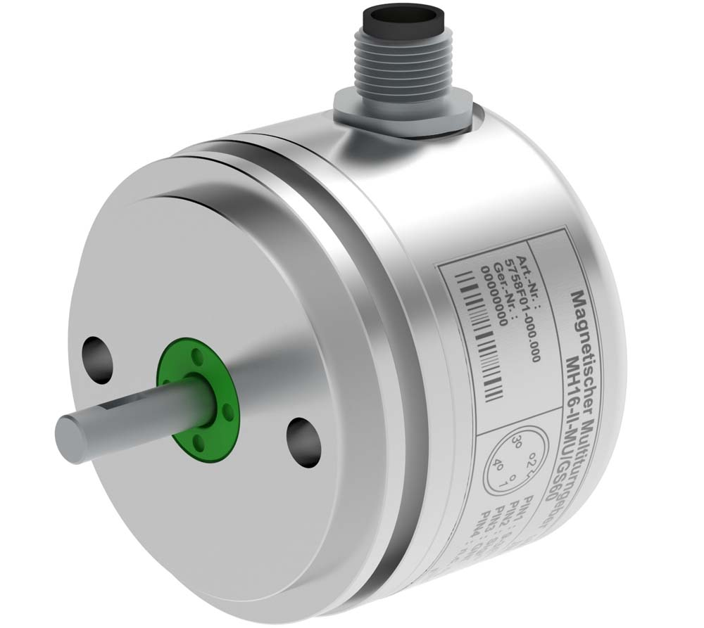
Illustration: The compact, low-cost multi-turn encoder is suitable for category PLd safety-critical applications

Illustrations: | MH64-II-CAN-MU-GS60 | Char.s: | 1.072
File name: | 201802031_pm_pld_safety_multi-turn_encoder_en | Date: | 03-14-2018
About FSG
FSG Fernsteuergeräte, a leading supplier of measuring and sensor technology, was founded in 1946. The company develops and manufactures high-quality measuring sensors and actuators for automation and safety engineering applications, providing a 90% depth of production. The product portfolio includes a wide range of customer-oriented systems solutions: linear displacement transmitters, angular position transducers, wind warning systems, manual X/Y control transmitters, pedal actuated transmitters and signal indication components. FSG employs a staff of 400 at its Berlin headquarters and in its Kablow, Zernsdorf, and Heppenheim plants, about 30 % of whom work in research and development, sales and quality management.

Contact:  FSG Fernsteuergeräte  Jahnstr. 68+70  12347 Berlin  Germany  Tel.: +49 . 30 . 629 11  Fax: +49 . 30 . 629 1277  Email: info@fernsteuergeraete.de  WWW: www.fernsteuergeraete.de |  | gii die Presse-Agentur GmbH  Immanuelkirchstr. 12  10405 Berlin  Germany  Tel.: +49 . 30 . 538 965 0  Fax: +49 . 30 . 538 965 29  Email: info@gii.de  WWW: www.gii.de

