Press Release

Liebherr-MCCtec Rostock award for the most innovative supplier goes to FSG

The industrial joystick series ST 2020 has earned FSG a prestigious supplier award from Liebherr-MCCtec Rostock in the coveted "Innovation" category. Liebherr-MCCtec is the group's maritime division that develops and manufactures ships, cranes, offshore cranes, reach stackers, and components for container cranes. Thorsten Finke from FSG's technical sales team accepted the award at Liebherr's first maritime supplier day.

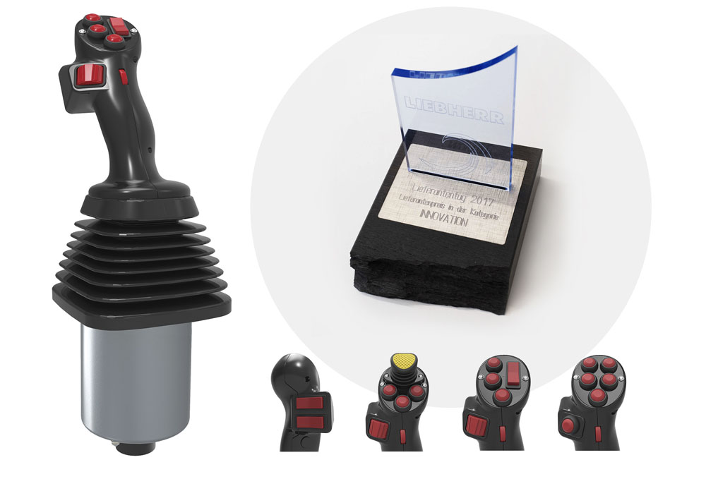
Illustration: FSG has won the "Innovation" category supplier award from Liebherr Group's maritime division for the development of the industrial joystick series ST 2020

FSG Fernsteuergeräte from Berlin, Germany, is a specialist in measuring and sensor technology for mobile applications. FSG closely cooperated with Liebherr-MCCtec Rostock for the development of the multifunctional joystick for crane and maritime applications. Central concerns included the robustness, ergonomics, functionality, and customizable configuration of the solution. At Liebherr's request, the handle was designed for flexible adaptation to different requirements, including the free selection and placement of the control elements. The ST 2020 joystick platform's handles accommodates up to 10 control elements such as buttons, dead man switches, rocker switches, and adjusting wheels. Even a miniature joystick at the top and a vibrator for tactile feedback may be integrated. The handles are available with left- or right-hand thumb rests. Further options include capacitive handle sensors and integrated heating. A customizable joint allows the handle to be connected to any handheld control unit. Featuring IP67 ingress protection with tightly sealed-off wire feedthroughs, these joysticks are even suitable for rugged applications outside an enclosed cabin. "We very much appreciate being recognized with this supplier award," says FSG co-CEO Christian Schulz. "Our entire team including me are proud to get such a seal of approval from a major customer like Liebherr for the development we have accomplished."

Illustrations: | liebherr-lieferantenpreis | Char.s: | 1,849
File name: | 201802032_pm_liebherr_supplier_award_en | Date: | 03-07-2018
About FSG
FSG Fernsteuergeräte, a leading supplier of measuring and sensor technology, was founded in 1946. The company develops and manufactures high-quality measuring sensors and actuators for automation and safety engineering applications, providing a 90% depth of production. The product portfolio includes a wide range of customer-oriented systems solutions: linear displacement transmitters, angular position transducers, wind warning systems, manual X/Y control transmitters, pedal actuated transmitters and signal indication components. FSG employs a staff of 400 at its Berlin headquarters and in its Kablow, Zernsdorf, and Heppenheim plants, about 30 % of whom work in research and development, sales and quality management.

Contact:  FSG Fernsteuergeräte  Jahnstr. 68+70  12347 Berlin  Germany  Tel.: +49 . 30 . 629 11  Fax: +49 . 30 . 629 1277  Email: info@fernsteuergeraete.de  WWW: www.fernsteuergeraete.de |  | gii die Presse-Agentur GmbH  Immanuelkirchstr. 12  10405 Berlin  Germany  Tel.: +49 . 30 . 538 965 0  Fax: +49 . 30 . 538 965 29  Email: info@gii.de  WWW: www.gii.de

