Press Release

Smart pyrometers for plug & play factory automation

Fluke Process Instruments has launched the Thermalert 4.0 spot pyrometer series for automatic noncontact temperature monitoring between -40 °C and 2,250 °C. The series currently comprises 13 models with varied spectral responses, including dedicated sensors for metals, glass, and plastics products. A large choice of optics is available for long and short focal distances. Due to the outstanding ambient temperature range of -20 °C to 85 °C, more measuring points can be set up without cooling accessories and without installing cooling media supplies. The rugged IP65 infrared thermometers exhibit best-in-class repeatabilities, response times, and accuracies. The system software supports remote configuration, monitoring, field calibration, and firmware updates. These functions can significantly lower service costs and time spent on setup and troubleshooting. Plug & play operation further facilitates installation and maintenance. The sensors feature galvanically isolated analog and RS485 interfaces. Up to 32 devices can be connected within an RS485 network. The manufacturer will keep on adding fieldbus and feature options in future. With the new Thermalert 4.0 series, Fluke Process Instruments took care to make retrofits as easy as possible. The new sensors are interchangeable with Endurance, Raytek Thermalert TX, and Raytek XR pyrometers. Adapters are available for use with Ircon Modline 4 and Raytek MM fixtures. Customers can therefore flexibly switch to another model at any time, if their measuring task has changed or to fully benefit from features like improved connectivity.

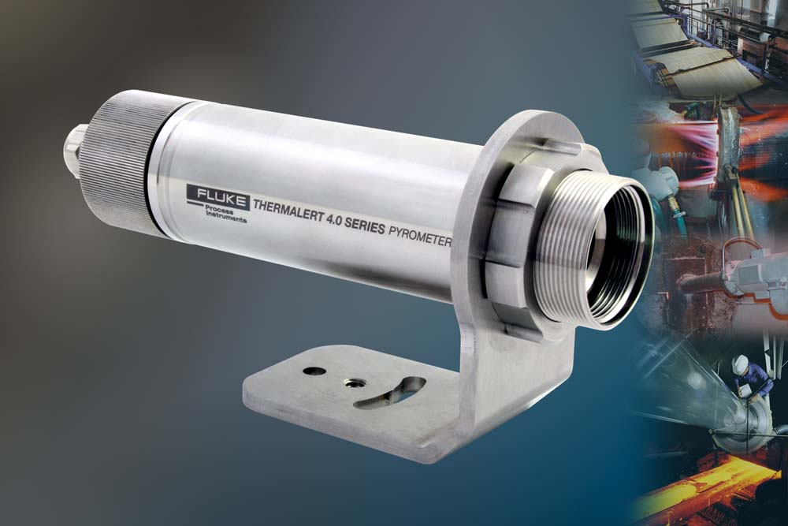
Illustration: The noncontact infrared thermometers feature superior optical resolution and save service costs

Illustrations: | thermalert_40_2000px.jpg | Char.s: | 1,599
File name: | 201803035_pm_thermalert_40_en | Date: | 05-29-2018
About Fluke Process Instruments
Fluke Process Instruments designs, manufactures, and markets a complete line of infrared temperature measurement and profiling solutions for industrial, maintenance, and quality control applications. Distributed worldwide under the Raytek, Ircon, and Datapaq brands, the products reflect the combined experience of over 125 years in manufacturing the world’s finest temperature measurement tools and devices.
About Fluke
Founded in 1948, Fluke Corporation is the world leader in compact, professional electronic test tools. Fluke customers are technicians, engineers, electricians, and metrologists who install, troubleshoot, and manage industrial, electrical, and electronic equipment and calibration processes.

Contact:  Fluke Process Instruments GmbH  Stephan Wilke  Blankenburger Str. 135  13127 Berlin  Germany |  | gii die Presse-Agentur GmbH  Immanuelkirchstr. 12  10405 Berlin  Germany  Tel.: +49 . 30 . 538 965-0  Fax: +49 . 30 . 538 965-29  Email: info@gii.de  WWW: www.gii.de
Tel.: +49 . 30 . 478 008-0
Fax: +49 . 30 . 471 0251
Email: marcom2.emea@flukeprocessinstruments.de
Internet: www.flukeprocessinstruments.com

Contact for Asia (except China):
Clothilde Bugnard
clothilde.bugnard@fluke.com

