Press Release

Achema trade show:
ATEX-certified temperature monitoring and more

Fluke Process Instruments presents infrared thermometers and thermal imagers for the process industry at the 2018 Achema trade show in Frankfurt, Germany. Intrinsically safe temperature sensors are available for use in hazardous environments (gas zones 1, 2, dust zones 21, 22). These support both fully automatic monitoring of measurement points with standalone devices and networked installations for IoT-enabled factory automation. Industrial-grade Raytek Thermalert TX pyrometers measure temperatures up to 2,000 °C. With cooling, they tolerate ambient temperatures up to 315 °C. Raytek Compact MI3 sensors have been designed for easy machine and plant integration. Two rugged, digital sensor heads can be used with one power supply and communication box at minimal costs per measuring point. Various fieldbus and Industrial Ethernet interface options are available. Both series comprise Ex i pyrometers for various spectral ranges and optics for different measurement distances. Thermal imaging solutions from Fluke Process Instruments for the process industry are based on the Raytek MP150 infrared linescanner. Applications include monitoring of textile fibers (presence detection) and kiln shell monitoring in chemical waste incineration, where the systems detect hotspots and thereby help extend the operational life of the refractory.

Fluke Process Instruments at Achema
11 – 15 June 2018, Frankfurt, Germany
Hall 11.1, Stand F31

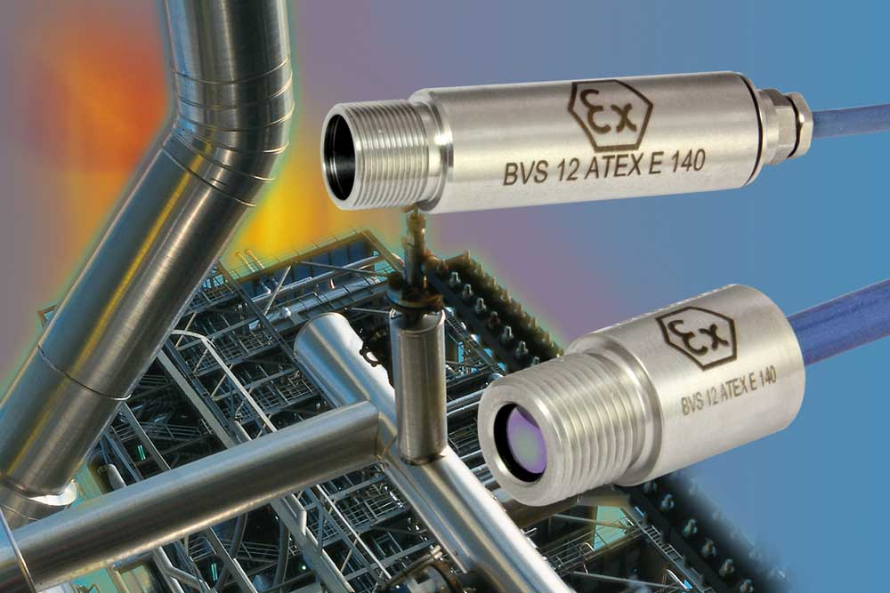
Illustration: Noncontact infrared temperature measurement solutions for the process industry include Ex i sensors suitable for network integration

Illustrations: | raytek_compact_mi3_atex_2000px.jpg | Char.s: | 1,348
File name: | 201804041_pm_achema_en | Date: | 05-31-2018
About Fluke Process Instruments
Fluke Process Instruments designs, manufactures, and markets a complete line of infrared temperature measurement and profiling solutions for industrial, maintenance, and quality control applications. Distributed worldwide under the Raytek, Ircon, and Datapaq brands, the products reflect the combined experience of over 125 years in manufacturing the world’s finest temperature measurement tools and devices.
About Fluke
Founded in 1948, Fluke Corporation is the world leader in compact, professional electronic test tools. Fluke customers are technicians, engineers, electricians, and metrologists who install, troubleshoot, and manage industrial, electrical, and electronic equipment and calibration processes.

Contact:  Fluke Process Instruments GmbH  Stephan Wilke  Blankenburger Str. 135  13127 Berlin  Germany |  | gii die Presse-Agentur GmbH  Immanuelkirchstr. 12  10405 Berlin  Germany  Tel.: +49 . 30 . 538 965-0  Fax: +49 . 30 . 538 965-29  Email: info@gii.de  WWW: www.gii.de
Tel.: +49 . 30 . 478 008-0
Fax: +49 . 30 . 471 0251
Email: marcom2.emea@flukeprocessinstruments.de
Internet: www.flukeprocessinstruments.com

Contact for Asia (except China):
Clothilde Bugnard
clothilde.bugnard@fluke.com

