Press Release

Temperature monitoring of hazardous waste incinerator

Compiling thermal images of objects that move at extremely slow speeds is a challenge in its own right. Fluke Process Instruments has solved this measuring task for a chemical waste incineration plant. Hazardous wastes are combusted in a rotary kiln that turns at 4 to 6 revolutions per hour. Over time, the refractory brick protecting the kiln wall degrades and has to be replaced. This used to be done in regular intervals with a big safety margin to prevent serious damage to the incinerator or even leakage of hazardous materials. Fluke Process Instruments supplied a Raytek CS210 infrared line-scanning system that is able to synchronize thermal images at speeds as low as 2 revolutions per hour. It detects temperature deviations across the entire kiln shell and provides the plant operator with information about the state of the incinerator. The kiln shell temperature ranges between 100 °C and 500 °C. Hotspots point to refractory loss or wear. The installation of the monitoring system has resulted in significant savings due to an extended operational life of the refractory and reduced downtimes.

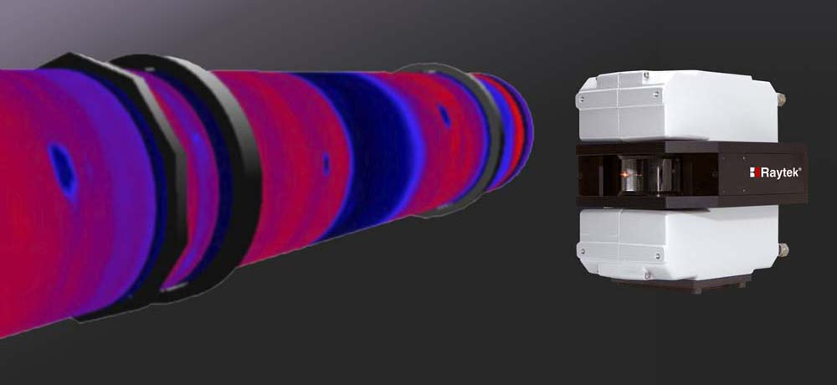
Illustration: The thermal imaging system detects refractory wear and allows extended maintenance intervals

Illustrations: | chem_kiln_raytek_cs210 | Char.s: | 1,108
File name: | 201805022_pm_chem_waste_incineration_en | Date: | 07-04-2018
About Fluke Process Instruments
Fluke Process Instruments designs, manufactures, and markets a complete line of infrared temperature measurement and profiling solutions for industrial, maintenance, and quality control applications. Distributed worldwide under the Raytek, Ircon, and Datapaq brands, the products reflect the combined experience of over 125 years in manufacturing the world’s finest temperature measurement tools and devices.
About Fluke
Founded in 1948, Fluke Corporation is the world leader in compact, professional electronic test tools. Fluke customers are technicians, engineers, electricians, and metrologists who install, troubleshoot, and manage industrial, electrical, and electronic equipment and calibration processes.

Contact:  Fluke Process Instruments GmbH  Stephan Wilke  Blankenburger Str. 135  13127 Berlin  Germany |  | gii die Presse-Agentur GmbH  Immanuelkirchstr. 12  10405 Berlin  Germany  Tel.: +49 . 30 . 538 965-0  Email: info@gii.de  WWW: www.gii.de
Tel.: +49 . 30 . 478 008-0
Email: marcom1.emea@flukeprocessinstruments.de
Internet: www.flukeprocessinstruments.com
Contact for Americas and Australasia:
Lindsay Schutter
lindsay.schutter@fluke.com
Contact for Asia (except China):
Clothilde Bugnard
clothilde.bugnard@fluke.com
Contact for China:
Grace Cheng
chen.cheng@fluke.com

