Press Release

ATEX infrared thermometer monitors sulfur recovery process

Fluke Process Instruments offers a dedicated, robust solution for monitoring Claus reactors during the recovery of elemental sulfur from process streams. In this setup, ATEX-certified infrared thermometers measure temperatures inside the furnace with short response times. Temperature control of the sulfur recovery process is vital since temperature variations can upset the chemical reaction, causing damage to the fire-clay refractory or even failure of the reactor. Conventionally, thermocouples are used for this application. Such probes must be exchanged at very short intervals, because of the highly corrosive process gases, resulting in significant maintenance costs and downtime. To overcome this problem, thermocouples can be embedded in the refractory or fully shielded by an enclosure. However, this leads to very long response times and inaccurate temperature readings. The tried-and-tested Fluke Process Instruments solution removes the thermocouple at 500 °C, before it can be damaged, and inserts a Raytek Thermalert TX pyrometer in the same opening. To enable this exchange on the fly, the pyrometers come with a hinged housing; both sensor and housing are made of stainless steel. The infrared sensors have a 500 to 2,000 °C measurement range. Equipped with an open or closed end target tube, they measure the refractory brick temperature at the near or far end. Due to the precise temperature data, the refractory lifespan can be extended and operators can optimize their process for fuel savings and higher throughput.

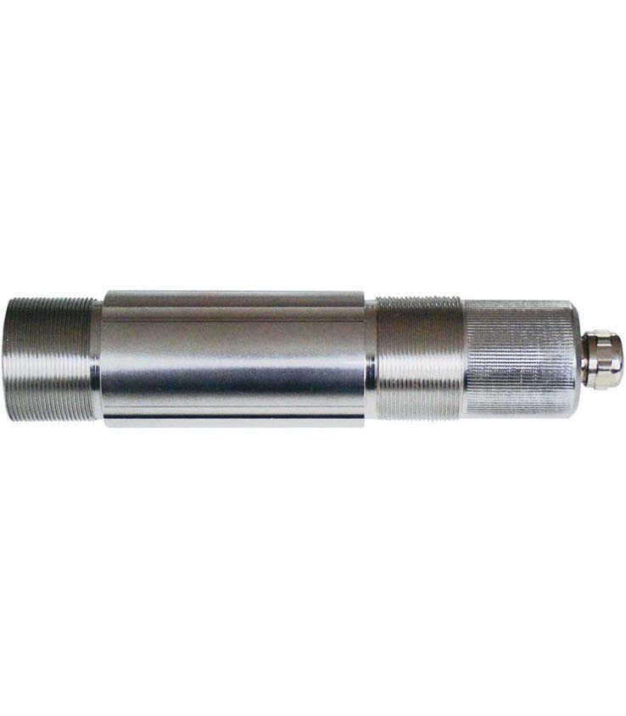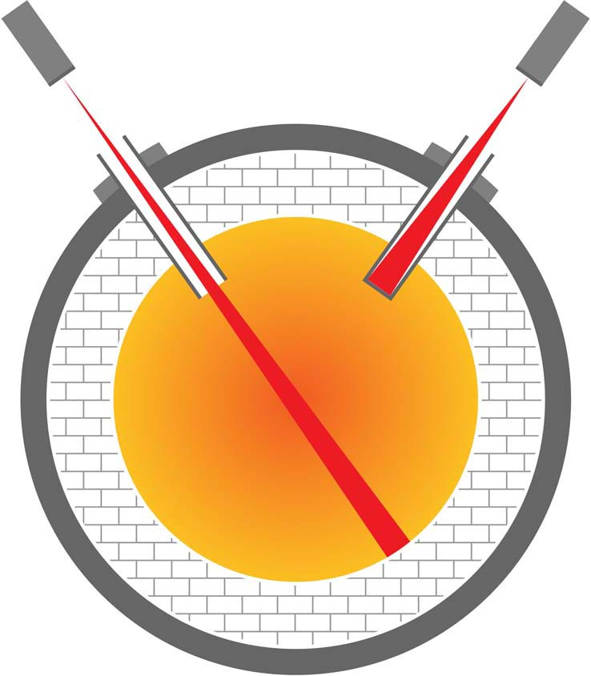
Illustration: The infrared sensors provide accurate temperature data from inside Claus reactors, enabling prolonged refractory lifetimes, fuel savings, and higher throughput

Illustrations: | raytek_thermalert_tx_2000px.jpg  sulfur_recovery_claus_reactor_2000px.jpg | Char.s: | 1,539
File name: | 201805023_pm_sulfur_recovery_en | Date: | 05-29-2018
About Fluke Process Instruments
Fluke Process Instruments designs, manufactures, and markets a complete line of infrared temperature measurement and profiling solutions for industrial, maintenance, and quality control applications. Distributed worldwide under the Raytek, Ircon, and Datapaq brands, the products reflect the combined experience of over 125 years in manufacturing the world’s finest temperature measurement tools and devices.
About Fluke
Founded in 1948, Fluke Corporation is the world leader in compact, professional electronic test tools. Fluke customers are technicians, engineers, electricians, and metrologists who install, troubleshoot, and manage industrial, electrical, and electronic equipment and calibration processes.

Contact:  Fluke Process Instruments GmbH  Stephan Wilke  Blankenburger Str. 135  13127 Berlin  Germany |  | gii die Presse-Agentur GmbH  Immanuelkirchstr. 12  10405 Berlin  Germany  Tel.: +49 . 30 . 538 965-0  Fax: +49 . 30 . 538 965-29  Email: info@gii.de  WWW: www.gii.de
Tel.: +49 . 30 . 478 008-0
Fax: +49 . 30 . 471 0251
Email: marcom2.emea@flukeprocessinstruments.de
Internet: www.flukeprocessinstruments.com

Contact for Asia (except China):
Clothilde Bugnard
clothilde.bugnard@fluke.com

