Press Release

New industrial-grade thermal imager

Fluke Process Instruments presents a new line of thermal imagers with integrated visible-light cameras: ThermoView TV40. The fixed-installation imagers enable 24/7 temperature monitoring in a -10 °C to 1200 °C range. Developed to meet today’s demanding industrial automation requirements, they support GigE streaming of images, automatic alarms, analysis and archiving. Images from multiple devices can be combined for display and analysis. Various field-interchangeable lens options are available, including wide-angle lenses. The imagers can be used to monitor applications such as press hardening, brake testing, lime kiln shells, metal spin forming, waste incinerators, and boilers. They capture images at 9 or 60 frames/sec. Currently, the series comprises two models with a 320 x 240 pixel or 640 x 480 pixel resolution, with more models to follow. The cameras can be configured and controlled via the internet. They feature a remote motorized focus. Thermal and visible-light images can be overlayed for easy camera alignment. Users can set independent emissivity values and alarm conditions for various areas of interest. Featuring a built-in lens, the standard ThermoView TV40 thermal imagers have no external moving parts. Housed in an IP67-rated aluminum casing, they tolerate ambient temperatures up to 50 °C without and up to 200 °C with an additional cooling enclosure.

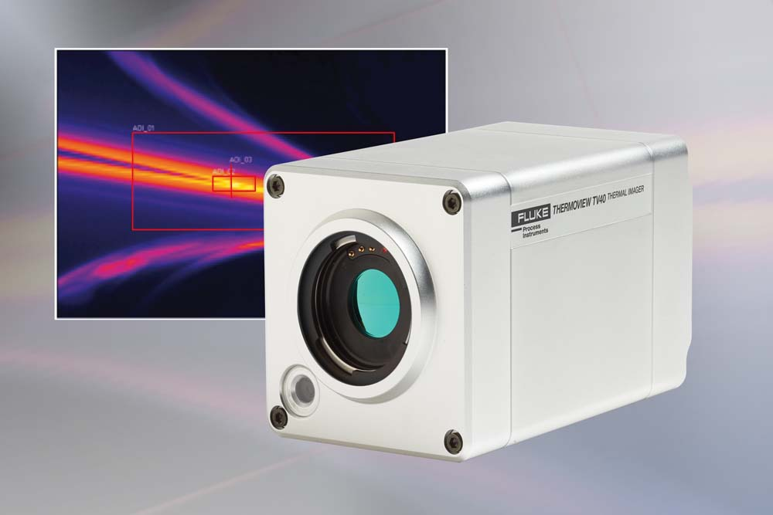
Illustration: The thermal and visible light camera enables 24/7 process monitoring with automatic alarms for overheating or defined irregularities

Illustrations: | thermoview_tv40_2000px.jpg | Char.s: | 1,383
File name: | 201805025_pm_thermoview_tv40_en | Date: | 06-21-2018
About Fluke Process Instruments
Fluke Process Instruments designs, manufactures, and markets a complete line of infrared temperature measurement and profiling solutions for industrial, maintenance, and quality control applications. Distributed worldwide under the Raytek, Ircon, and Datapaq brands, the products reflect the combined experience of over 125 years in manufacturing the world’s finest temperature measurement tools and devices.
About Fluke
Founded in 1948, Fluke Corporation is the world leader in compact, professional electronic test tools. Fluke customers are technicians, engineers, electricians, and metrologists who install, troubleshoot, and manage industrial, electrical, and electronic equipment and calibration processes.

Contact:  Fluke Process Instruments GmbH  Stephan Wilke  Blankenburger Str. 135  13127 Berlin  Germany |  | gii die Presse-Agentur GmbH  Immanuelkirchstr. 12  10405 Berlin  Germany  Tel.: +49 . 30 . 538 965-0  Fax: +49 . 30 . 538 965-29  Email: info@gii.de  WWW: www.gii.de
Tel.: +49 . 30 . 478 008-0
Fax: +49 . 30 . 471 0251
Email: marcom2.emea@flukeprocessinstruments.de
Internet: www.flukeprocessinstruments.com
Contact for Americas and Australasia:
Lindsay Schutter
lindsay.schutter@fluke.com
Contact for Asia (except China):
Clothilde Bugnard
clothilde.bugnard@fluke.com
Contact for China:
Grace Cheng
chen.cheng@fluke.com

