Press Release

Low-cost two-axis tilt sensor for mobile machinery

The cost-efficient two-axis inclinometers from FSG's PE-MEMS-x/y-i/GS60L series measure tilt angles of the x and y axes up to ±60°. Measured values for each inclination axis are transmitted via a 4 – 20 mA output. Featuring a wear-free micro-electromechanical measuring system, a robust, IP67-rated plastic housing, and easy connection via a 4-pin M12 plug, the tilt sensor is ideally suited for use in mobile machinery. Typical applications include detecting inclinations of vehicle platforms or angular position measurement on boom arms of construction machinery. The 3000 digits/16 mA resolution and ±0,25° accuracy also enable it for many other applications. The operating temperature range is -30 °C to 70 °C. The sensor case with a 50 x 50 mm footprint is 35 mm high including the central M12 connector. It has four M4 screws holes for mounting.

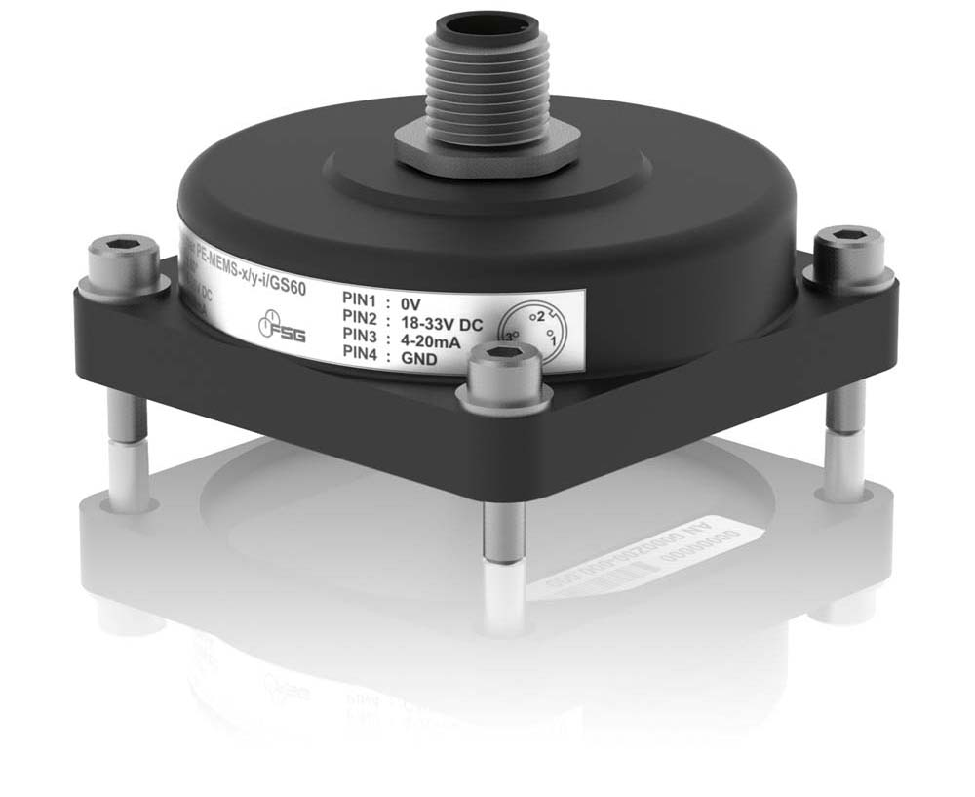
Illustration: Cost-efficient inclinometers from FSG measure tilt angles of the x and y axes

Illustrations: | Neigungssensor_PE-MEMS-x_y-i_GS60 | Char.s: | 851
File name: | 201806010_pm_tilt_sensor_pe-mems-xy-i-gs60l_en | Date: | 09-18-2018
About FSG
FSG Fernsteuergeräte, a leading supplier of measuring and sensor technology, was founded in 1946. The company develops and manufactures high-quality measuring sensors and actuators for automation and safety engineering applications, providing a 90% depth of production. The product portfolio includes a wide range of customer-oriented systems solutions: linear displacement transmitters, angular position transducers, wind warning systems, manual X/Y control transmitters, pedal actuated transmitters and signal indication components. FSG employs a staff of 400 at its Berlin headquarters and in its Kablow, Zernsdorf, and Heppenheim plants, about 30 % of whom work in research and development, sales and quality management.

Contact:  FSG Fernsteuergeräte  Jahnstr. 68+70  12347 Berlin  Germany  Tel.: +49 . 30 . 629 11  Fax: +49 . 30 . 629 1277  Email: info@fernsteuergeraete.de  WWW: www.fernsteuergeraete.de |  | gii die Presse-Agentur GmbH  Immanuelkirchstr. 12  10405 Berlin  Germany  Tel.: +49 . 30 . 538 965 0  Fax: +49 . 30 . 538 965 29  Email: info@gii.de  WWW: www.gii.de

