Press Release

IZB suppliers fair:
Thermal imagers for the automotive industry

At the IZB automotive industry suppliers fair in Wolfsburg, Germany, Fluke Process Instruments will present a brand-new thermal camera in addition to well-established thermal imaging solutions. These devices facilitate troubleshooting, QA, and process optimization in various applications. They help reduce scrap, save fuel costs, and ensure traceability to meet auditing requirements. They can be integrated in OPC and plant-specific networks. The new ThermoView TV40 integrates both an infrared and a visible-light camera. Designed for fixed installation, it enables continuous monitoring of processes and products. Applications include laser plastic welding and testing of seat warmers. Operators can define various areas of interest with discrete tolerances, alarms, and trending. Raytek MP150 linescanners are used for thermal imaging in moving processes. Co-exhibitor Selmatec Systems will present comprehensive in-line monitoring solutions based on this linescanner and Raytek pyrometers. The German system integrator has implemented modular, scalable solutions for automotive applications such as press hardening. Scanning moving blanks and press parts at a 150 Hz frequency, the linescanners generate thermal images that provide information on temperature uniformity, part integrity (thickness variations, overlapping material), oven performance, die wear, and cooling cycle performance. The imager provides a ±1% accuracy compliant with CQI-9 HTSA.
Fluke Process Instruments at the IZB International Suppliers Fair
Wolfsburg, Germany, 16 – 18 October 2018
Hall 5, Stand 5104

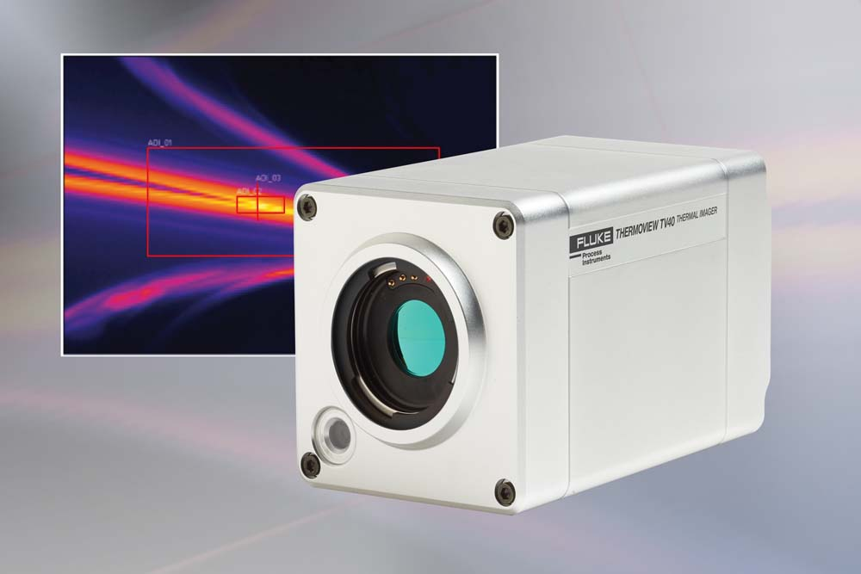
Illustration: Thermal imagers such as ThermoView TV enable automatic pass/fail process control in applications like laser plastic welding and hot press forming

Illustrations: | thermoview_tv40 | Char.s: | 1458
File name: | 201808007_pm_izb_fair_preview_en | Date: | 08-16-2018
About Fluke Process Instruments
Fluke Process Instruments designs, manufactures, and markets a complete line of infrared temperature measurement and profiling solutions for industrial, maintenance, and quality control applications. Distributed worldwide under the Raytek, Ircon, and Datapaq brands, the products reflect the combined experience of over 125 years in manufacturing the world’s finest temperature measurement tools and devices.
About Fluke
Founded in 1948, Fluke Corporation is the world leader in compact, professional electronic test tools. Fluke customers are technicians, engineers, electricians, and metrologists who install, troubleshoot, and manage industrial, electrical, and electronic equipment and calibration processes.

Contact:  Fluke Process Instruments GmbH  Stephan Wilke  Blankenburger Str. 135  13127 Berlin  Germany |  | gii die Presse-Agentur GmbH  Immanuelkirchstr. 12  10405 Berlin  Germany  Tel.: +49 . 30 . 538 965-0  Email: info@gii.de  WWW: www.gii.de
Tel.: +49 . 30 . 478 008-0
Email: marcom2.emea@flukeprocessinstruments.de
Internet: www.flukeprocessinstruments.com
Contact for Americas and Australasia:
Lindsay Schutter
lindsay.schutter@fluke.com
Contact for Asia (except China):
Clothilde Bugnard
clothilde.bugnard@fluke.com
Contact for China:
Grace Cheng
chen.cheng@fluke.com

