Press Release

InnoTrans 2018: transducer innovations by Knick

Smooth-running services as well as passenger and employee safety in railway operations depend on functions such as emergency shutdown in the event of short circuits, detection of delayed potentials, and safe signal transmission. Therefore, transducers for railway applications must meet the highest standards of reliability and precision. For Knick Elektronische Messgeräte, this has been the cornerstone in the development and manufacturing of highly available transducers and signal conditioners over several decades. The instrumentation manufacturer based in Berlin, Germany, has been supplying the international railway industry with products for high-voltage applications for over 40 years.

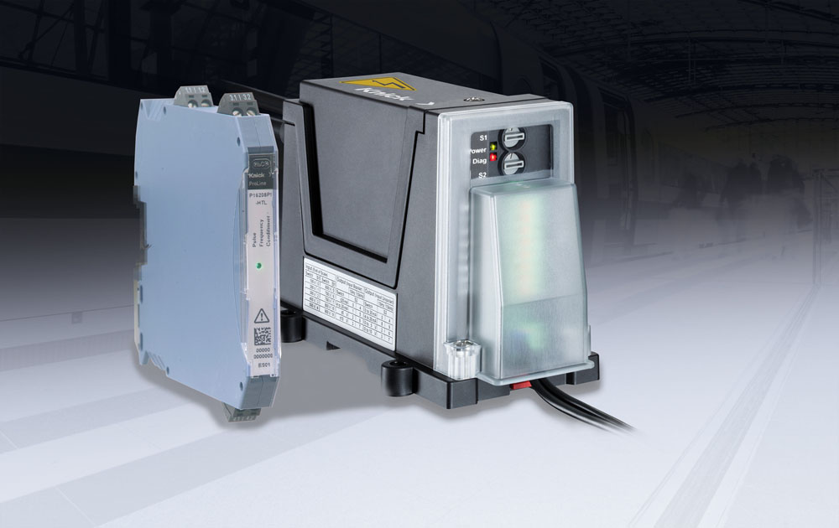
Illustration: Knick provides SIL-2-compliant pulse frequency conditioners and high-voltage transducers

At the 2018 InnoTrans exhibition in Berlin, Knick will showcase its proven transducers for traction power substations as well as new products for use on rolling stock: the SIL-2-compliant P16000 pulse frequency conditioner converts pulse signals from speed encoders into galvanically isolated analog 0/4…20 mA or 0…10 V standard signals required by control systems and subsystems to detect the travel speed. The transducer's signal input is designed according to the SIL 2 safety integrity level to ensure that there can be no inadvertent impact on the signal source. The ability to separate the encoder signal and make it available for other applications eliminates the need to install additional encoders on vehicle axles. Another highlight is the new ProLine P 50000 transducer series for high-precision energy measurement according to EN 50463. This series enables current and voltage measurement in traction inverters and auxiliary converters, and short-circuit detection in protective devices. These are the only devices in their class featuring calibrated range selection, which enables high flexibility in selecting input voltages in the ±4200 V range or currents in the kA range. After range selection, the transducers meet the high specified accuracy without renewed calibration. As the latest addition to the P 50000 series, Knick will present the P 52000 VPD voltage detector for reliable detection of voltages up to 4200 V. The detector compares the input signal with a selected threshold value that can be set at the unit. If, irrespective of positive or negative polarity, the threshold is breached, the detector displays an optical alert and generates an output signal that can activate or control hardware relays, protective devices, or controllers. The signal level is matched to type 1 PLC signal inputs according to EN 6131-2. All products are fully compliant with applicable railway standards and comply with demanding requirements regarding fire protection (HL3 according to EN 45545-2 [2016]), electrical safety, mechanical robustness, high resilience to extreme climatic conditions and low EMI susceptibility.
Knick at InnoTrans exhibition
Berlin, Germany, 18 – 21 September 2018
Hall 17, Stand 212

Illustrations: | InnoTrans2018_P16000_P50000 | Char.s: | 2828
File name: | 201808019_pm_innotrans_en | Date: | 08-16-2018
About Knick
Founded by engineer Ulrich Knick in Berlin more than 70 years ago, Knick Elektronische Messgeräte GmbH & Co. KG still uphold the family company tradition today. The innovative enterprise manufactures measuring and monitoring devices for the chemical industry, system engineering, and industrial automation.

Contact:  Knick Elektronische  Messgeräte GmbH & Co. KG  Alina Rose  Marketing Communication  Beuckestr. 22  14163 Berlin  Germany  Tel.: +49 . 30 . 80 191-0  Fax: +49 . 30 . 80 191-200  Email: info@knick.de  Internet: www.knick.de |  | gii die Presse-Agentur GmbH  Immanuelkirchstr. 12  10405 Berlin  Germany  Tel.: +49 . 30 . 538 965-0  Fax: +49 . 30 . 538 965-29  Email: info@gii.de  Internet: www.gii.de

