Press Release

UL- and VDE-certified cabling ducts

CONTA-CLIP offers a wide range of UL- and VDE-certified cabling ducts. These ducts are notable for their excellent form stability. They also feature tight-fitting covers that allow for very easy detachment and reattachment. Pegs with pre-determined breakage points enable comfortable customization of the ducts for incoming and outgoing cabling. The product comes with deburred edges to minimize the risk of injury during assembly and cable fitting and to protect the cable sheathing. The ducts are supplied with a standard length of two meters. They are made from a rigid PVC material that is lead-free, flame-retardant and self-extinguishing according to UL 94 V-0. For use in public buildings, CONTA-CLIP also provides halogen-free versions in accordance with VDE 0472 part 815. In case of a fire, the plastic these cabling ducts are made from does not break down to release toxic gases. Moreover, this material meets the F2 and I3 requirements of the NF F 16-101 railway standards. The product range also includes all the necessary tools for mounting, like, for instance, the VKS cutter for exact 90° angle cuts of cabling ducts up to a width of 125 mm. Another one is the ergonomically shaped SN-SW setting tool that allows for secure, high-speed application of expanding rivets. Its long shaft makes it suitable for placing rivets even in very deep ducts and in other places that are otherwise hard to reach. The VK-AKZ notching pliers can be used to work on the walls of a cabling duct and break off the pegs all the way to the bottom. CONTA-CLIP also supplies miscellaneous accessories such as flexible cabling ducts, coiled tubing, wire holders, support lugs and expanding rivets.

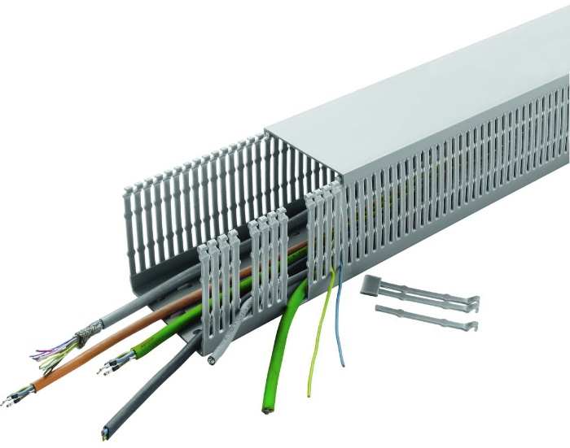
Illustration: Excellent dimensional stability, simple customization: UL- and VDE-certified cabling ducts from CONTA-CLIP

Illustrations: | terminal-plus_4 | Char.s: |  | 1689
File name: | 201808044_pm_ul_vde_cert_cabling_ducts_en | Date: | 08-29-2018
About CONTA-CLIP
CONTA-CLIP is one of Europe’s leading manufacturers of electric terminal blocks. Based in Hövelhof, Germany, the medium-sized, family-run company has been producing electric and electronic connection systems for the process and automation industries for 40 years. CONTA-CLIP supplies all industry sectors, focusing on railroad industries, shipbuilding, building automation, conveyor technology, machine and plant engineering and construction, instrumentation and control technology, control panel manufacturing, transformer manufacturing, and environmental technology. The company consists of three specialized branches: CONTA-CONNECT for electric connection technology, CONTA-ELECTRONICS for electronics and CONTA-CON for PCB edge connectors. Additionally, CONTA-CLIP provides services such as customizing housings and mounting rails, labeling and supplying user-specific electronic components.

Contact:  CONTA-CLIP  Verbindungstechnik GmbH  Christian Quade  Otto-Hahn-Str. 7  33161 Hövelhof  Germany  Tel.: +49 . 5257 . 9833 - 0  Fax: +49 . 5257 . 9833 - 33  Email: christian.quade@conta-clip.de  WWW: www.conta-clip.com |  | gii die Presse-Agentur GmbH  Immanuelkirchstr. 12  10405 Berlin  Germany  Tel.: +49 30 / 538 965 - 0  Fax: +49 30 / 538 965 - 29  Email: info@gii.de  WWW: www.gii.de

