Press Release

SIL-2-compliant pulse frequency conditioners and isolated standard signal conditioners for rail vehicles

Many systems installed on rolling stock need reliable information about the current speed – from braking systems to drives to door locks. This information is usually provided by speed encoders installed on the vehicle axles. Up until now, additional encoders had to be installed, if other systems also required speed data. This proves difficult sometimes, due to space limitations at the axles. And of course, the installation incurs additional costs. Introducing the ProLine P 16000 pulse frequency conditioner, Knick Elektronische Messgeräte now provides an economical solution, which can reliably and accurately reproduce encoder signals. The SIL-2-compliant conditioner enables functionally safe decoupling of speed sensor signals as well as of standard signals.
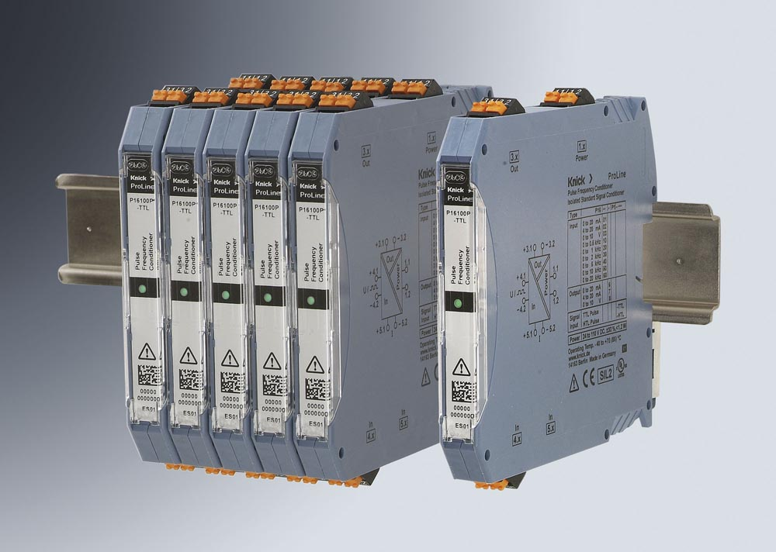
Illustration: The SIL-2-rated ProLine P 16000 pulse frequency conditioners ensures functionally safe detection and transmission of encoder signals on rolling stock

It converts these signals into galvanically isolated, analog 0/4…20 mA or 0…10 V standard signals that can be directly transmitted to the controller or other subsystems. The pulse input reproduces the measuring ranges 0...500 Hz or 0... 20 kHz with a ≤0.2 % full scale accuracy. The signal inputs are designed according to the SIL 2 safety integrity level so that there can be no unwanted impact on the signal source, which could distort measured values. Since pulse signals are directly converted into standard signals, there is no need for additional pulse counting inputs in the controller. Furthermore, safety-related standard signals from existing measuring circuits can be picked up and transmitted as electrically isolated signals. P 16000 complies with all standard requirements for use on rolling stock. It is highly resistant to harsh environmental conditions. Proper function of the device is unaffected by electromagnetic interference, extreme temperatures, vibrations, or shock impacts. The conditioner complies with current fire regulations for rolling stock according to EN 45525-2 and UL61010.

Illustrations: | ProLine_P16000_Reihe | Char.s: | 1876
File name: | 201808046_pm_proline_p_16000_en | Date: | 09-18-2018
About Knick
Founded by engineer Ulrich Knick in Berlin more than 70 years ago, Knick Elektronische Messgeräte GmbH & Co. KG still uphold the family company tradition today. The innovative enterprise manufactures measuring and monitoring devices for the chemical industry, system engineering, and industrial automation.

Contact:  Knick Elektronische  Messgeräte GmbH & Co. KG  Alina Rose  Marketing Communication  Beuckestr. 22  14163 Berlin  Germany  Tel.: +49 . 30 . 80 191-0  Fax: +49 . 30 . 80 191-200  Email: info@knick.de  Internet: www.knick.de |  | gii die Presse-Agentur GmbH  Immanuelkirchstr. 12  10405 Berlin  Germany  Tel.: +49 . 30 . 538 965-0  Fax: +49 . 30 . 538 965-29  Email: info@gii.de  Internet: www.gii.de

