Press Release

New voltage presence detector for traction substations and rolling stock

In the rail sector, reliable detection of applied voltages or unwanted potential differences is essential to ensure human safety and the protection of electrical installations. On the one hand, different ground potentials can cause dangerous voltages between wagons and platforms. On the other, many switches and electric/electronic components must not be switched under load. Knick Elektronische Messgeräte has developed the ProLine P 52000 VPD voltage presence detector for the safe detection of voltages up to 4200 V in traction substations and on rolling stock. P 52000 VPD is based on the P 50000 transducer series, which complies with all relevant railway standards. A rotary switch installed on the front enables selection of ten predefined thresholds or user-defined values. The voltage detector compares the input signal with the selected threshold value. If, irrespective of positive or negative polarity, the threshold is breached, the detector will open a solid-state switch to signal an applied dangerous voltage. The output is isolated, protected against polarity reversal, and short-circuit-proof up to 30 V DC. The signal level is based on type 1 PLC signal inputs according to EN 61131-2 and is suitable to trigger controllers, hardware relays, and protection devices. Just like all P 50000 transducers, the P 52000 VPD voltage detector features calibrated range selection, 3-port isolation, full touch protection, and an integrated broad-range power supply for all voltages typical for the rail sector. It thus sets a new standard for this class of equipment. The voltage detector is compliant with current railway standards and meets all requirements on fire protection (HL3 according to EN 45545-2 [2016]), electrical safety, mechanical robustness, resilience to extreme climatic conditions, and low EMI susceptibility.

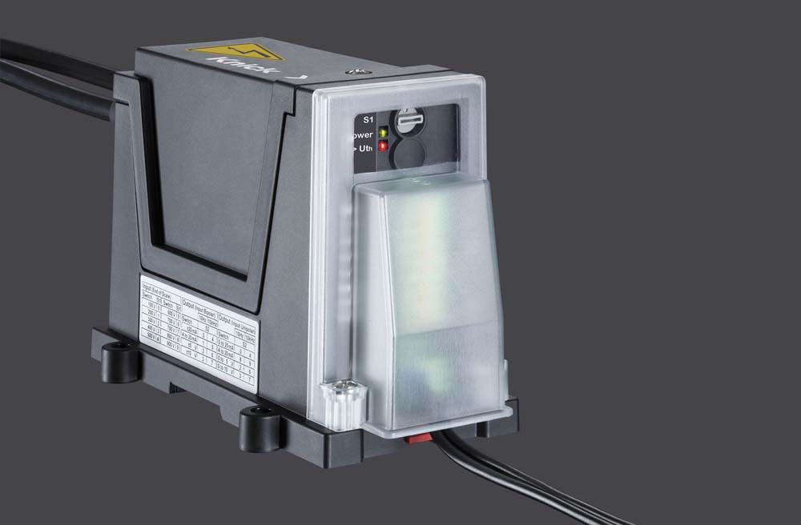
Illustration: The voltage presence detector enables the safe detection of voltages up to 4200 V in traction substations and on rolling stock

Illustrations: | ProLine_P52000_VPD | Char.s: | 1839
File name: | 201808047_pm_proline_p_52000_vpd_en | Date: | 09-18-2018
About Knick
Founded by engineer Ulrich Knick in Berlin more than 70 years ago, Knick Elektronische Messgeräte GmbH & Co. KG still uphold the family company tradition today. The innovative enterprise manufactures measuring and monitoring devices for the chemical industry, system engineering, and industrial automation.

Contact:  Knick Elektronische  Messgeräte GmbH & Co. KG  Alina Rose  Marketing Communication  Beuckestr. 22  14163 Berlin  Germany  Tel.: +49 . 30 . 80 191-0  Fax: +49 . 30 . 80 191-200  Email: info@knick.de  Internet: www.knick.de |  | gii die Presse-Agentur GmbH  Immanuelkirchstr. 12  10405 Berlin  Germany  Tel.: +49 . 30 . 538 965-0  Fax: +49 . 30 . 538 965-29  Email: info@gii.de  Internet: www.gii.de

