Press Release

New Spot Size Calculator App

Fluke Process Instruments has released the new Spot Size Calculator app for Android and iOS mobile devices, for desktop computers running Windows 10, and as an online app for use with all common internet browsers. It integrates all Fluke Process Instruments infrared spot sensors and thermal imagers as well as legacy Raytek and Ircon devices. Users simply select a product and enter the mounting distance. The app then calculates the spot diameter or camera field of view. This will help customers find the right spot pyrometer for their installation environment – the measured object must be larger than the spot size to prevent measuring errors. In addition, the app will help customers optimally set up thermal cameras so they focus all areas of interest. The app supports English, German, French, Spanish, and Chinese.

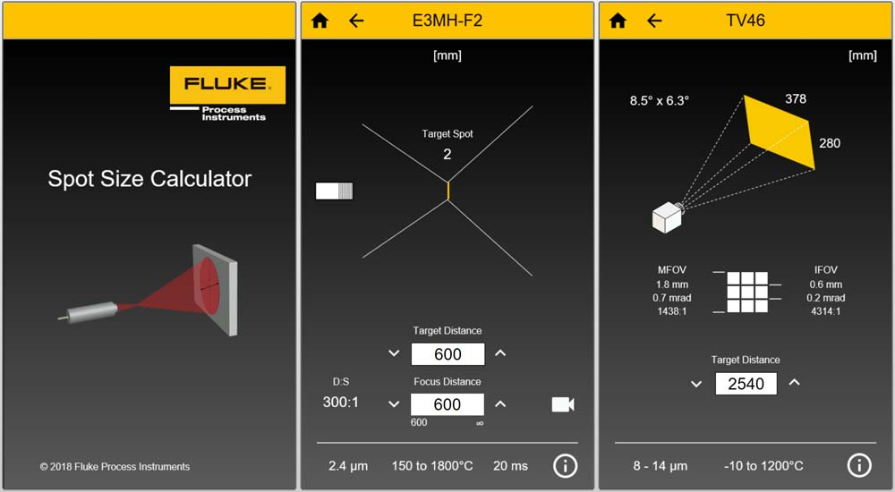
Illustration 1: The intuitive app calculates measurement spot sizes for infrared pyrometers depending on the mounting distance


Illustration 2: The Spot Size Calculator app is available for Android, iOS, Windows 10, and online, and can be downloaded from the respective app stores

Illustrations: | spot_size_calculator_en  ssc_app_store_links | Char.s: | XXX
File name: | 201808053_pm_spot_size_calculator_app_en | Date: | 09-28-2018
About Fluke Process Instruments
Fluke Process Instruments designs, manufactures, and markets a complete line of infrared temperature measurement and profiling solutions for industrial, maintenance, and quality control applications. Distributed worldwide under the Raytek, Ircon, and Datapaq brands, the products reflect the combined experience of over 125 years in manufacturing the world’s finest temperature measurement tools and devices.
About Fluke
Founded in 1948, Fluke Corporation is the world leader in compact, professional electronic test tools. Fluke customers are technicians, engineers, electricians, and metrologists who install, troubleshoot, and manage industrial, electrical, and electronic equipment and calibration processes.

Contact:  Fluke Process Instruments GmbH  Stephan Wilke  Blankenburger Str. 135  13127 Berlin  Germany |  | gii die Presse-Agentur GmbH  Immanuelkirchstr. 12  10405 Berlin  Germany  Tel.: +49 . 30 . 538 965-0  Email: info@gii.de  WWW: www.gii.de
Tel.: +49 . 30 . 478 008-0
Email: marcom2.emea@flukeprocessinstruments.de
Internet: www.flukeprocessinstruments.com
Contact for Americas and Australasia:
Lindsay Schutter
lindsay.schutter@fluke.com
Contact for Asia (except China):
Clothilde Bugnard
clothilde.bugnard@fluke.com
Contact for China:
Grace Cheng
chen.cheng@fluke.com

