Press Release

Compact Emergency Stop button

The new LUMOTAST 22 is the first Emergency Stop button from RAFI's LUMOTAST range for 22.3 mm mounting holes. Featuring a compact size and a low installation depth of 17.6 mm, this pushbutton is very useful whenever space above or below the front panel is limited. The actuating element is designed to protect the Emergency Stop button against blocking by foreign objects, with its positively driven mechanism that is tamper-proof in keeping with DIN EN ISO 13850. LUMOTAST 22 versions are available with two NC or two NO contacts, or with one NO and one optional signaling contact. In addition, customers can select models sporting a night-time design with illuminated arrows showing how to release the buttons. The switching elements with silver contacts are designed for 250 V voltage and 2.5 A switching current. They provide IP65 ingress protection. The E-Stops can be installed in seconds, inserting easily into the mounting hole and secured in place by a single threaded nut behind the housing front panel. The pushbuttons are connected via 2.8 x 0.8 mm quick connectors. Alternatively, wires can be soldered to the switch contacts.

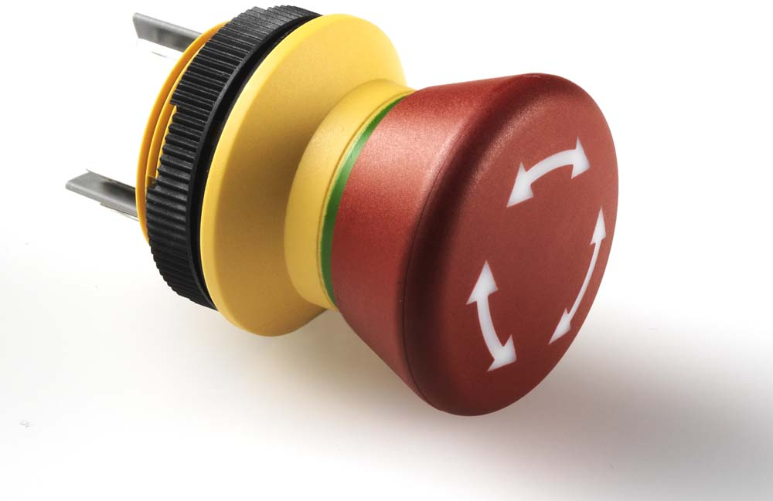
Illustration: The new E-Stop for 22.3 mm mounting holes is ideal for limited installation space

Illustrations: | lumotast_22 | Char.s: | 1139
File name: | 201809008_pm_lumotast_22_e-stop_en | Date: | 12-05-2018
Company background RAFI group
Founded in 1900, RAFI now develops and produces electromechanical components such as pushbuttons and switches, operating systems such as touch screens, keyboards, electronic components, and systems for man-machine communication. RAFI products are employed in more than 30 industries, e.g., in medical equipment, mechanical engineering, road and railway vehicles, household appliances, and telecommunications. The RAFI group operates internationally with approx. 2,500 employees at ten sites in Germany, Europe, China, and the USA. The group’s headquarters are located in Berg (Baden-Württemberg, Germany).

Contact:  RAFI GmbH & Co. KG  Artur Krug  Ravensburger Str. 128-134  88276 Berg  Germany  Tel.: +49 . 751 . 891 307  Fax: +49 . 751 . 891 300  e-mail: artur.krug@rafi.de  WWW: www.rafi.de |  | gii die Presse-Agentur GmbH  Immanuelkirchstr. 12  10405 Berlin  Germany  Tel.: +49 . 30 . 5389 650  Fax: +49 . 30 . 5389 6529  email: info@gii.de  Internet: www.gii.de

