Press Release

InnoTrans exhibition:
FSG presents modular traction/brake lever system

At this year's InnoTrans trade fair, FSG Fernsteuergeräte presents the prototype of a traction/brake lever system based on a modular design. It features mechanically coupled components suitable to be combined in any way, enabling custom configurations for different requirements. The main traction module with a deadman button is an extremely sturdy and durable lever with spring return. A built-in gear transmits the lever movements to a total of four mechanical couplings on the sides and the bottom of the lever module, which can be customized by fitting extra components for locking, braking, switching, and signal functions as required. The locking and braking module enables users to keep the traction lever fixed in adjustable positions at different angles. The switch module with forced-open cam switches serves to close or open contacts at freely adjustable switching points and lever angles. The signal module is used to monitor the lever position and provide analog or digital position signals. It is designed to accommodate any commercially available encoder attachment. The modular traction lever system is suitable for installation in all types of panels and can be mounted in a horizontal as well as a vertical orientation.
FSG at InnoTrans
Berlin, Germany, 18 – 21 September 2018
Hall 6.2, Stand 410

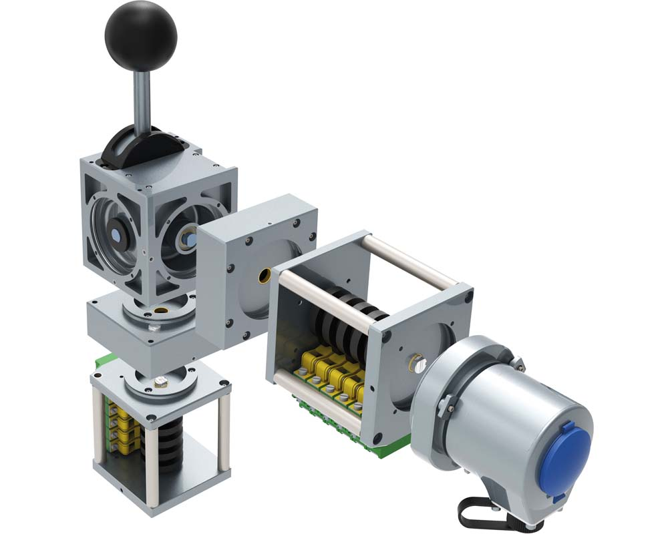
Illustration: FSG prototype of a new traction/brake lever system based on a modular design

Illustrations: | Fahr-Bremshebelsystem | Char.s: | 1238
File name: | 201809016_pm_innotrans_en | Date: | 09-18-2018
About FSG
FSG Fernsteuergeräte, a leading supplier of measuring and sensor technology, was founded in 1946. The company develops and manufactures high-quality measuring sensors and actuators for automation and safety engineering applications, providing a 90% depth of production. The product portfolio includes a wide range of customer-oriented systems solutions: linear displacement transmitters, angular position transducers, wind warning systems, manual X/Y control transmitters, pedal actuated transmitters and signal indication components. FSG employs a staff of 400 at its Berlin headquarters and in its Kablow, Zernsdorf, and Heppenheim plants, about 30 % of whom work in research and development, sales and quality management.

Contact:  FSG Fernsteuergeräte  Jahnstr. 68+70  12347 Berlin  Germany  Tel.: +49 . 30 . 629 11  Fax: +49 . 30 . 629 1277  Email: info@fernsteuergeraete.de  WWW: www.fernsteuergeraete.de |  | gii die Presse-Agentur GmbH  Immanuelkirchstr. 12  10405 Berlin  Germany  Tel.: +49 . 30 . 538 965 0  Fax: +49 . 30 . 538 965 29  Email: info@gii.de  WWW: www.gii.de

