Press Release

Cooling curve monitoring in glass annealing lehrs

Thermalert 4.0 spot pyrometers from Fluke Process Instruments enable precise monitoring of critical glass manufacturing processes such as annealing of glass bottles and containers. The noncontact infrared sensors measure product as well as belt temperatures. That way, operators can ensure that the lehr is set correctly for products with different glass thicknesses and sizes, and that the transportation belt is heated correctly. The latter is especially important for glass containers with a thick bottom, to prevent uneven cooling and breakage. Continuous monitoring helps operators improve quality and uniformity and reduce reject rates. It also supports troubleshooting by detecting faulty burners under the transportation belt.

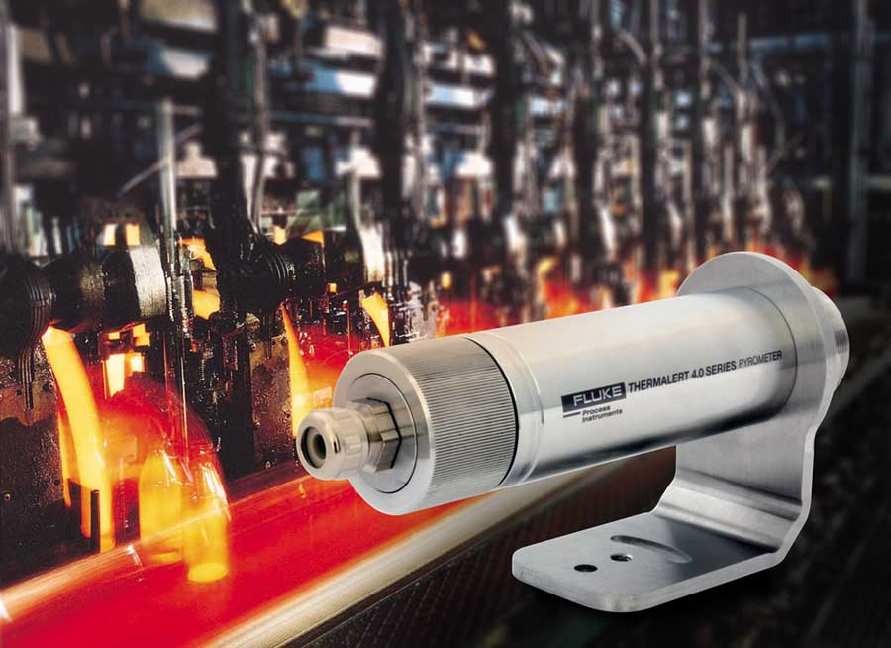
Illustration: Noncontact infrared thermometers monitor belt temperatures and cooling curves of glass containers

The annealing process is designed to remove residual stress in formed containers. Obtaining the correct temperature and cooling curve is essential to achieve the required strength in the finished product. Temperature monitoring in this process also serves to confirm correct cure of decorative print or coatings. The high-accuracy Thermalert 4.0 spot pyrometer series comprises various wavelength models for different materials, including two specialized glass models. A peak hold function enables monitoring of moving glass containers. The series covers measured temperatures between -40 °C and 2250 °C. The infrared thermometers have the largest ambient temperature range in their class: -20 °C to 85 °C. Therefore, many measuring points can be set up without cooling accessories, saving costs. Moreover, the sensors can be read out, configured, calibrated, and fitted with firmware updates remotely via the internet. This minimizes service costs per measuring point. Fluke Process Instruments industry specialists will be happy to advise customers on selecting and setting up the ideal measuring solution for their plant.

Illustrations: | thermalert_40_annealing | Char.s: | 1858
File name: | 201810004_pm_glass_annealing_thermalert_40_en | Date: | 12-05-2018
About Fluke Process Instruments
Fluke Process Instruments designs, manufactures, and markets a complete line of infrared temperature measurement and profiling solutions for industrial, maintenance, and quality control applications. Distributed worldwide under the Raytek, Ircon, and Datapaq brands, the products reflect the combined experience of over 125 years in manufacturing the world’s finest temperature measurement tools and devices.
About Fluke
Founded in 1948, Fluke Corporation is the world leader in compact, professional electronic test tools. Fluke customers are technicians, engineers, electricians, and metrologists who install, troubleshoot, and manage industrial, electrical, and electronic equipment and calibration processes.

Contact:  Fluke Process Instruments GmbH  Stephan Wilke  Blankenburger Str. 135  13127 Berlin  Germany |  | gii die Presse-Agentur GmbH  Immanuelkirchstr. 12  10405 Berlin  Germany  Tel.: +49 . 30 . 538 965-0  Email: info@gii.de  WWW: www.gii.de
Tel.: +49 . 30 . 478 008-0
Email: marcom2.emea@flukeprocessinstruments.de
Internet: www.flukeprocessinstruments.com
Contact for Americas and Australasia:
Lindsay Schutter
lindsay.schutter@fluke.com
Contact for Asia (except China):
Clothilde Bugnard
clothilde.bugnard@fluke.com
Contact for China:
Grace Cheng
chen.cheng@fluke.com

