Press Release

Camera ring lights in six colors

autoVimation now offers Meganova ring lights in six different colors. These modules are equipped with an onboard strobe controller. Developed to fit into autoVimation’s enclosures with a 3" front window, like the Orca and Mammoth housings, the special clamping mount ensures good heat dissipation. Each light contains eight high-performance LEDs in four optional beam angles between 14° and 76° for optimal illumination of the camera field of view. In addition to two white ring lights with different CRIs, Meganova is available with red, green, blue, and infrared light. They are mounted using the integrated clamps with a large contact area. The ring lights feature a large enough inner radius for wide-angle lenses with diameters up to 36 mm to be fitted right behind the front window. This prevents reflection of light onto the camera lens. The LEDs can be pulsed with almost six times the nominal current, resulting in four times the normal brightness. The onboard controller calculates the maximum pulse/pause ratio depending on shutter speed and gain and prevents users from selecting damaging settings.

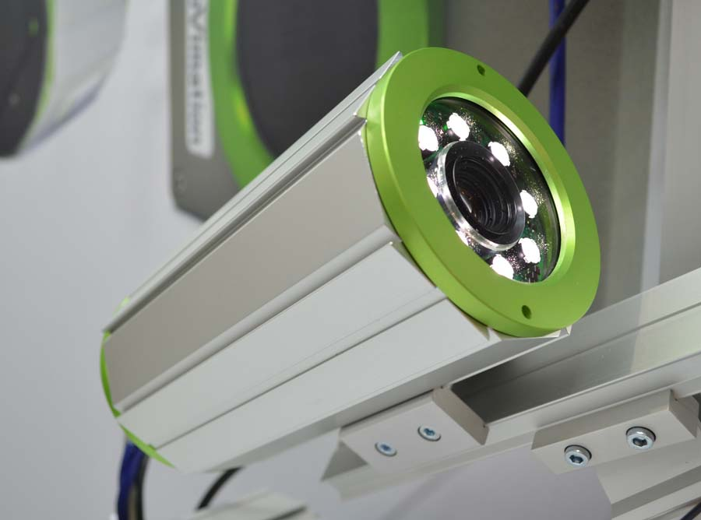
Illustration: autoVimation's LED ring lights are now available in six colors with onboard flash controllers

Due to good heat dissipation via the camera enclosure, 200 % nominal current – almost twice the normal brightness – can be continuously maintained under room temperature conditions at 16 W power consumption. Continuous temperature monitoring with automatic emergency shut-off prevents overheating. Users can set the pulse length, triggering behavior, exposure time, current amplification, and other ring lighting and flash parameters exactly as required via RS232 interface. The trigger is controlled via an optically isolated 5...24 V DC wide-range input. The onboard flash controller enables direct connection of the camera trigger output to synchronize light activation, ensuring particularly accurate flashing especially with short pulses. Reflections at a vertical angle of view can be reduced with an optional polarizing filter ring. A matching diffuser ensures homogenous illumination. Water cooling systems developed by autoVimation can additionally protect the lights and camera even at higher ambient temperatures of up to 200 °C.

Illustrations: | led_kameraringbeleuchtung | Char.s: | 2150
File name: | 201810011_pm_meganova_ring_lights_en | Date: | 10-31-2018
About autoVimation
Established in 2008, Karlsruhe-based autoVimation was founded by Peter Neuhaus to provide solutions for easier installation and adjustment of image processing components. The company has developed a modular construction kit that simplifies the connection of all required components, which does away with costly and time-consuming manufacturing of dedicated mounting brackets. The product portfolio also includes compact, easy-to-integrate enclosures that provide optimal protection for cameras and lenses in industrial applications, and ensure good heat dissipation. autoVimation supplies complete, ready-to-install mechanical solutions for cameras and light fittings, and enables the integration of special lenses, filters, light barriers, encoders, or other sensors.
autoVimation's customers include renowned companies from various industry branches, such as the pharmaceutical and food industry, measuring technology, quality control, and security technology.

Contact:  autoVimation GmbH  Peter Neuhaus  Roemerweg 1  76287 Rheinstetten  Germany  Tel.: +49 . 721 . 627 6756  Fax: +49 . 721 . 627 6759  Email: sales@autovimation.com  WWW: www.autovimation.com |  | gii die Presse-Agentur GmbH  Immanuelkirchstr. 12  10405 Berlin  Germany  Tel.: +49 30 / 5389 650  Fax: +49 30 / 5389 6529  Email: info@gii.de  WWW: www.gii.de

