Press Release

Hygienic camera enclosures in three sizes

A specialist in protective enclosures for industrial cameras and laser systems, German manufacturer autoVimation has further expanded its range of Dolphin camera housings for very demanding hygienic requirements. The Dolphin series now comprises three lengths suitable for compact cameras with cross sections between 29 x 47 mm and 40 x 40 mm. Up to 218 mm long camera assemblies including lens and connectors can be comfortably fitted within. Since the enclosures are made to EHEDG design specifications, direct contact with food and placement in high contamination risk areas are no problem. The housings made of V4A AISI 316L stainless steel can be cleaned with pressure washers. Electropolished surfaces and a surface roughness of less than 0.8 μm reliably prevent bacteria buildup. All seals and cable conduits are FDA-approved and comply with EU regulations 10/2011 or 1935/2004 for use in hygienically sensitive areas in the food, pharmaceutical, and chemical industries. The sealing materials feature high chemical and temperature resistance. They permanently withstand fats, mineral oils as well as aggressive cleaning agents. The enclosures achieve IP69K ingress protection, and the lids feature dual seals for additional safety. The front lid is optionally available in acrylic or BK7 glass. Versatile mounting options and compact dimensions allow for vibration-proof installation of the Dolphin enclosures in any location. The new rear wall mount enables 360° enclosure rotation and 50 mm height adjustment above the mounting surface. The patented Quick-lock/Heat-guide mount provides excellent dissipation to the outer housing and therefore cools the housed camera.

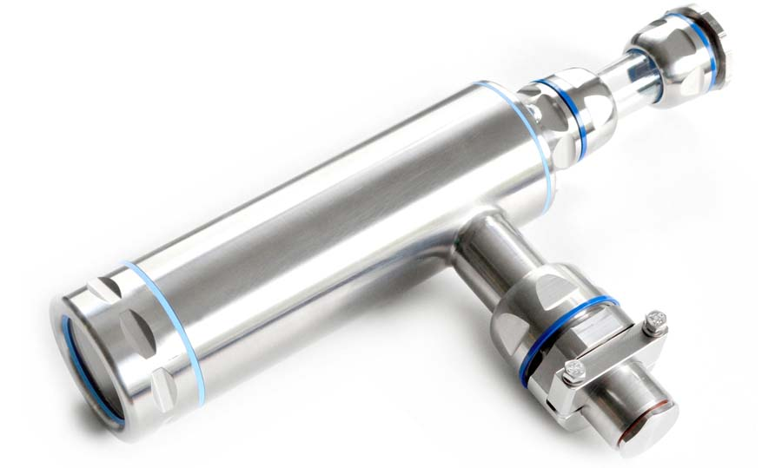
Illustration: Hygienic Dolphin camera enclosures comply with EHEDG and FDA standards

Illustrations: | dolphin_m | Char.s: | 1678
File name: | 201810015_pm_dolphin_hygienic_housings_en | Date: | 12-05-2018
About autoVimation
Established in 2008, Karlsruhe-based autoVimation was founded by Peter Neuhaus to provide solutions for easier installation and adjustment of image processing components. The company has developed a modular construction kit that simplifies the connection of all required components, which does away with costly and time-consuming manufacturing of dedicated mounting brackets. The product portfolio also includes compact, easy-to-integrate enclosures that provide optimal protection for cameras and lenses in industrial applications, and ensure good heat dissipation. autoVimation supplies complete, ready-to-install mechanical solutions for cameras and light fittings, and enables the integration of special lenses, filters, light barriers, encoders, or other sensors.
autoVimation's customers include renowned companies from various industry branches, such as the pharmaceutical and food industry, measuring technology, quality control, and security technology.

Contact:  autoVimation GmbH  Peter Neuhaus  Roemerweg 1  76287 Rheinstetten  Germany  Tel.: +49 . 721 . 627 6756  Fax: +49 . 721 . 627 6759  Email: sales@autovimation.com  WWW: www.autovimation.com |  | gii die Presse-Agentur GmbH  Immanuelkirchstr. 12  10405 Berlin  Germany  Tel.: +49 30 / 5389 650  Fax: +49 30 / 5389 6529  Email: info@gii.de  WWW: www.gii.de

