Press Release

autoVimation celebrates 10th anniversary

autoVimation celebrates its 10th anniversary this year. The company has been developing and manufacturing modular enclosures for cameras and laser systems since 2008. Under the direction of founder and managing director Peter Neuhaus, the company has made its name as a renowned specialist in rugged protective housings and fixtures for vision technology. "Our concept, first launched at VISION Stuttgart in 2008, became an instant success with customers," says Neuhaus. "Our modular system enables easy installation of sensitive cameras and laser technology in virtually any environment. It allows users to save a lot of effort for in-house development of protective housings and mounting accessories." The company has seen a steady growth in sales volume. Its products and special solutions made in Germany are in demand around the world. Only last year, autoVimation's expanding business prompted an HQ relocation to a larger facility in the Karlsruhe area.

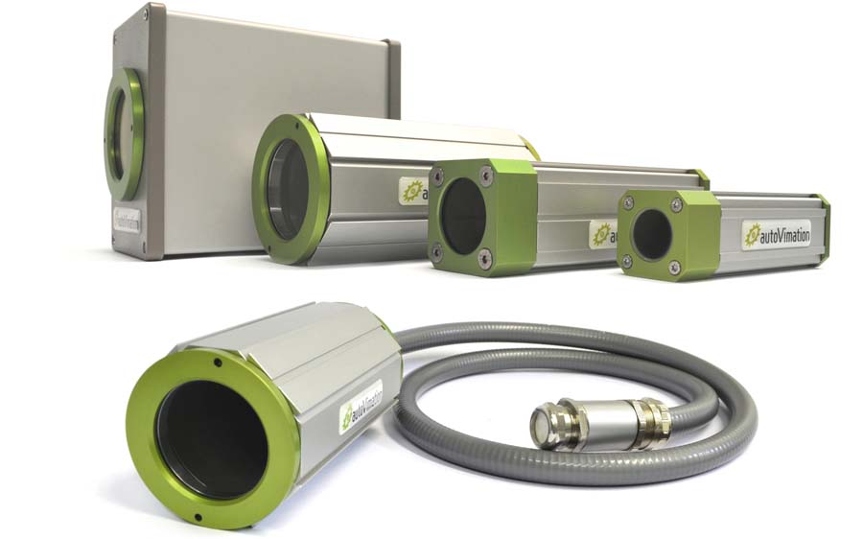
Illustration: Celebrating ten successful years in business, autoVimation is a well-established provider of modular enclosures and fixtures for cameras and laser systems

autoVimation has won the innovation prize of the Technologiefabrik Karlsruhe tech hub on two different occasions: in 2011 for its overall concept of protective enclosures and mounting systems; in 2013 for temperature-controlled desert-proof enclosures used by the solar industry. autoVimation enclosing solutions feature in all industrial sectors and across a wide variety of special applications. They are used in extreme climates and for extremely varied purposes, from solar power plant operations in the Mojave Desert to penguin monitoring in Antarctica. Past projects have also covered numerous water and underwater applications, including one with an underwater camera in a TV show segment about seven swimmers climbing into one bathing cap. Most recently, the company has launched a hygienic camera mounting and enclosing system for the food and pharmaceutical sectors, as well as ring lights in six colors with a flash controller for installation in Orca protective camera enclosures. More information on the company, applications, and international distributors as well as the product catalog are available at www.autovimation.com.

Illustrations: | kameraschutzgehaeuse | Char.s: | 2100
File name: | 201810016_pm_10_yrs_autovimation_en | Date: | 10-31-2018
About autoVimation
Established in 2008, Karlsruhe-based autoVimation was founded by Peter Neuhaus to provide solutions for easier installation and adjustment of image processing components. The company has developed a modular construction kit that simplifies the connection of all required components, which does away with costly and time-consuming manufacturing of dedicated mounting brackets. The product portfolio also includes compact, easy-to-integrate enclosures that provide optimal protection for cameras and lenses in industrial applications, and ensure good heat dissipation. autoVimation supplies complete, ready-to-install mechanical solutions for cameras and light fittings, and enables the integration of special lenses, filters, light barriers, encoders, or other sensors.
autoVimation's customers include renowned companies from various industry branches, such as the pharmaceutical and food industry, measuring technology, quality control, and security technology.

Contact:  autoVimation GmbH  Peter Neuhaus  Roemerweg 1  76287 Rheinstetten  Germany  Tel.: +49 . 721 . 627 6756  Fax: +49 . 721 . 627 6759  Email: sales@autovimation.com  WWW: www.autovimation.com |  | gii die Presse-Agentur GmbH  Immanuelkirchstr. 12  10405 Berlin  Germany  Tel.: +49 30 / 5389 650  Fax: +49 30 / 5389 6529  Email: info@gii.de  WWW: www.gii.de

