Press Release

RAMO standalone industrial controls and indicators with M12 connectors

Complex wiring and properly sealed, dedicated enclosures often drive up the cost of fitting industrial applications with pushbuttons, function switches, E-Stops, or signaling devices. The RAMO line of control components and signal lamps provides highly economical and easy-to-install alternatives. These standalone RAFI products need no extra housings or special gaskets, and they are plug-and-play ready, reducing costly wiring time and precluding mistakes. Even untrained personnel can install the devices.

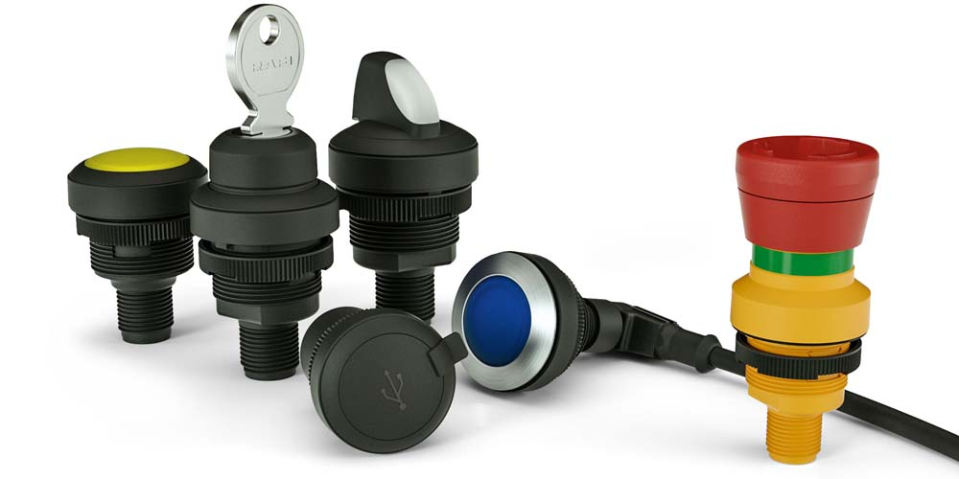
Illustration 1: The RAMO range includes pushbuttons, emergency stops, selector switches, key switches, and signal lamps with M12 connectors, as well as USB 3.0 and RJ45 bushings

Due to their single-piece, fully enclosed mono-housings and connection via M12 circular plug connectors, RAMO pushbuttons, emergency stops, selector switches, key switches, and LED signal lamps can be installed in standard 22.3 mm and 30.3 mm mounting holes without any additional sealing. The RAMO EDGE 90° mounting bracket enables quick mounting of standalone RAMO components. The bracket fits on 40 mm profile rails. Depending on the type of RAMO component, the installation depth varies between 30.2 mm (RAMO 22) and 36.4 mm (RAMO 30). For applications with restricted space, devices are available with M12 connectors featuring angled cable exits. Rotated by 135°, these cable exits allow for a high packing density. The RAMO series is designed to fit the look and dimensions of the RAFIX FS+ series, allowing users to mix and match control components from both series as they wish. The pushbuttons are available with fully illuminated bezels in many different colors and with a normally open contact. The pushbuttons can be individually labeled using the FLEXLAB system. In addition to pushbuttons, function switches, and LED lamps in five colors, the RAMO range also includes USB 3.0 and RJ45 bushings that feature the same design.
A product video at https://www.youtube.com/watch?v=LO5Wcbx5eL0 presents application examples and installation variants for the RAMO series.

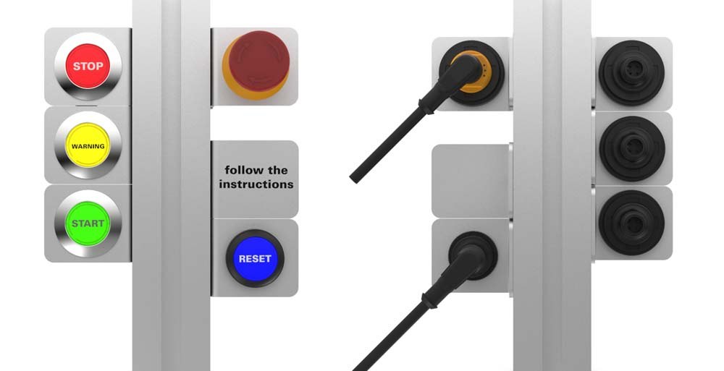
Illustration 2: The RAMO EDGE mounting bracket enables easy installation of RAMO control components on 40 mm profile rails

Illustrations: | RAMO-Gruppe_g  ramo_edge_gruppe | Char.s: | 1884
File name: | 201811040_pm_ramo_control_elements_en | Date: | 01-31-2019
About RAFI
Founded in 1900, RAFI now develops and produces electromechanical components such as pushbuttons and switches, operating systems such as touch screens, keyboards, electronic components, and systems for man-machine communication. RAFI products are employed in more than 30 industries, e.g., in medical equipment, mechanical engineering, road and railway vehicles, household appliances, and telecommunications. The RAFI group operates internationally with approx. 2,500 employees at ten sites in Germany, Europe, China, and the USA. The group’s headquarters are located in Berg (Baden-Württemberg, Germany).

Contact:  RAFI GmbH & Co. KG  Artur Krug  Ravensburger Str. 128-134  88276 Berg  Germany  Tel.: +49 . 751 . 891 307  Fax: +49 . 751 . 891 300  e-mail: artur.krug@rafi.de  WWW: www.rafi.de |  | gii die Presse-Agentur GmbH  Immanuelkirchstr. 12  10405 Berlin  Germany  Tel.: +49 . 30 . 5389 650  Fax: +49 . 30 . 5389 6529  email: info@gii.de  Internet: www.gii.de

