Press Release

Easy customization of cabling ducts

CONTA-CLIP provides all necessary tools for customizing its UL- and VDE-certified VK series cabling ducts. The VK-S cutter allows for shortening up to 125 mm wide standard or halogen-free cabling ducts to the required length. Cuts are clean, without burrs, and with the exact required angle. This tool can be installed at a workbench. VK-AKZ notching pliers are made for breaking out sections of the side walls cleanly and completely all the way down to the base of the cabling duct. Expanding rivets can be processed safely and quickly using the SN-SW setting tool. Featuring a long shaft, it facilitates setting rivets in deep channels or in other difficult-to-access positions. CONTA-CLIP supplies VK cabling ducts with a length of two meters. These ducts made of rigid PVC are notable for their excellent form stability. They feature tight-fitting covers that nevertheless allow for very easy detachment and reattachment. The material is lead-free, flame-retardant, and self-extinguishing according to UL 94 V-0. CONTA-CLIP also provides cabling ducts in accordance with VDE 0472 part 815 for use in public buildings. These are manufactured from halogen-free plastic that does not release toxic gases in case of a fire. Moreover, this material meets the F2 and I3 requirements of the NF F 16-101 railway standards. CONTA-CLIP also supplies miscellaneous accessories such as flexible cabling ducts, coiled tubing, wire holders, support lugs, and expanding rivets.

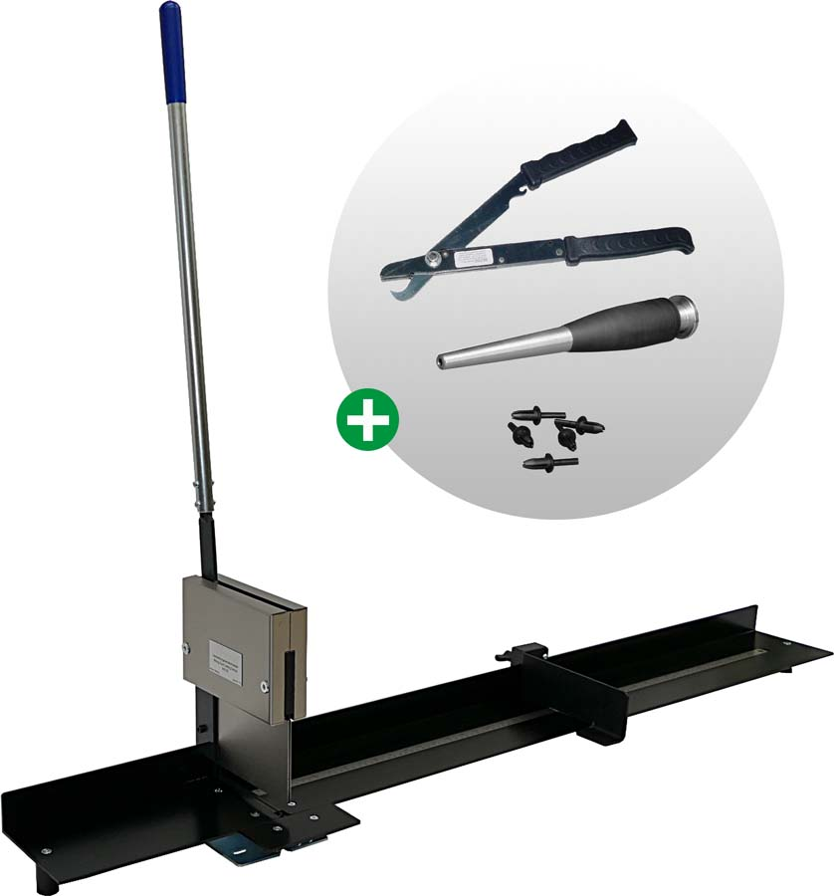
Illustration: CONTA-CLIP provides all necessary tools for customizing its VK-series cabling ducts

Illustrations: | vk-werkzeug_collage | Char.s: | 1466
File name: | 201902002_pm_cabling_duct_tools_en | Date: | 05-24-2019
About CONTA-CLIP
CONTA-CLIP is one of Europe’s leading manufacturers of electrical and electronic connection elements and cable management solutions. Based in Hövelhof, Germany, the medium-sized, family-run company has been producing electric and electronic connection systems for the process and automation industries for 40 years. CONTA-CLIP supplies all industry sectors, focusing on railroad industries, shipbuilding, building automation, conveyor technology, machine and plant engineering and construction, instrumentation and control technology, control panel manufacturing, transformer manufacturing, and environmental technology. The company consists of three specialized branches: CONTA-CONNECT for electric connection technology, CONTA-ELECTRONICS for electronics and CONTA-CON for PCB edge connectors. Additionally, CONTA-CLIP provides services such as customizing housings and mounting rails, labeling and supplying user-specific electronic components.

Contact:  CONTA-CLIP  Verbindungstechnik GmbH  Christian Quade  Otto-Hahn-Str. 7  33161 Hövelhof  Germany  Tel.: +49 . 5257 . 9833 - 0  Fax: +49 . 5257 . 9833 - 33  Email: christian.quade@conta-clip.de  WWW: www.conta-clip.com |  | gii die Presse-Agentur GmbH  Immanuelkirchstr. 12  10405 Berlin  Germany  Tel.: +49 30 / 538 965 - 0  Fax: +49 30 / 538 965 - 29  Email: info@gii.de  WWW: www.gii.de

