Press Release

bauma trade fair:
Custom-tailored operating systems for mobile machinery

At the 2019 bauma trade fair in Munich, Germany, RAFI (Hall A2, Booth 432) showcases customer-specific operating, monitoring, and control systems, as well as control components for construction and agricultural machinery, municipal vehicles, and forklifts. Exhibits include operating panels for wheel loaders, concrete mixers, and forklifts, a robust display module for road rollers, and a snowplow input and control interface for controlling the blade, gritter, and sprayer. Two custom-tailored armrests demonstrate RAFI's advanced design capabilities for highly integrated control technology. The SmartTouch armrest developed for a Finnish tractor manufacturer won the Red Dot Award for its ergonomic design. It contains an innovative multifunctional drive stick that enables optional full manual control of all vehicle movements otherwise controlled by pedals. Operators can individually adapt all control and operating functions via a touchscreen installed at the front end of the armrest. The second armrest shown at bauma, is used in Pistenbully snow groomers. RAFI not only integrated various sturdy, durable buttons and command devices from its extensive portfolio, but also a four-axis joystick that controls the blade movement with all degrees of freedom. This armrest is designed to withstand extreme ambient temperatures ranging from -40 °C to +80 °C.

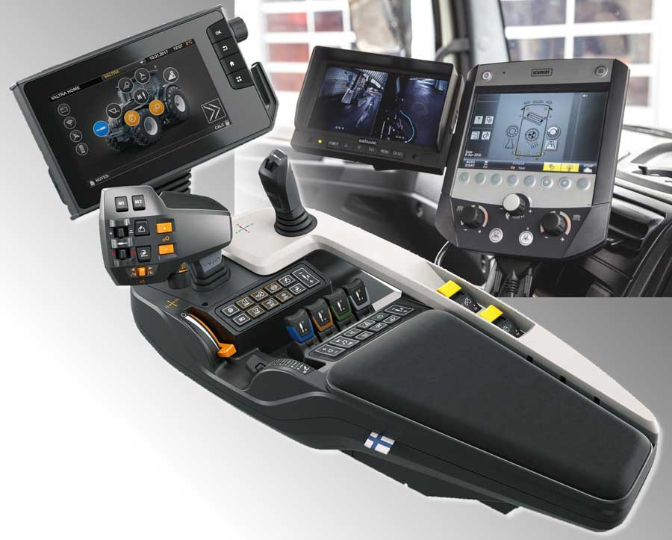
Illustration: RAFI exhibits at bauma include an armrest HMI for tractors and a touchscreen control unit for municipal service vehicles

Illustrations: | collage_bauma | Char.s: | 1363
File name: | 201903002_pm_bauma_en | Date: | 03-21-2019
About RAFI
Founded in 1900, RAFI now develops and produces electromechanical components such as pushbuttons and switches, operating systems such as touch screens, keyboards, electronic components, and systems for man-machine communication. RAFI products are employed in more than 30 industries, e.g., in medical equipment, mechanical engineering, road and railway vehicles, household appliances, and telecommunications. The RAFI group operates internationally with approx. 2,500 employees at ten sites in Germany, Europe, China, and the USA. The group’s headquarters are located in Berg (Baden-Württemberg, Germany).

Contact:  RAFI GmbH & Co. KG  Artur Krug  Ravensburger Str. 128-134  88276 Berg  Germany  Phone: +49 . 751 . 891 307  Fax: +49 . 751 . 891 300  Email: artur.krug@rafi.de  Internet: www.rafi.de | gii die Presse-Agentur GmbH  Immanuelkirchstr. 12  10405 Berlin  Germany  Phone: +49 . 30 . 5389 650  Fax: +49 . 30 . 5389 6529  Email: info@gii.de  Internet: www.gii.de

