Press Release

The organizer in the cabling duct

CONTA-CLIP further enhances its range of usability aids for VK cabling ducts, adding fast-mount wire holders. The wire holders can be clipped into the cabling ducts without tools. They make it easier to neatly arrange conductors and keep signal and power lines clearly apart. They also simplify adding new wiring, since existing cables stay put and do not come lose and entangled when the cover is removed. Last but not least, users will find it easier to clean their well-organized cabling duct of dust. The wire holders are available in two versions. The DHG type holder has closed spring brackets – cables can be pushed in from above. It comes in three sizes: 34 x 35 mm, 34 x 53 mm and 53 x 75 mm. The DHGB holder, on the other hand, is a small clip that securely holds cable ties of any size. The wire holders are made of RoHS compliant PC and PA. They are suitable for ambient temperatures from -20 °C to +60 °C.

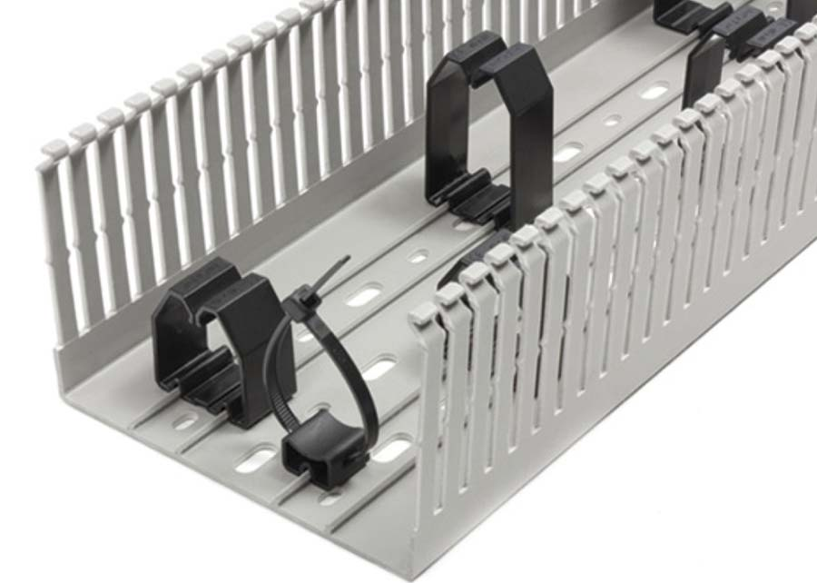
Illustration: CONTA-CLIP introduces wire holders for VK cabling ducts

Illustrations: | drahthalter_vk-kabelkanaele | Char.s: | 918
File name: | 201903003_pm_wire_holders_en | Date: | 03-21-2019
About CONTA-CLIP
CONTA-CLIP is one of Europe’s leading manufacturers of electrical and electronic connection elements and cable management solutions. Based in Hövelhof, Germany, the medium-sized, family-run company has been producing electric and electronic connection systems for the process and automation industries for 40 years. CONTA-CLIP supplies all industry sectors, focusing on railroad industries, shipbuilding, building automation, conveyor technology, machine and plant engineering and construction, instrumentation and control technology, control panel manufacturing, transformer manufacturing, and environmental technology. The company consists of three specialized branches: CONTA-CONNECT for electric connection technology, CONTA-ELECTRONICS for electronics and CONTA-CON for PCB edge connectors. Additionally, CONTA-CLIP provides services such as customizing housings and mounting rails, labeling and supplying user-specific electronic components.

Contact:  CONTA-CLIP  Verbindungstechnik GmbH  Christian Quade  Otto-Hahn-Str. 7  33161 Hövelhof  Germany  Phone: +49 . 5257 . 9833 - 0  Fax: +49 . 5257 . 9833 - 33  Email: christian.quade@conta-clip.de  Internet: www.conta-clip.com | gii die Presse-Agentur GmbH  Immanuelkirchstr. 12  10405 Berlin  Germany  Phone: +49 . 30 . 538 965 - 0  Fax: +49 . 30 . 538 965 - 29  Email: info@gii.de  Internet: www.gii.de

