Press Release

Lothar Seybold new RAFI CEO

A new generation of leadership will be guiding HMI specialist RAFI GmbH into a digital future. Long-time managing directors Albert Wasmeier and Gerhard Schenk will leave their executive positions and join the RAFI board of directors in the second half of 2019. Dr. Lothar Seybold, who has held various high-level management positions at RAFI for more than 10 years, has been named the new CEO and technical director at the beginning of this year. His principal goal as RAFI CEO is to make the company more digital across the board, while keeping it focused on the physical requirements of the design and function of modern operating technology. Seybold holds a doctorate in electronics engineering, an MBA, Master of Business Administration (University of Wuerzburg), and a PhD in control technology (University of Zielona Gora). He began his career at RAFI as a product manager for operating systems. In 2013, Seybold became the head of system development. In 2016, he was promoted to head of the Components and Systems business units, and focused the company on innovation management, new technologies, and improving overall customer satisfaction. Seybold has extensive international experience, having worked as a project engineer and consultant in New Zealand and Switzerland. Before joining RAFI, he worked at the software company is Integrated Systems AG, Radolfzell. Seybold is also a passionate skier.

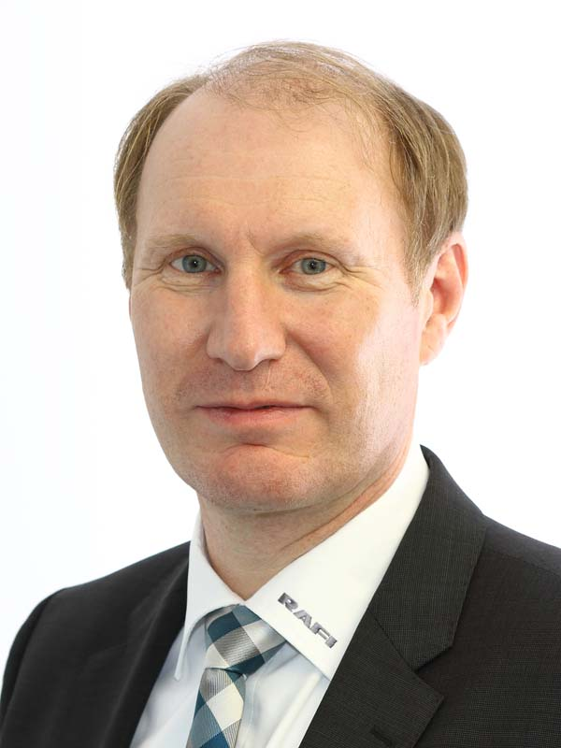
Illustration: New RAFI CEO Lothar Seybold seeks to further advance the digital transformation of the company

Illustrations: | seybold_lothar | Char.s: | 1409
File name: | 201903011_pm_seybold_ceo_en | Date: | 03-21-2019
About RAFI
Founded in 1900, RAFI now develops and produces electromechanical components such as pushbuttons and switches, operating systems such as touch screens, keyboards, electronic components, and systems for man-machine communication. RAFI products are employed in more than 30 industries, e.g., in medical equipment, mechanical engineering, road and railway vehicles, household appliances, and telecommunications. The RAFI group operates internationally with approx. 2,500 employees at ten sites in Germany, Europe, China, and the USA. The group’s headquarters are located in Berg (Baden-Württemberg, Germany).

Contact:  RAFI GmbH & Co. KG  Artur Krug  Ravensburger Str. 128-134  88276 Berg  Germany  Phone: +49 . 751 . 891 307  Fax: +49 . 751 . 891 300  Email: artur.krug@rafi.de  Internet: www.rafi.de | gii die Presse-Agentur GmbH  Immanuelkirchstr. 12  10405 Berlin  Germany  Phone: +49 . 30 . 5389 650  Fax: +49 . 30 . 5389 6529  Email: info@gii.de  Internet: www.gii.de

