Press Release

Sheet-metal puncher with hydraulic hand pump

CONTA-CLIP now offers a combination of a hydraulic hand pump and sheet-metal punching tool. Users can thereby produce break-outs in control cabinets for KDSClick, KDS-FB, KDS-KV, and KES cable entries within a few minutes. The hydraulic hand pump contains no hose and features a user-friendly, compact design. It weighs only 2 kg. The hydraulic cylinder can be rotated and swiveled by 360° along three axes, allowing for flexible use even in hard-to-reach places. The punching tool includes round hole punchers for all diameters from M20 to M63 for KDS-KV separable cable glands and square and rectangular hole punchers for all KDSClick, KDS-FB, and KES cable entries as well as for 110 by 131 mm KDS-FP flange plates. In order to create a break-out in a sheet-metal enclosure, the hydraulically operated draw bolt is inserted in a bore hole. Next, stamp and matrix are fixed with counter nuts both on the inside and outside. When operated, the draw bolt pulls stamp and matrix towards each other, producing the opening in the required size. The built-in punch-hole marking tip can be used to clearly punch-mark the drill points for screw-on attachment of the cable entry. Stamps are available for 3 mm sheet steel and 2 mm stainless steel.

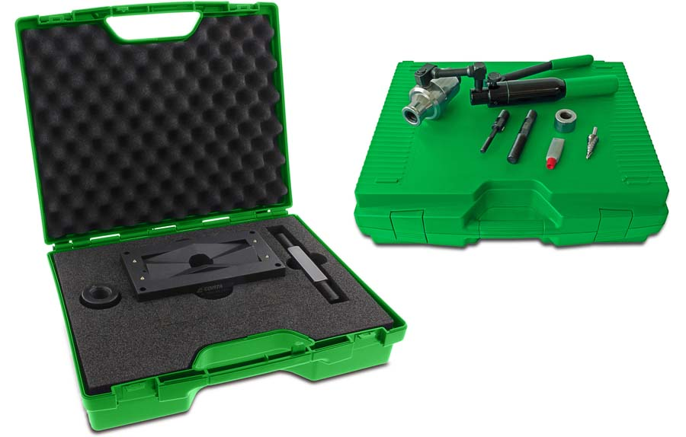
Illustration: CONTA-CLIP offers its punching tool for break-outs in control cabinets with a hydraulic hand pump

Illustrations: | Hydraulikhandpumpe_Stanzwerkzeug | Char.s: | 1240
File name: | 201903014_pm_hydraulic_puncher_en | Date: | 04-30-2019
About CONTA-CLIP
CONTA-CLIP is one of Europe’s leading manufacturers of electrical and electronic connection elements and cable management solutions. Based in Hövelhof, Germany, the medium-sized, family-run company has been producing electric and electronic connection systems for the process and automation industries for 40 years. CONTA-CLIP supplies all industry sectors, focusing on railroad industries, shipbuilding, building automation, conveyor technology, machine and plant engineering and construction, instrumentation and control technology, control panel manufacturing, transformer manufacturing, and environmental technology. The company consists of three specialized branches: CONTA-CONNECT for electric connection technology, CONTA-ELECTRONICS for electronics and CONTA-CON for PCB edge connectors. Additionally, CONTA-CLIP provides services such as customizing housings and mounting rails, labeling and supplying user-specific electronic components.

Contact:  CONTA-CLIP  Verbindungstechnik GmbH  Christian Quade  Otto-Hahn-Str. 7  33161 Hövelhof  Germany  Phone: +49 . 5257 . 9833 - 0  Fax: +49 . 5257 . 9833 - 33  Email: christian.quade@conta-clip.de  Internet: www.conta-clip.com | gii die Presse-Agentur GmbH  Immanuelkirchstr. 12  10405 Berlin  Germany  Phone: +49 . 30 . 538 965 - 0  Fax: +49 . 30 . 538 965 - 29  Email: info@gii.de  Internet: www.gii.de

