Press Release

TwinTouch industrial touchscreens with force detection

RAFI expands its GLASSCAPE portfolio of industrial-grade capacitive touchscreens, introducing the new TwinTouch input technology, which in addition to touch evaluates the force of inputs. Combining touch and force detection, TwinTouch significantly increases operational safety. Capacitive switches and fields in the touchscreen can be configured to require a defined pressure force for touch commands. This helps prevent accidental input through unintended contact with the screen. The switching thresholds for the applied pressure can be individually adjusted via software. At the same time, the combined evaluation of touch and mechanical force enables an implementation of additional input levels. For instance, pressing a screen button for a prolonged time may activate a context menu, or applying different amounts of pressure may be used to adjust parameter values. The TwinTouch system with trackless pressure measurement ensures reliable IP65 ingress protection.
Video clip: https://www.youtube.com/watch?v=r5dRQgXlDsc
Deep link: https://www.rafi.de/en/products/control-systemshmi/capacitive-systemsglasscape/
PDF brochure: https://www.rafi.de/en/company/download-center/pdf-brochures-flyers/

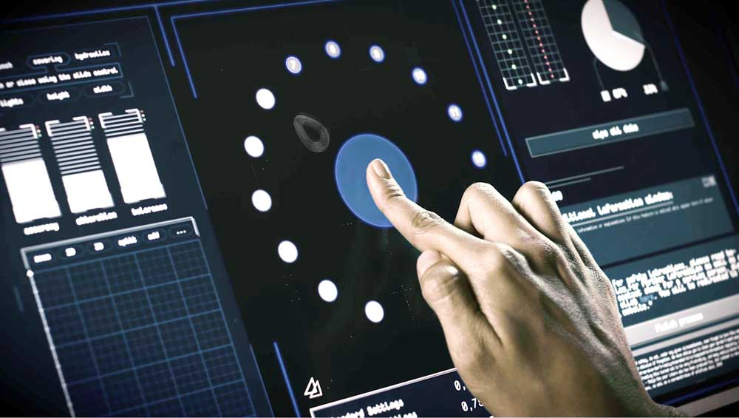
Caption: Featuring force as well as touch detection, the new TwinTouch panels achieve enhanced functional accuracy and enable extra input options

Image/s: | TwinTouch | Characters: | 971
File name: | 201903025_pm_twintouch_en | Date: | 11-19-2019
About RAFI
Founded in 1900, RAFI today develops and manufactures electromechanical components and systems for human–machine interaction. The range of products includes pushbuttons, switches, touchscreens, and operating systems, as well as electronic assemblies. RAFI products are employed in automation, medical technology, machine and plant engineering, vehicles, rolling stock, household appliances, and telecommunications. The RAFI group operates internationally with 2,500 employees at sites in Germany, Europe, China, and the USA. Its headquarters are in Berg, Germany.

Contact:  RAFI GmbH & Co. KG  Artur Krug  Ravensburger Str. 128-134  88276 Berg  Germany  Phone: +49 . 751 . 891 307  Fax: +49 . 751 . 891 300  Email: artur.krug@rafi.de  Internet: www.rafi.de | gii die Presse-Agentur GmbH  Immanuelkirchstr. 12  10405 Berlin  Germany  Phone: +49 . 30 . 5389 650  Fax: +49 . 30 . 5389 6529  Email: info@gii.de  Internet: www.gii.de

